## Image 01 (zoo)

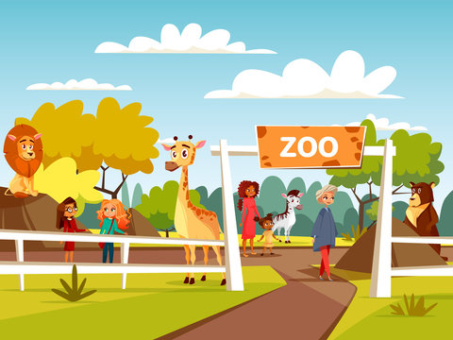

1. How many mammals are visible? 5 (taxonomic) (lion, giraffe, deer, bear, child)

2. How many people are standing next to each other? 2 (relational) (woman and child)

3. If the zoo sign was made of metal instead of wood, how many objects made of metal would there be? 1 (physical) (zoo sign)

## Image 02 (kitchen)

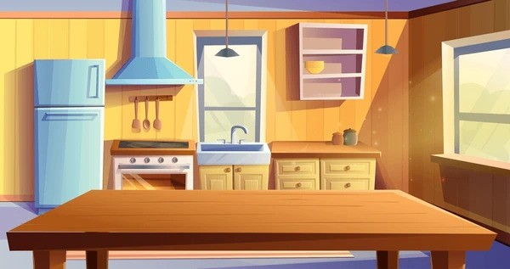

1. How many objects made of metal are present? 4 (physical) (handles, faucet, stove knobs, range hood)

2. How many objects are on top of the counter? 5 (relational) (sink, spice jars, bowl, faucet, hanging utensils)

3. If the refrigerator was a different color, how many blue objects would be visible? 1 (taxonomic) (refrigerator)

## Image 03 (garage)

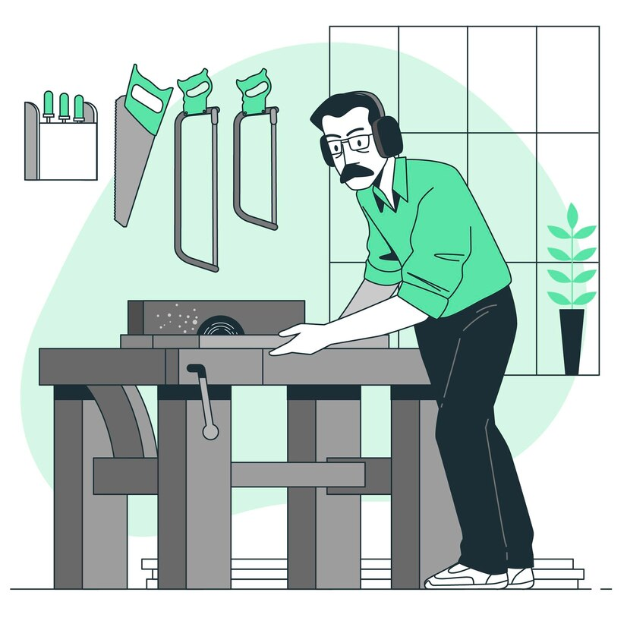

1. How many tools are hanging on the wall? 3 (taxonomic) (saws and tool holder)

2. How many legs does the workbench have? 8 (physical) (workbench legs)

3. If the plant was not in the pot, how many pots would be visible? 0 (relational) (pots)

## Image 04 (biking)

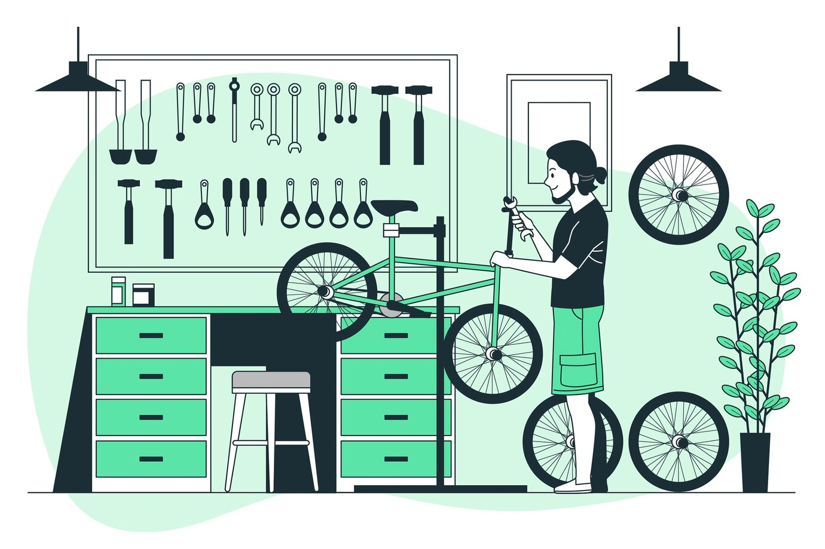

1. How many tools are hanging on the wall? 13 (taxonomic) (tools)

2. How many wheels are visible in the image? 4 (physical) (wheels)

3. If the plant was not present, how many green objects would be visible? 8 (taxonomic) (objects)

## Image 05 (park)

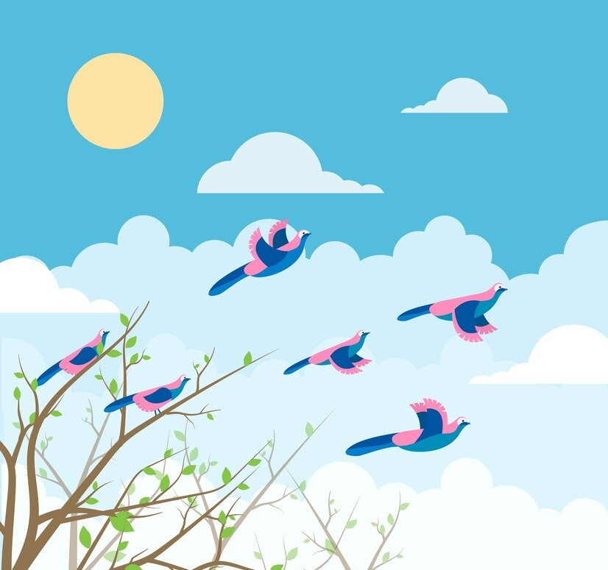

1. How many birds are visible? 8 (taxonomic) (birds)

2. How many birds are flying in a flock? 5 (relational) (birds)

3. If all the birds were green, how many green birds would there be? 8 (taxonomic) (birds)

## Image 06 (urban)

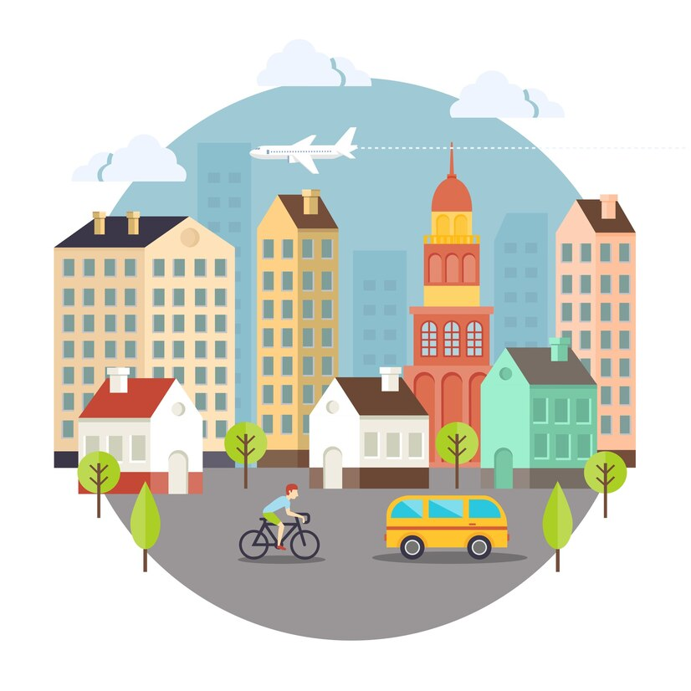

1. How many buildings are present? 8 (taxonomic) (buildings)

2. How many vehicles are visible on the road? 2 (functional) (vehicles)

3. If the plane disappeared from the sky, how many flying objects would be visible? 0 (taxonomic) (flying objects)

## Image 07 (beach cleanup)



1. How many objects made of plastic are present? 7 (physical) (bottles)

2. How many containers with recycling symbols are visible? 2 (functional) (trash bins)

3. If the bag of bottles was empty, how many bottles would the person be holding? 2 (relational) (bottles)

## Image 08 (meeting room)



1. How many chairs are present? 6 (taxonomic) (furniture)

2. How many items are on top of the table? 4 (relational) (objects)

3. If the plants were removed from the pots, how many pots would remain? 3 (taxonomic) (containers)

## Image 09 (kitchen)

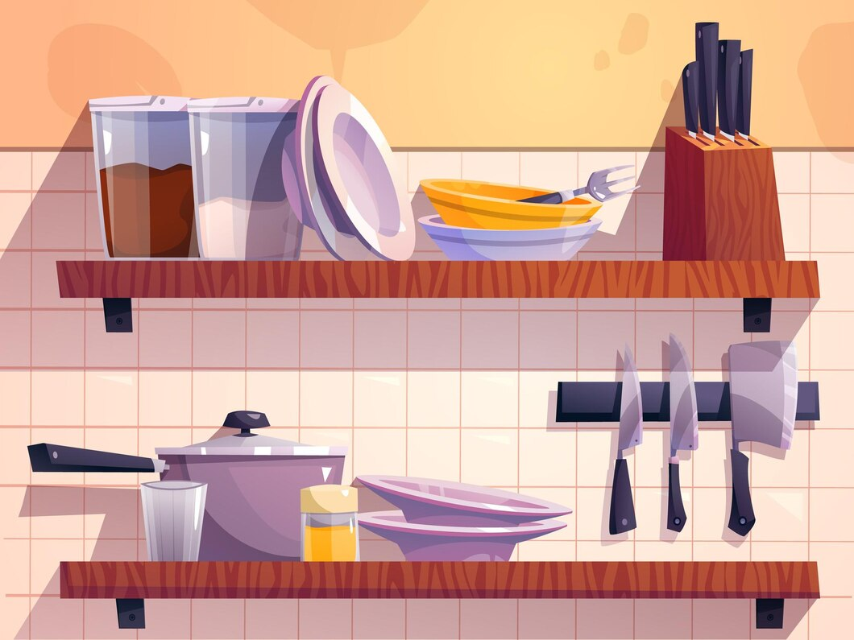

1. How many objects made of metal are present? 6 (physical) (knives)

2. How many items are stacked on top of each other? 4 (relational) (plates)

3. If the pot was transparent, how many objects could you see inside? 0 (functional) (objects)

## Image 10 (meeting room)

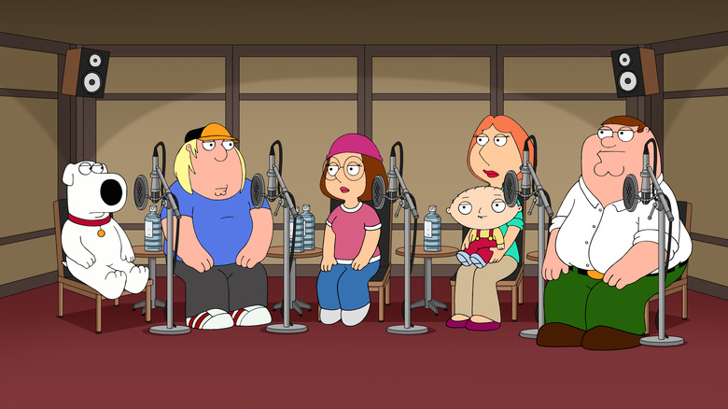

1. How many mammals are present? 2 (taxonomic) (dog, baby)

2. How many characters are sitting in chairs? 6 (relational) (characters)

3. If all the water bottles were removed, how many bottles would be missing? 6 (physical) (water bottles)

## Image 11 (kitchen)

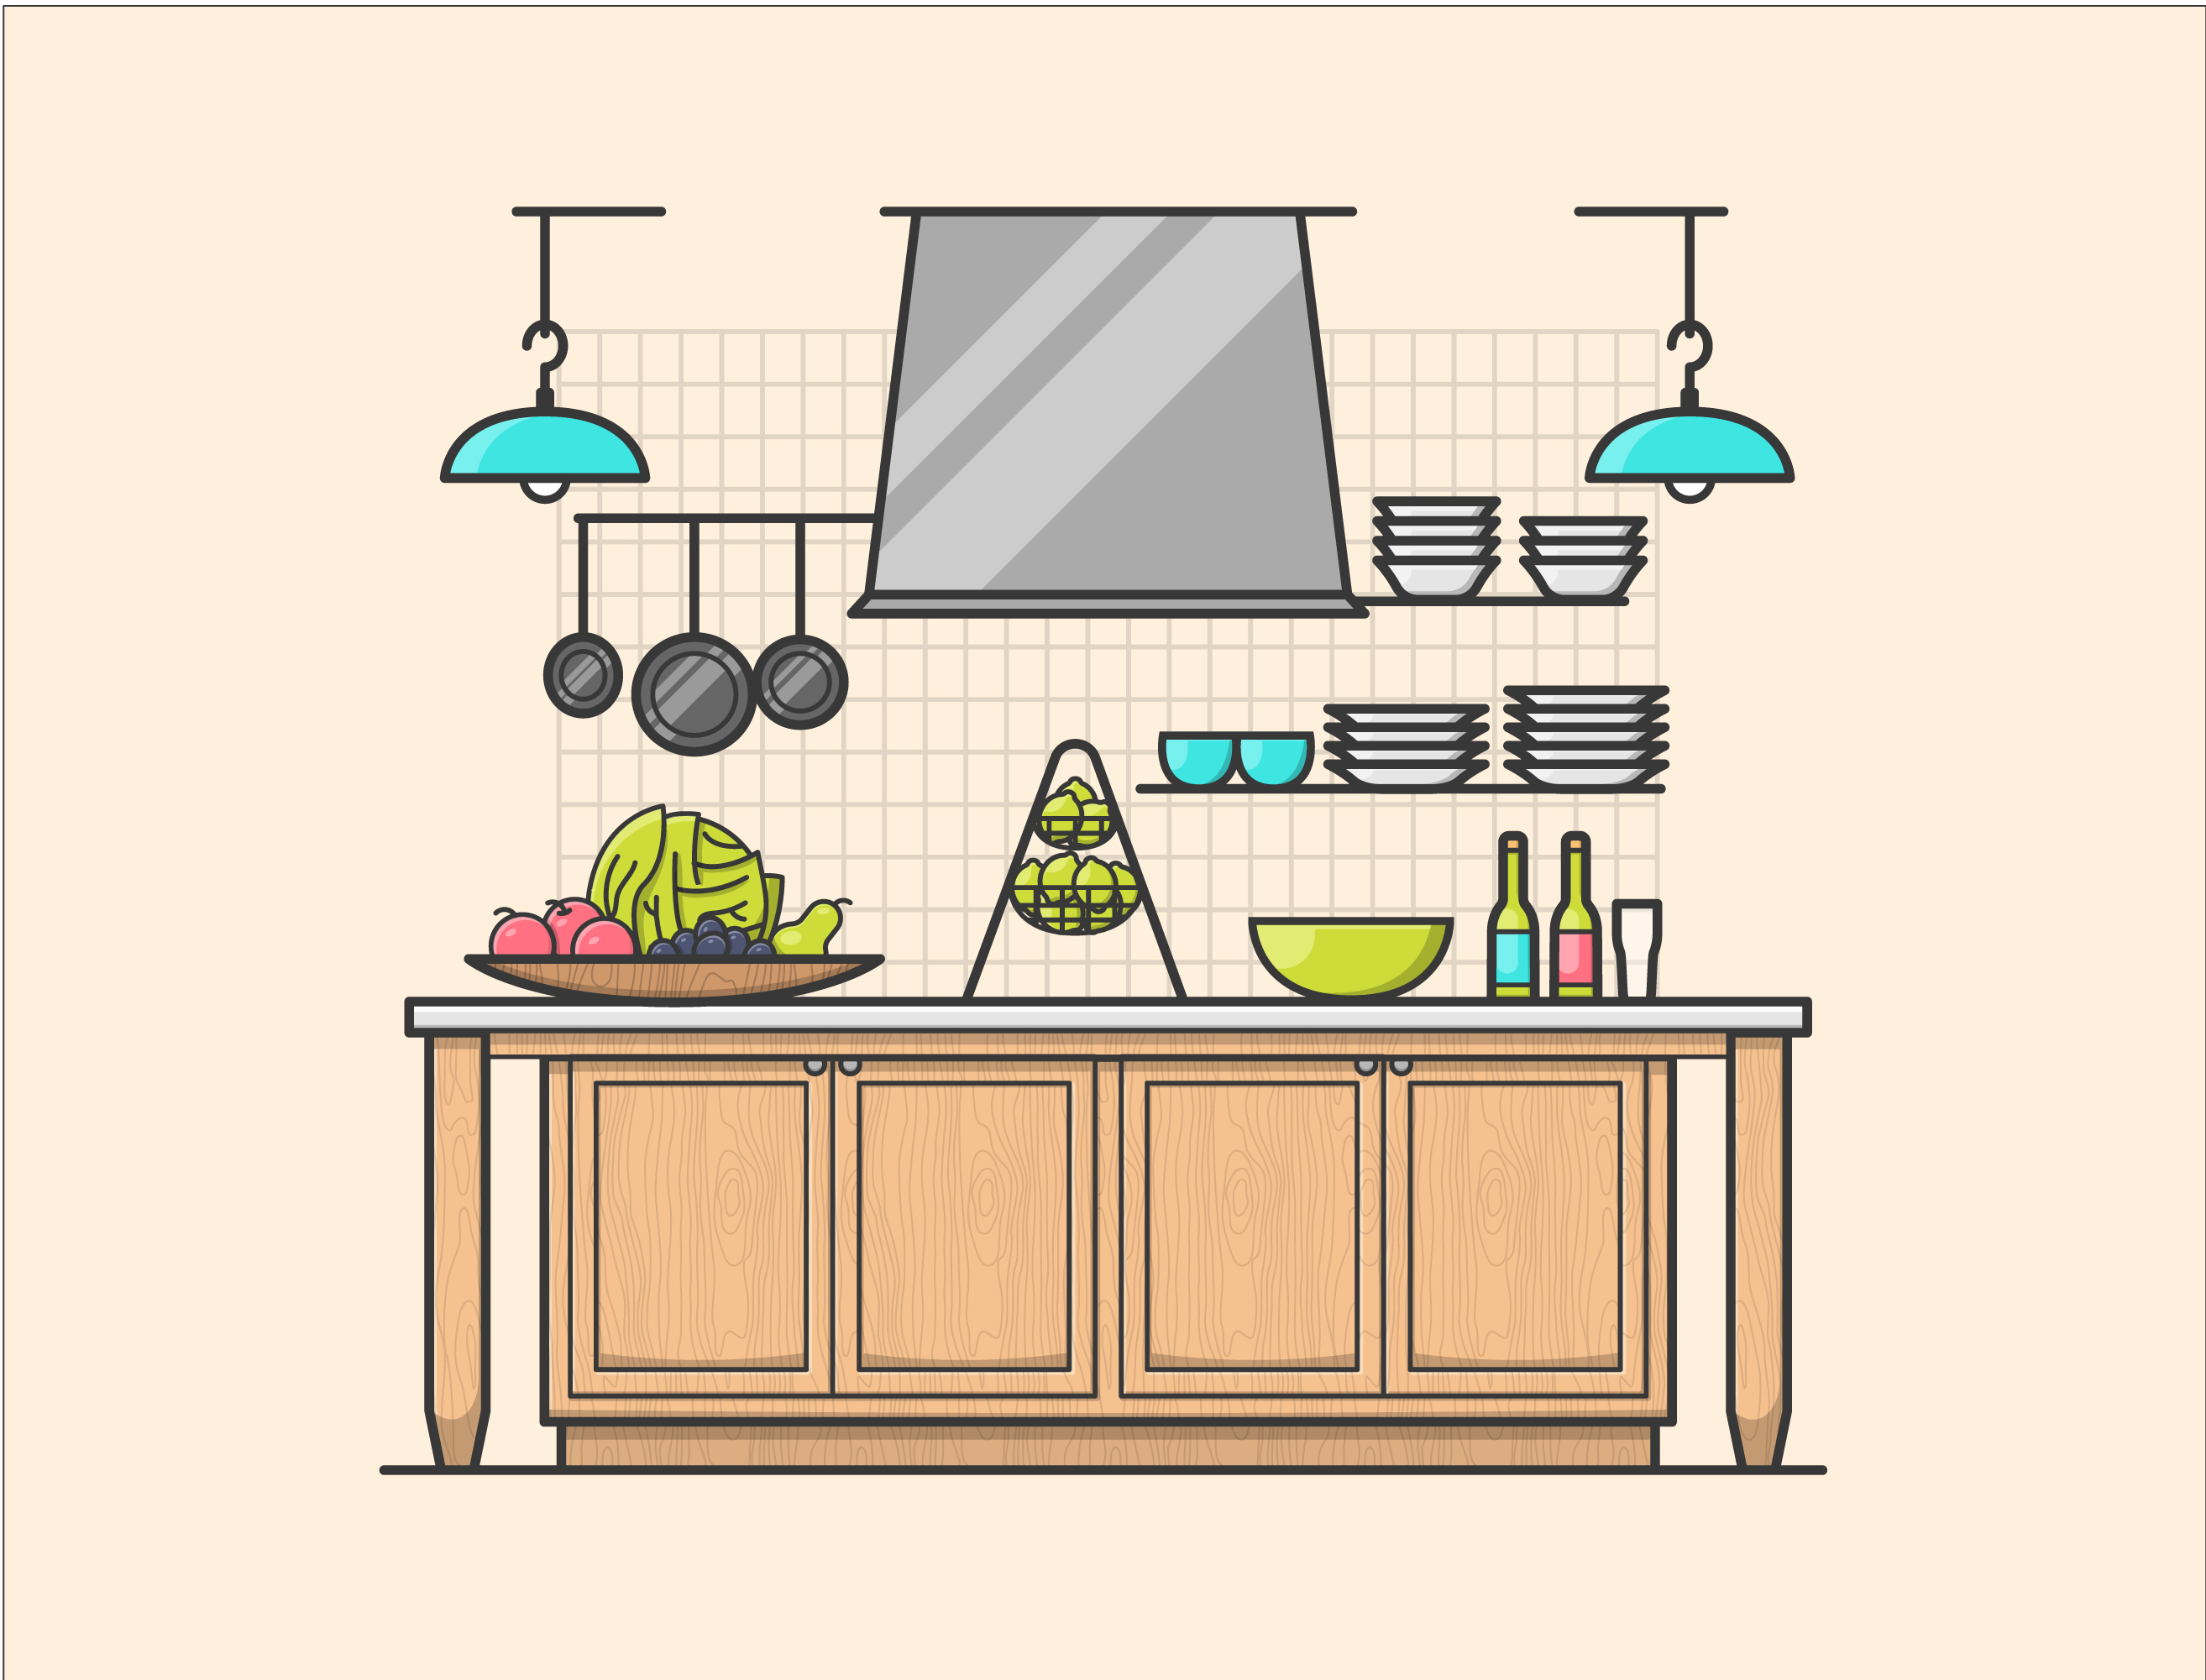

1. How many fruits are visible? 5 (taxonomic) (apples, plums, pears)

2. How many items are stacked on top of each other? 3 (relational) (plates)

3. If the hanging pots and pans were made of plastic instead of metal, how many plastic items would be hanging? 3 (physical) (pots and pans)

## Image 12 (gardening)



1. How many potted plants are visible? 6 (taxonomic) (plants)

2. How many items are used for holding something? 3 (functional) (watering can, pots)

3. If the ladder was not present, how many plants would be on the floor? 2 (relational) (plants)

## Image 13 (meeting room)

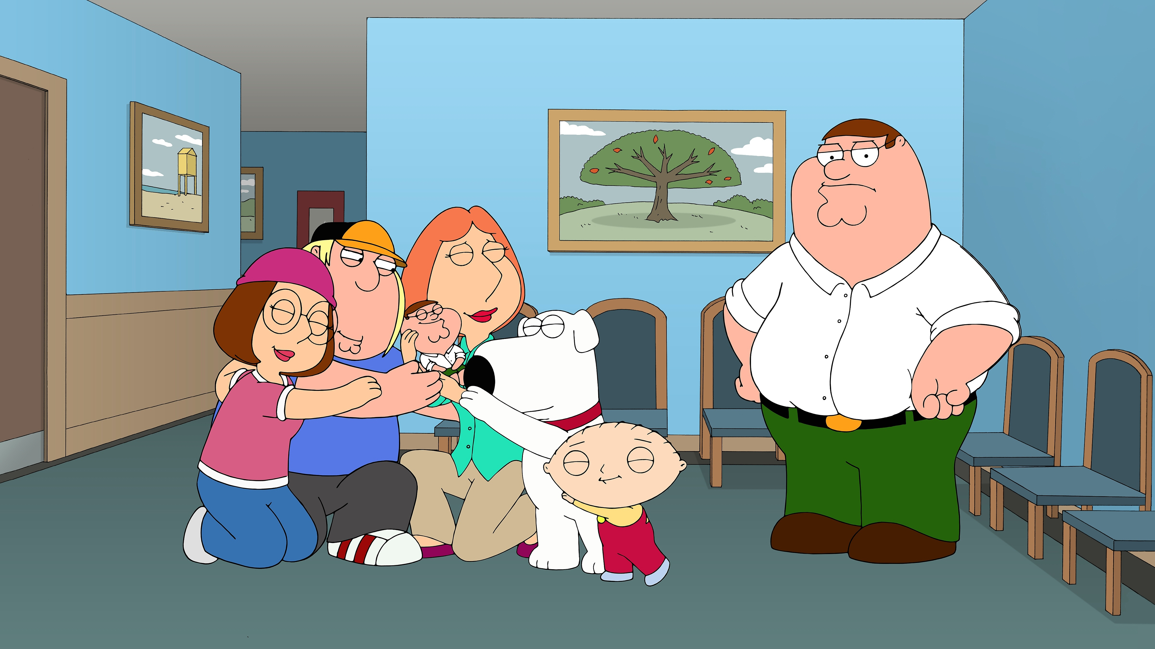

1. How many mammals are present? 3 (taxonomic) (dog, Stewie, Brian)

2. How many characters are embracing another character? 3 (relational) (Meg, Chris, Lois)

3. If all the chairs were removed from the room, how many chairs would be visible? 0 (physical) (chairs)

## Image 14 (salon)

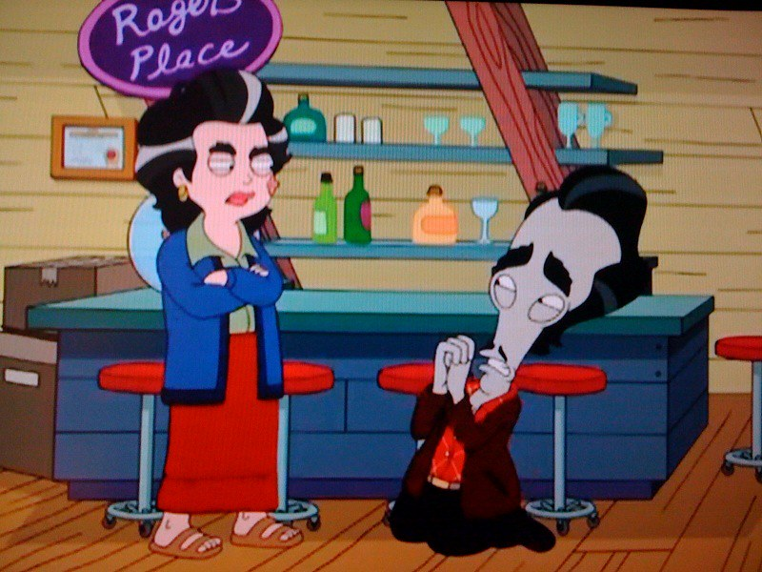

1. How many stools with wheels are present? 3 (physical) (stools)

2. How many objects that can hold liquid are visible on the counter? 6 (functional) (glasses/bottles)

3. If Roger's Place sign was removed, how many signs are visible? 0 (taxonomic) (signs)

## Image 15 (urban)

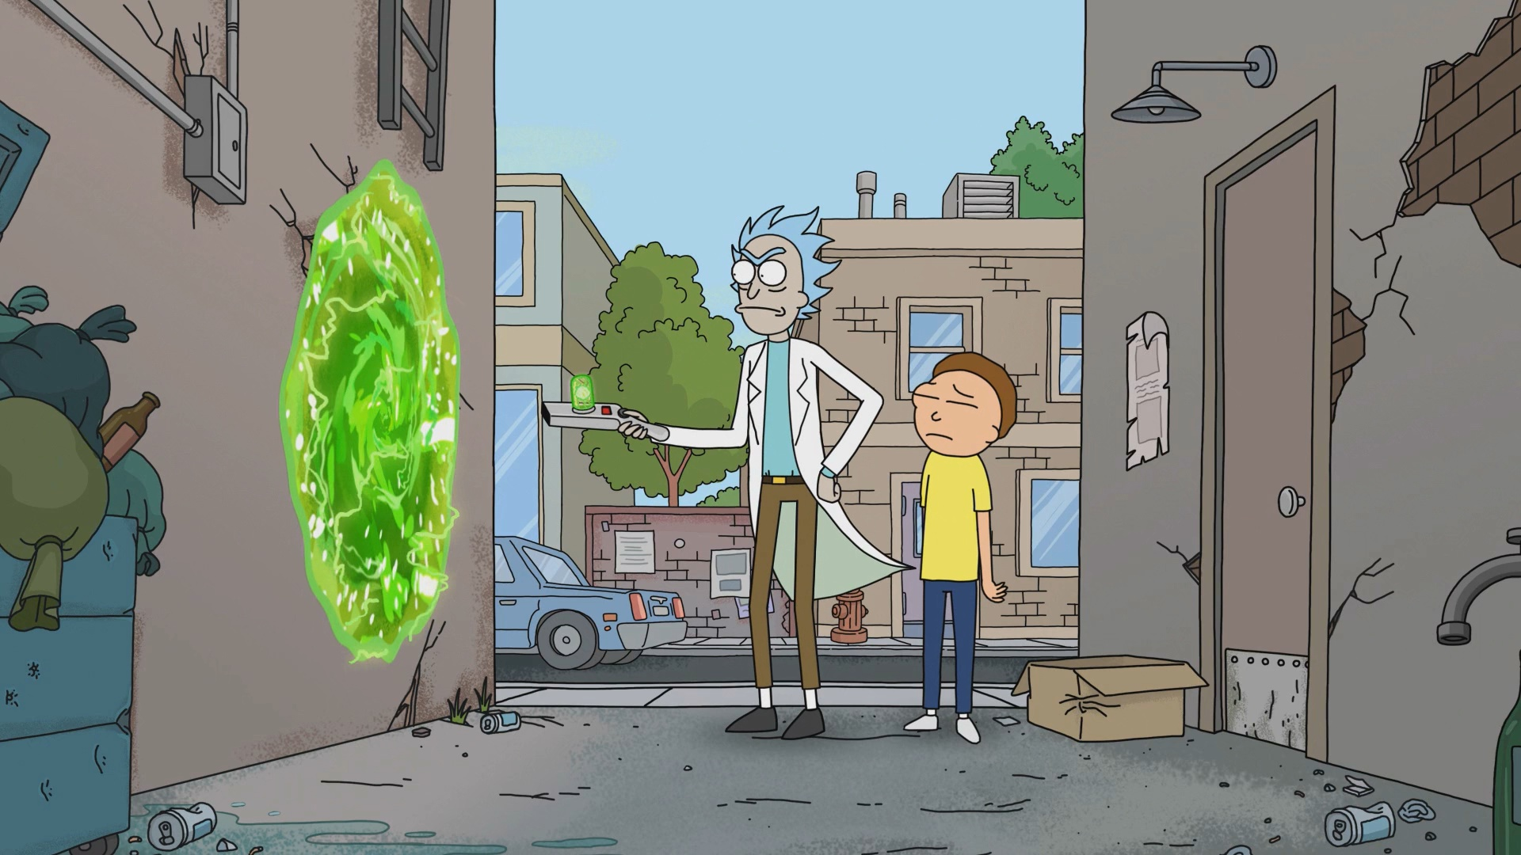

1. How many vehicles are present? 1 (taxonomic) (car)

2. How many characters are standing next to each other? 2 (relational) (Rick and Morty)

3. If the trash cans were all full of liquid, how many containers holding liquid would there be? 3 (functional) (trash cans and bottle)

## Image 16 (beach cleanup)

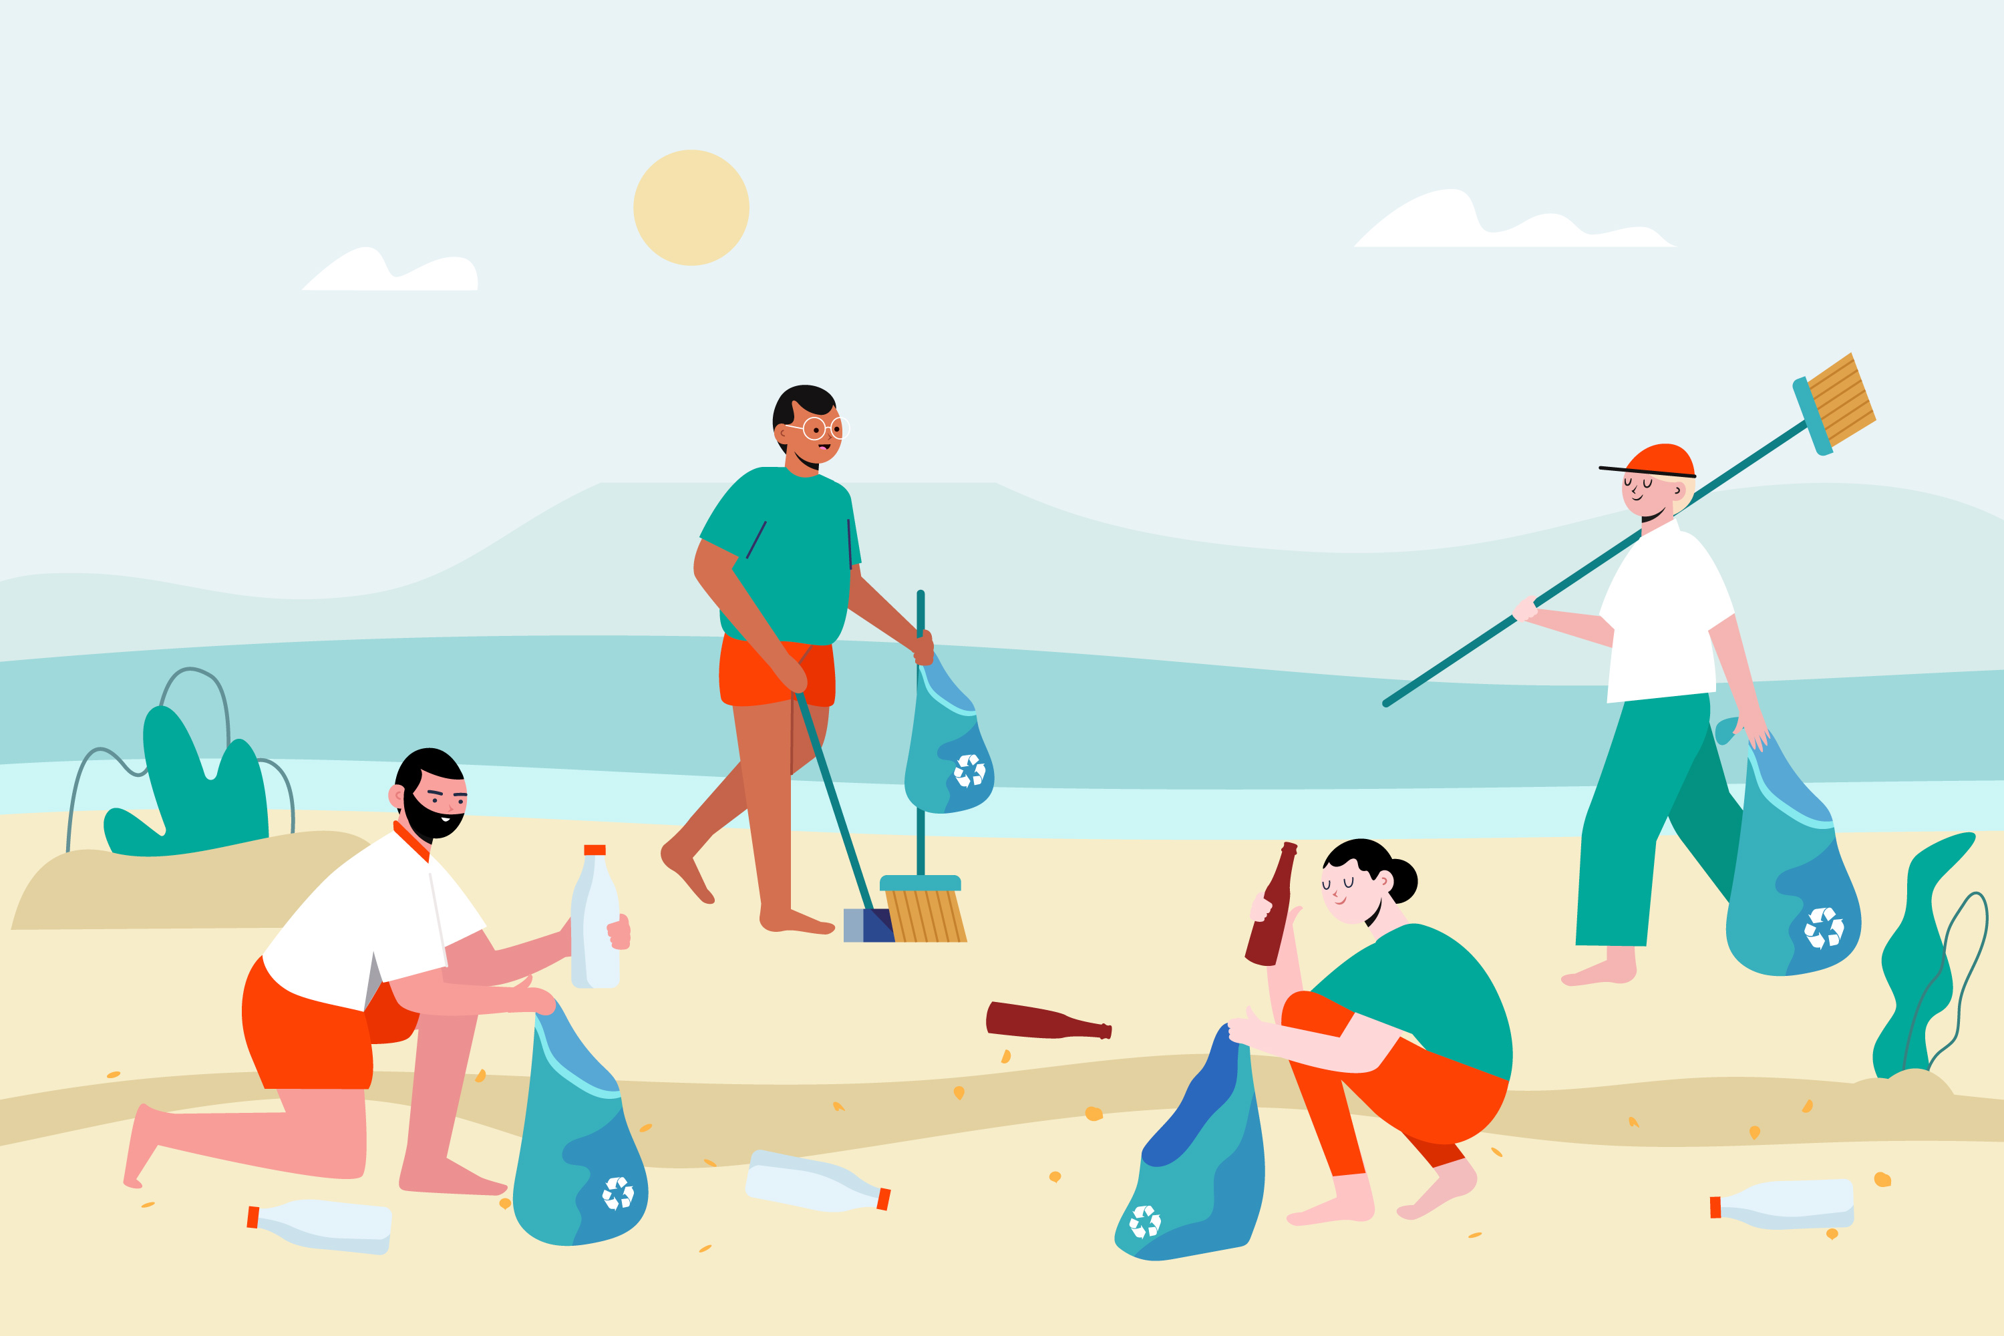

1. How many plastic items are visible? 6 (physical) (bottles and trash)

2. How many people are holding trash bags? 3 (relational) (people and bags)

3. If the people were not cleaning the beach, how many trash items would be visible? 9 (physical) (trash items)

## Image 17 (bedroom)

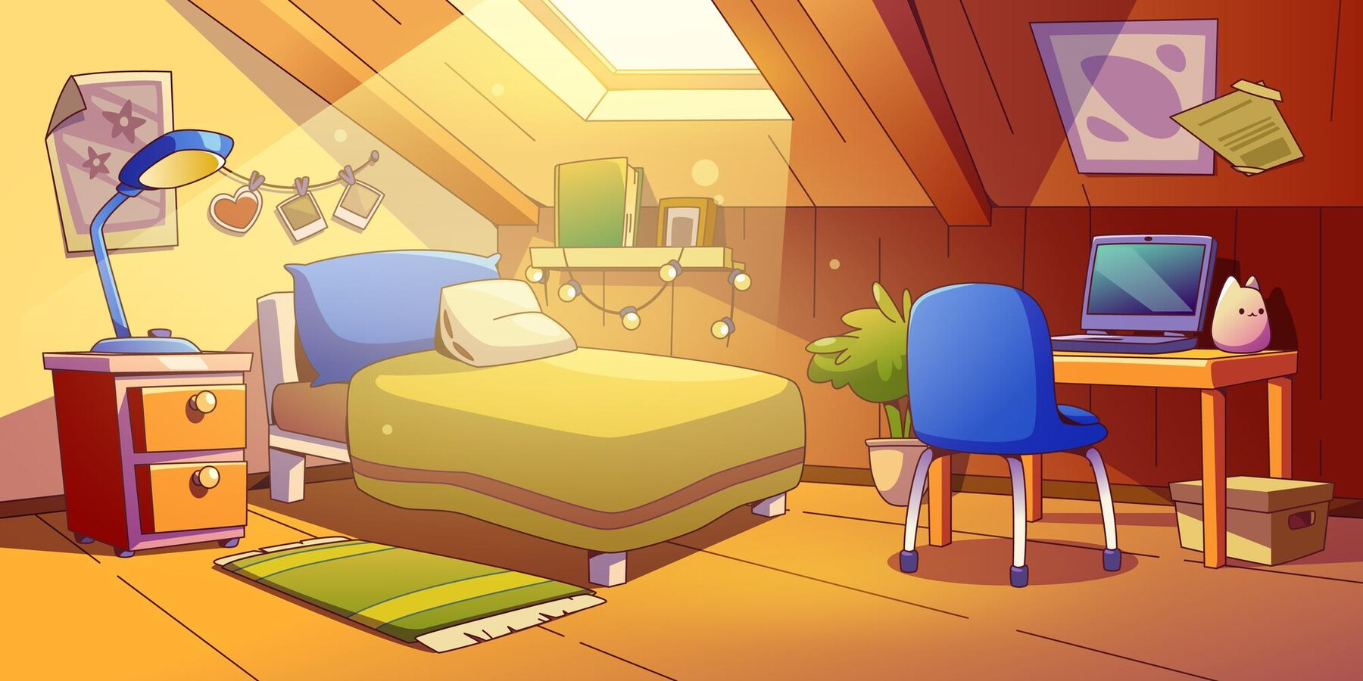

1. How many pieces of furniture are present? 5 (taxonomic) (bed, nightstand, desk, chair, box)

2. How many items are on top of other items? 3 (relational) (laptop on desk, cat on laptop, books on shelf)

3. If the rug was replaced with two smaller rugs, how many rugs would there be? 2 (physical) (rugs)

## Image 18 (garage)

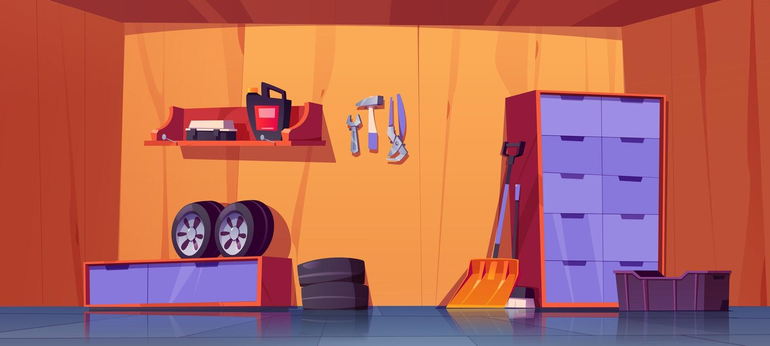

1. How many objects that are tools are present? 4 (taxonomic) (wrench, hammer, screwdriver, red machine)

2. How many objects are stacked on top of each other? 4 (relational) (tires)

3. If the cabinet was empty, how many storage containers would be visible? 2 (functional) (cabinet, box)

## Image 19 (gym)

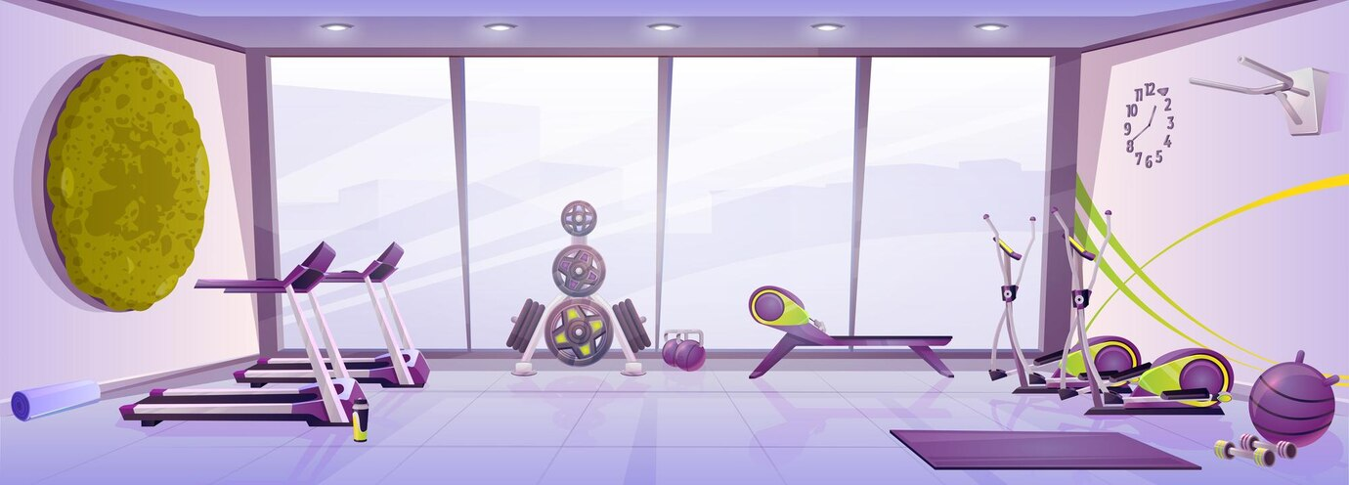

1. How many pieces of exercise equipment are visible? 6 (taxonomic) (treadmill, weight rack, bench, elliptical, exercise ball, dumbbells)

2. How many items are positioned on the floor? 9 (relational) (exercise equipment and accessories)

3. If the large window was replaced with a solid wall, how many wall-mounted objects would be visible? 2 (relational) (clock, coat rack)

## Image 20 (meeting room)

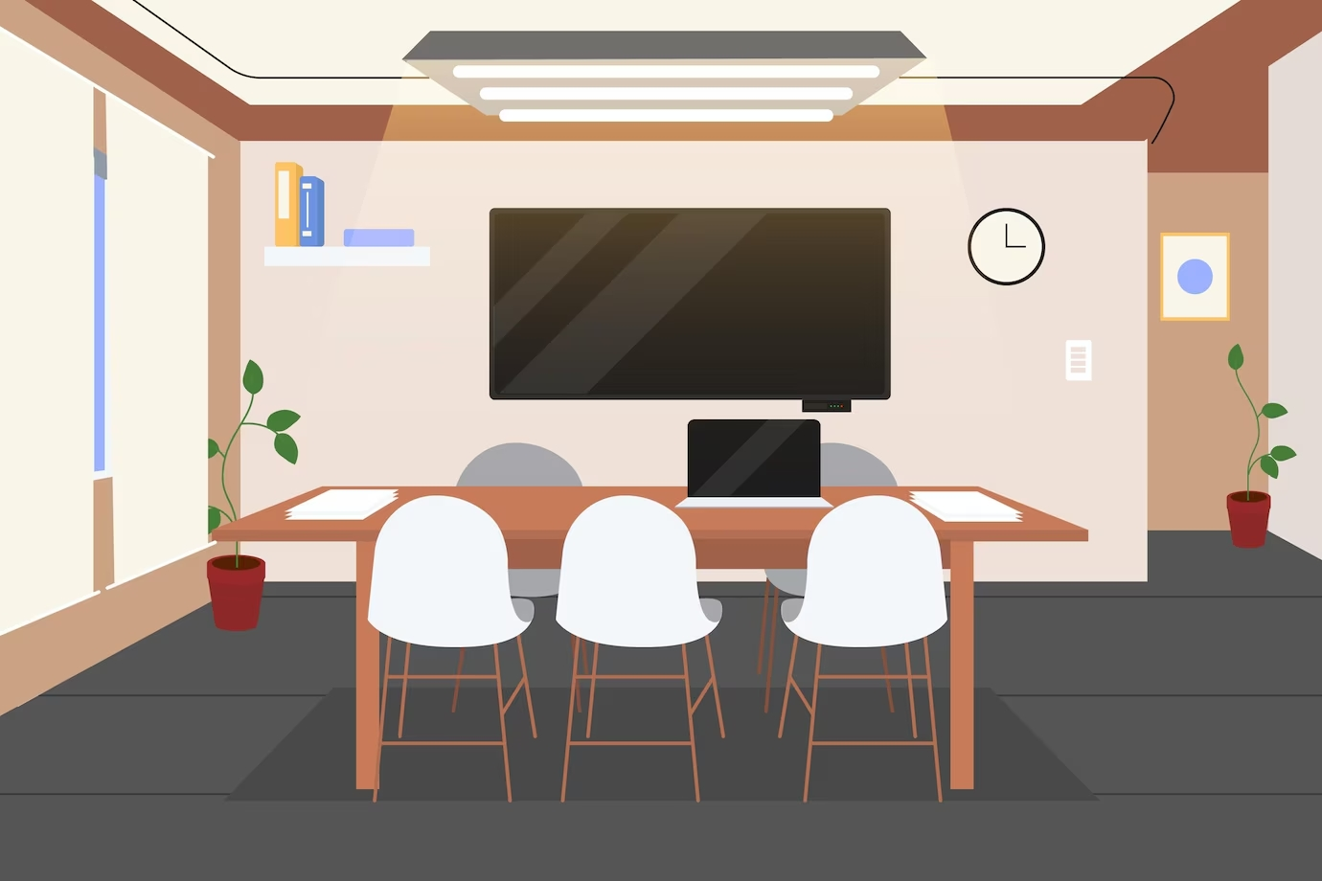

1. How many items of furniture are present? 5 (taxonomic) (table, chairs)

2. How many objects are on top of the table? 4 (relational) (papers, device)

3. If the plants were removed from the room, how many potted plants would be visible? 0 (taxonomic) (plants)

## Image 21 (wardrobe)

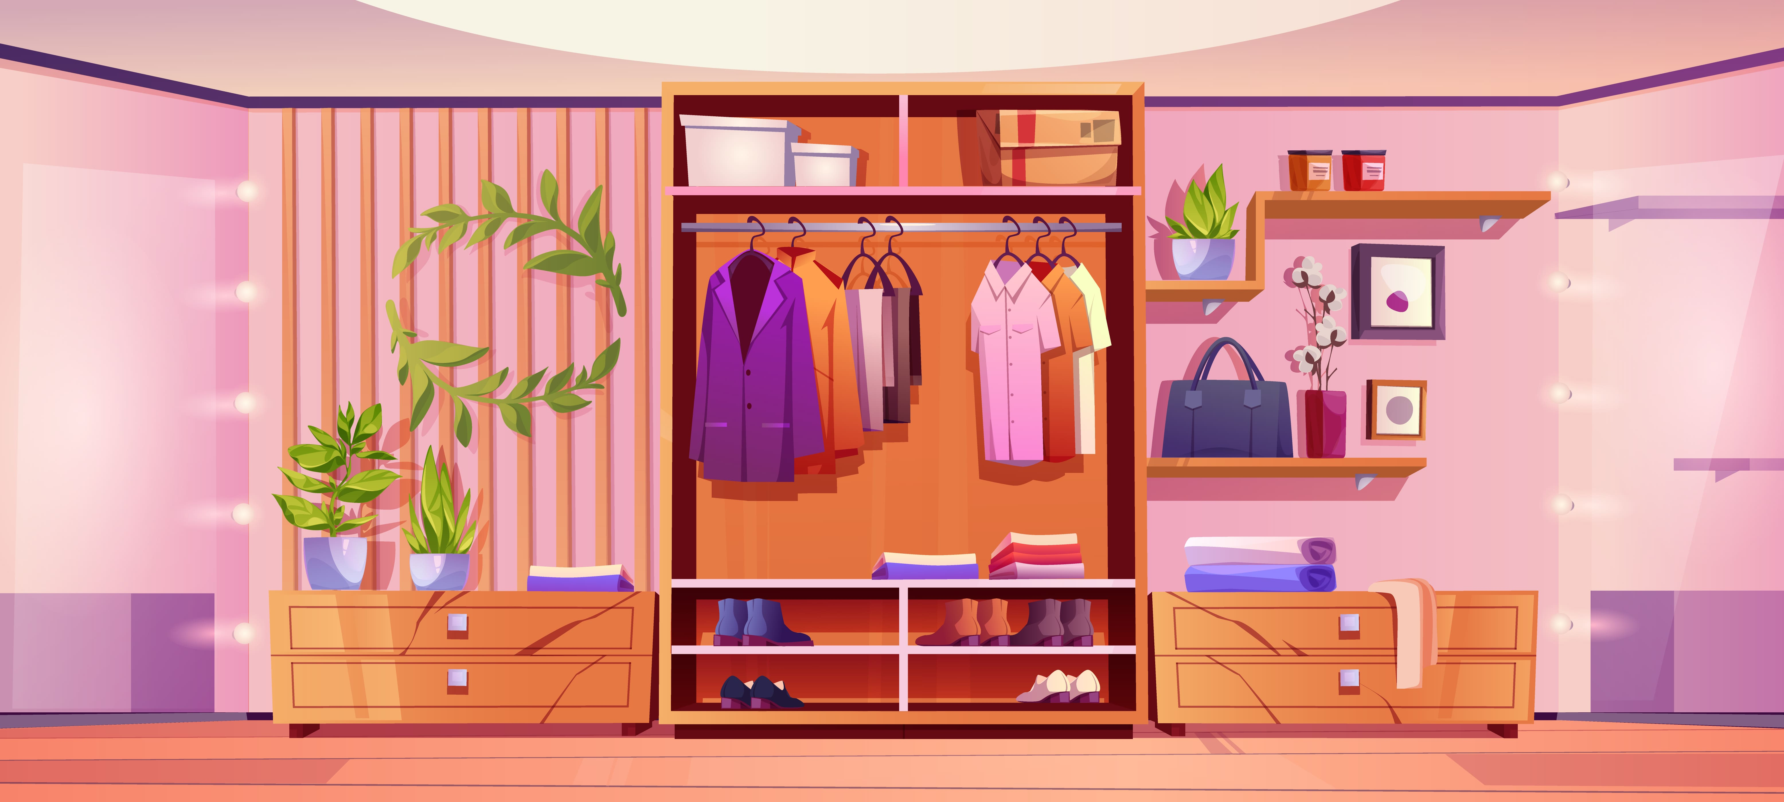

1. How many pieces of furniture are present? 4 (taxonomic) (wardrobe, two dressers, shelf)

2. How many items are inside the wardrobe? 12 (relational) (clothes, shoes, boxes)

3. If all the plants were removed, how many green objects would remain? 0 (taxonomic) (plants)

## Image 22 (wardrobe)

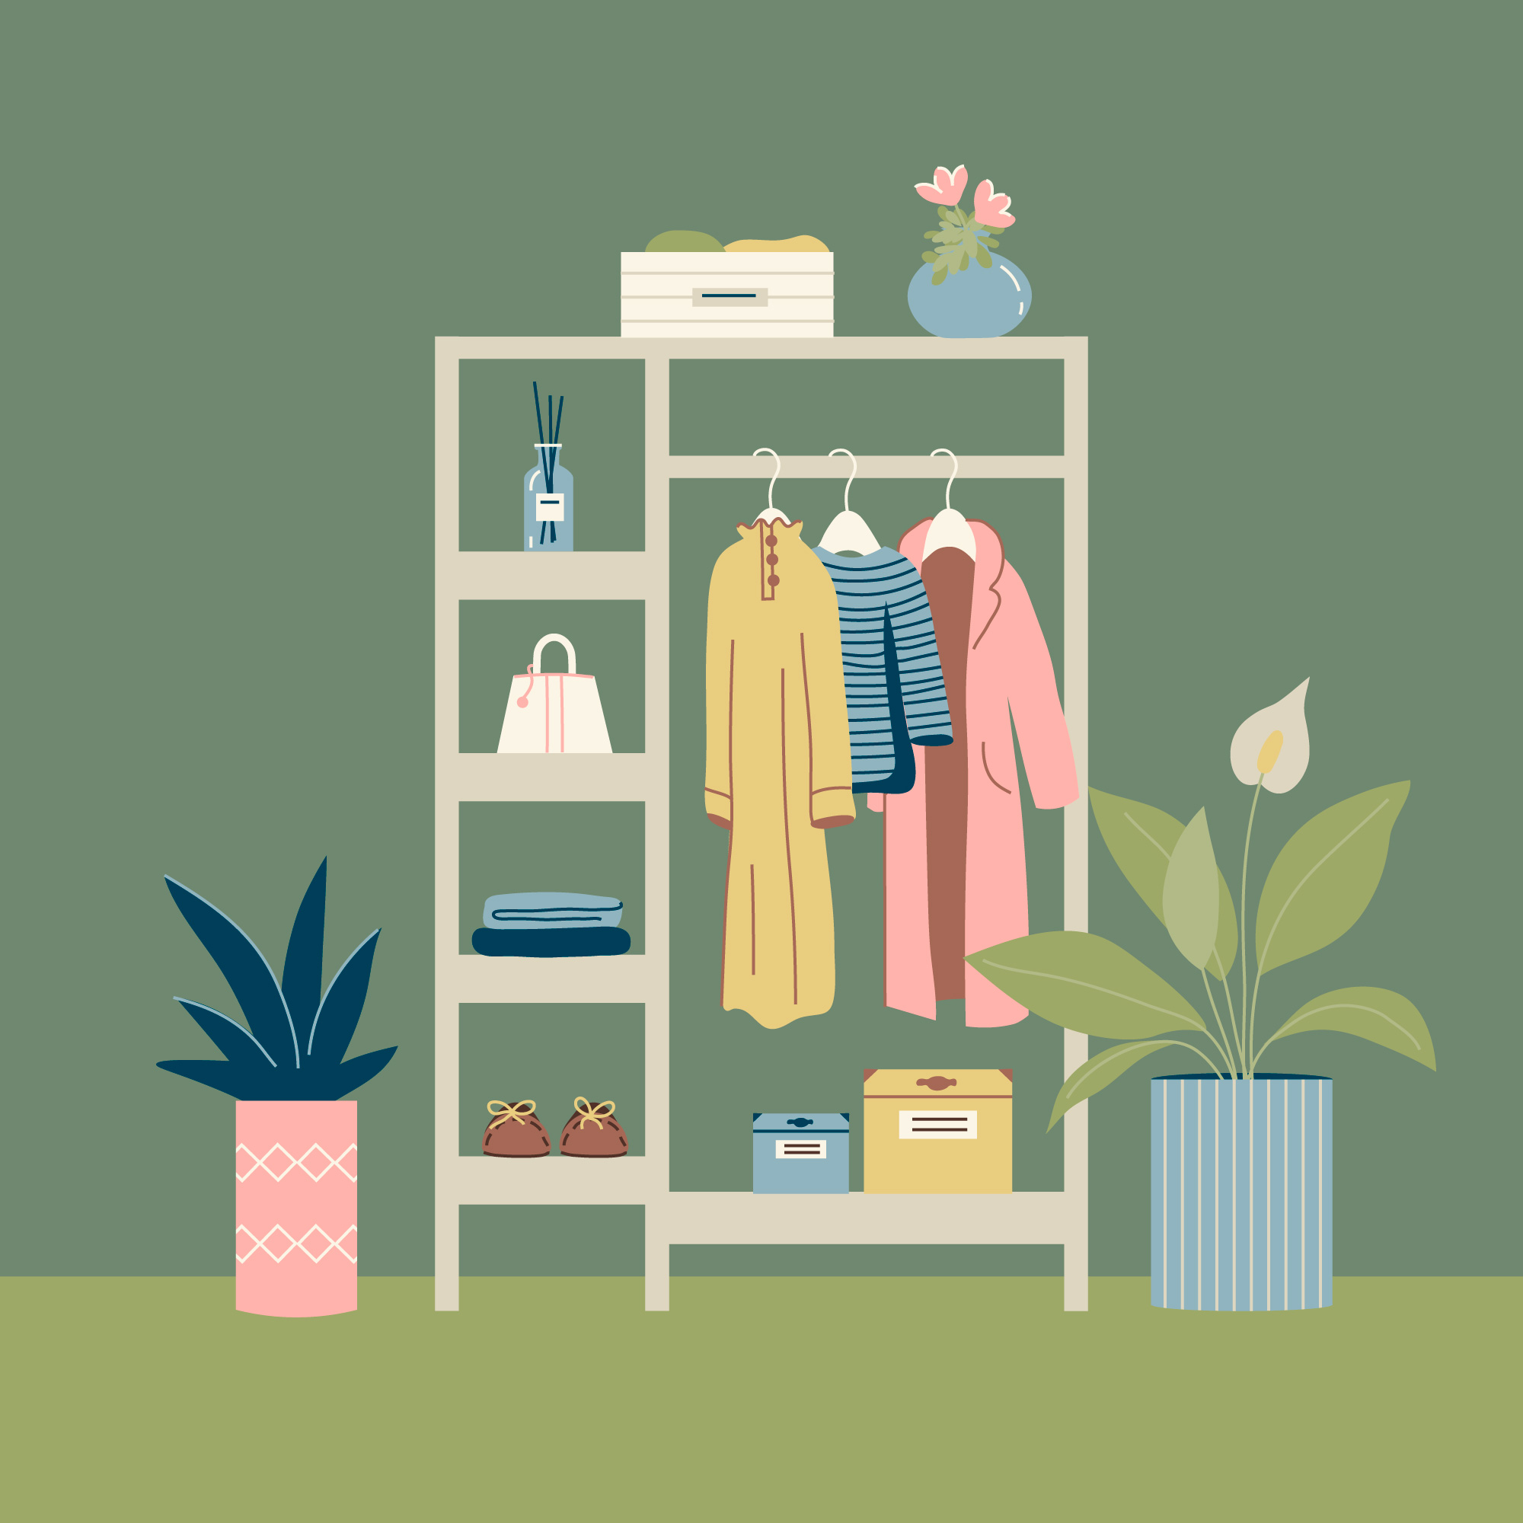

1. How many items of clothing are hanging? 3 (taxonomic) (shirts/jackets)

2. How many items are located on the shelves? 8 (relational) (boxes, plants, bags, folded clothes)

3. If the two plants were removed, how many containers would be visible? 4 (physical) (boxes, pots)

## Image 23 (wardrobe)

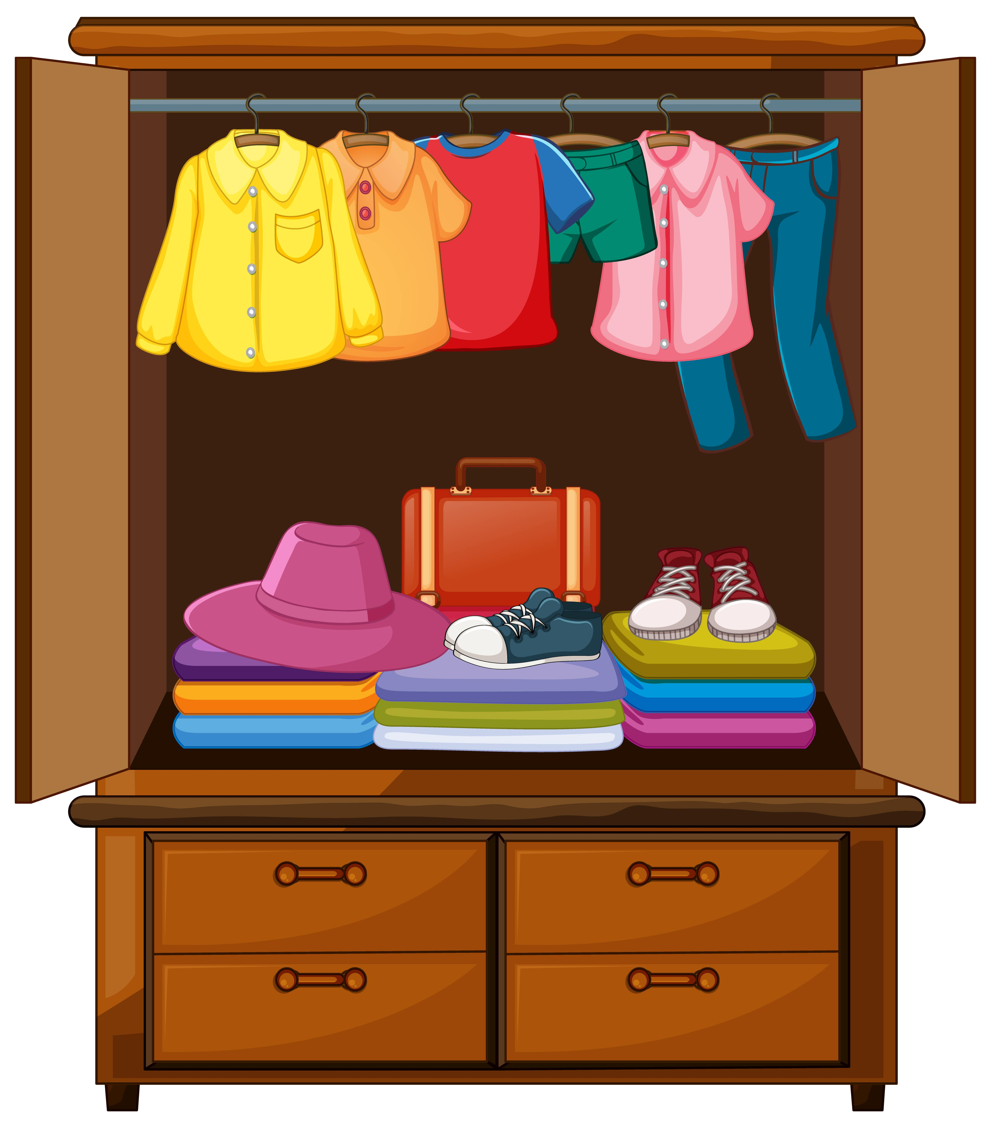

1. How many items of clothing are hanging? 4 (taxonomic) (shirts and pants)

2. How many items are stacked on top of other items? 4 (relational) (hat, suitcase, shoes, folded clothes)

3. If the drawers were open, how many drawers would be visible? 4 (physical) (drawers)

## Image 24 (home setup)

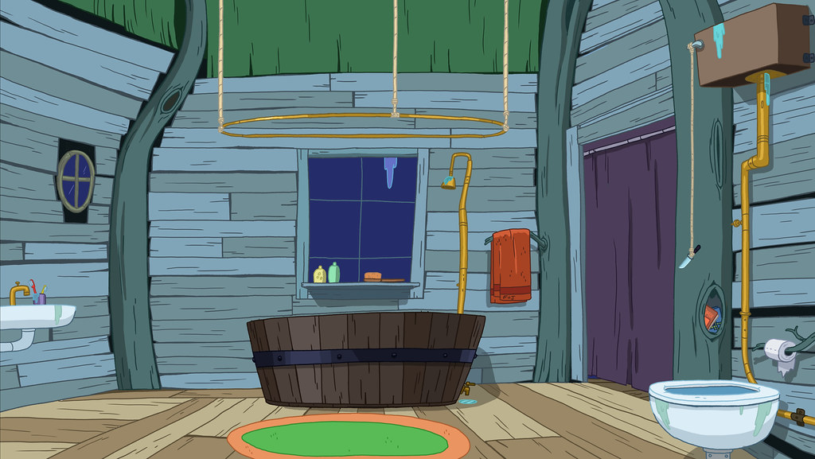

1. How many objects made of wood are present? 4 (physical) (door, barrel, window frame, floor)

2. How many objects that can hold liquid are visible? 2 (functional) (toilet bowl, barrel)

3. If the window was replaced with a door, how many doors would be visible? 2 (relational) (doors)

## Image 25 (bedroom)

[ERROR: Could not add image image25.jpg - ]

## Image 26 (bedroom)

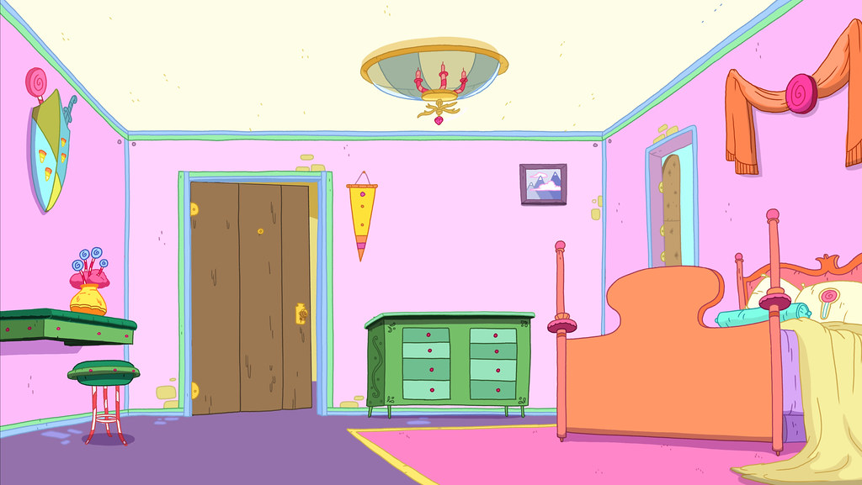

1. How many pieces of furniture are present? 5 (taxonomic) (bed, dresser, stools, table, door)

2. How many objects are on top of other objects? 2 (relational) (vases on table, lamp on dresser)

3. If the chandelier was made of glass instead of metal, how many fragile objects would be visible? 1 (physical) (chandelier)

## Image 27 (home setup)

[ERROR: Could not add image image27.jpg - ]

## Image 28 (home setup)

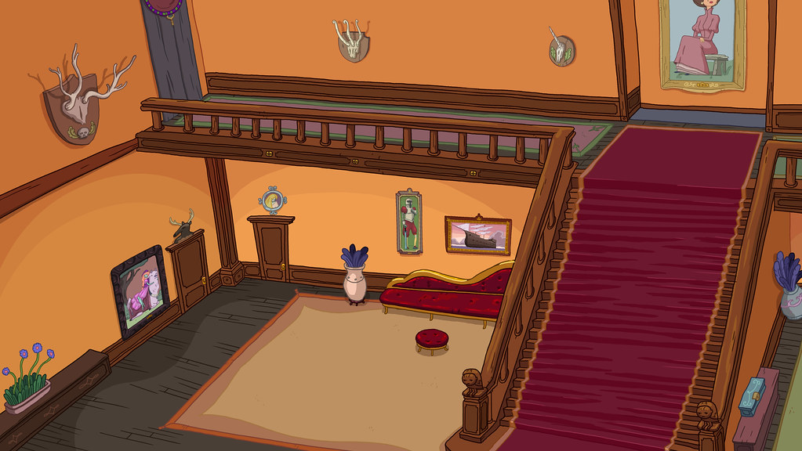

1. How many items of furniture are present? 4 (taxonomic) (couch, stool, table, chair)

2. How many items are on top of other items? 3 (relational) (pictures on wall, plant on table, clock on table)

3. If all the animal heads were replaced with portraits, how many portraits would there be? 5 (taxonomic) (portraits)

## Image 29 (home setup)

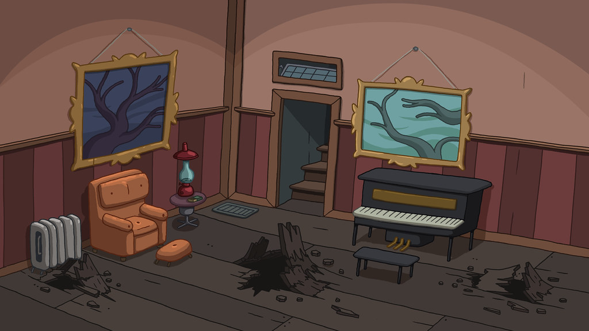

1. How many pieces of furniture are present? 3 (taxonomic) (chair, piano, bench)

2. How many objects are on top of other objects? 2 (relational) (pictures on wall)

3. If all the broken pieces were whole, how many complete objects would there be? 7 (physical) (broken pieces)

## Image 30 (bedroom)

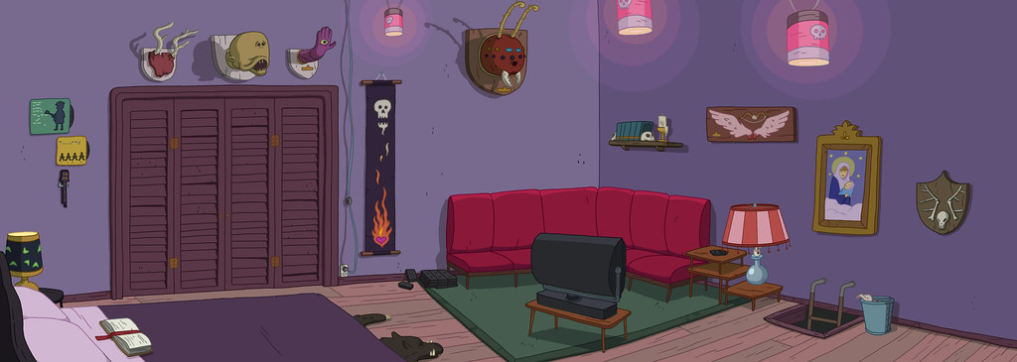

1. How many objects depicting animals are present? 6 (taxonomic) (animal heads)

2. How many objects are placed on top of other objects? 5 (relational) (lamps, books, jars)

3. If all the lamps were removed, how many light sources would be visible? 2 (functional) (jars)

## Image 31 (bedroom)

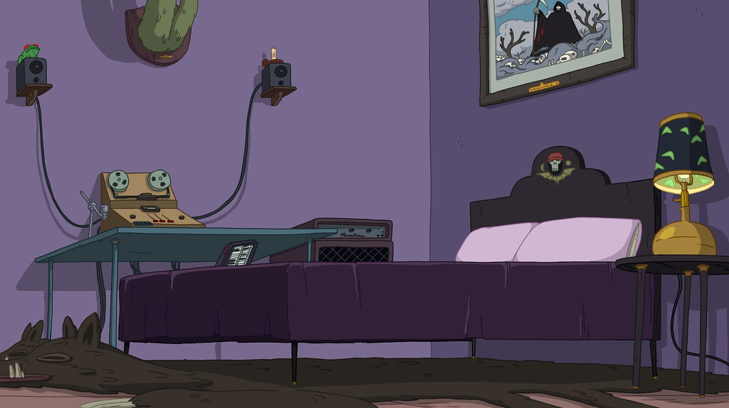

1. How many pieces of furniture are present? 4 (taxonomic) (bed, table, nightstand, couch)

2. How many items are on top of other items? 3 (relational) (lamp on nightstand, picture on wall, equipment on table)

3. If the cactus speakers were replaced with regular speakers, how many speakers would be visible? 2 (taxonomic) (speakers)

## Image 32 (home setup)

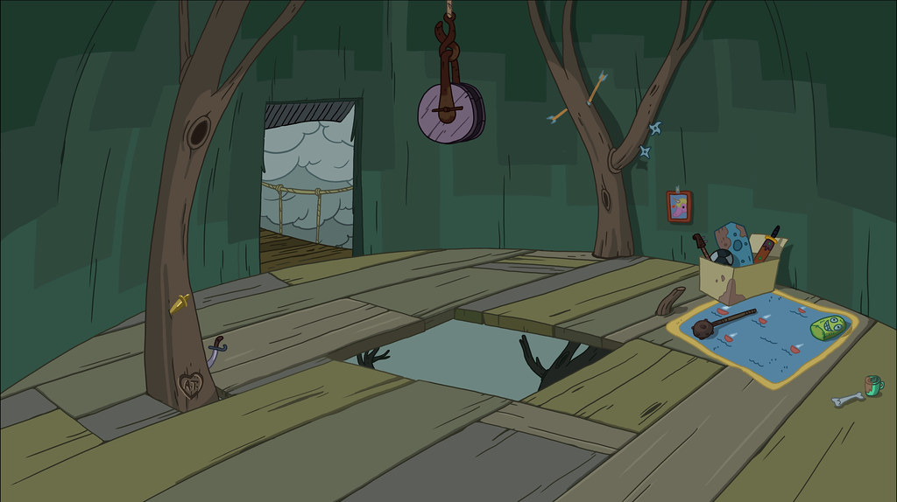

1. How many objects made of wood are present? 14 (physical) (planks)

2. How many objects are on top of other objects? 3 (relational) (items on table)

3. If the hole in the floor were filled with wood, how many solid surfaces would be visible? 15 (physical) (surfaces)

## Image 33 (garage)

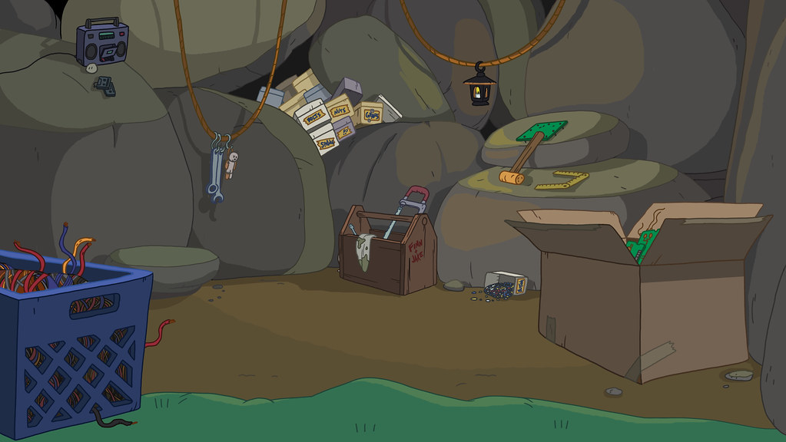

1. How many boxes are present? 4 (taxonomic) (cardboard boxes)

2. How many items are inside containers? 8 (relational) (items in basket and boxes)

3. If the toolbox was empty, how many tools would be visible outside of containers? 4 (physical) (tools)

## Image 34 (laboratory)

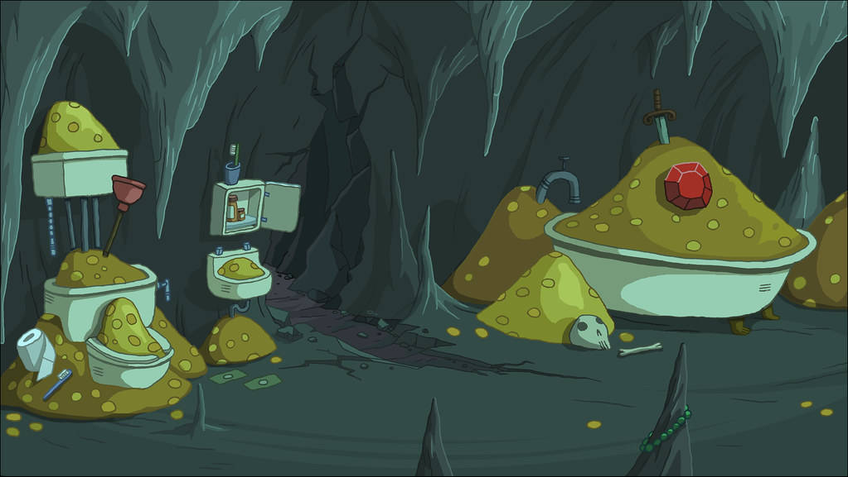

1. How many toilets are present? 3 (taxonomic) (toilets)

2. How many items are on top of piles of gold? 2 (relational) (bathtub and toilet)

3. If all the gold coins were replaced with apples, how many apples would there be? 50 (physical) (coins)

## Image 35 (park)

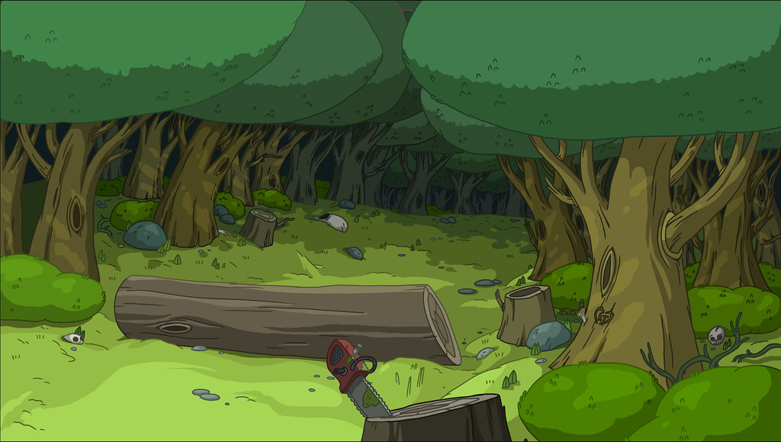

1. How many tree stumps are present? 4 (taxonomic) (tree stumps)

2. How many objects lying on top of other objects are visible? 2 (relational) (chainsaw on log, skull on stump)

3. If all the logs were made of metal instead of wood, how many metal objects would there be? 3 (physical) (logs)

## Image 36 (urban)

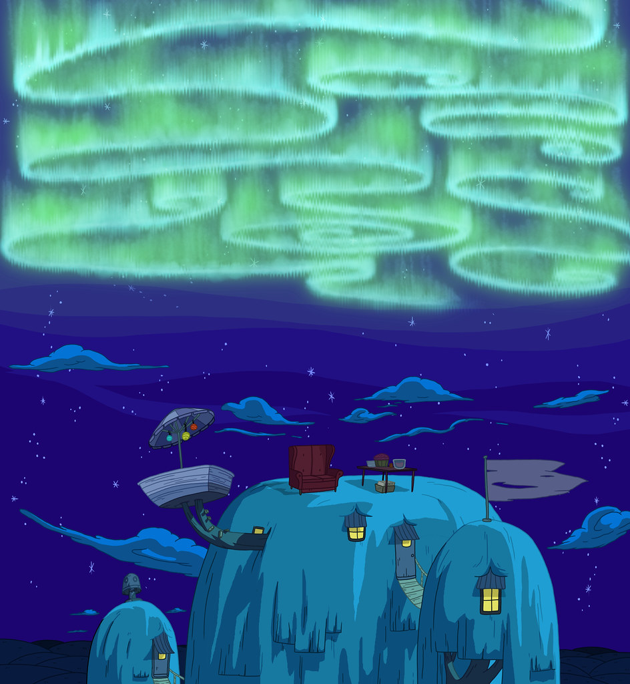

1. How many houses are visible? 4 (taxonomic) (buildings)

2. How many objects are on top of other objects? 3 (relational) (furniture, table, lamp)

3. If the aurora borealis disappeared, how many stars would be visible? 20 (physical) (stars)

## Image 37 (kitchen)

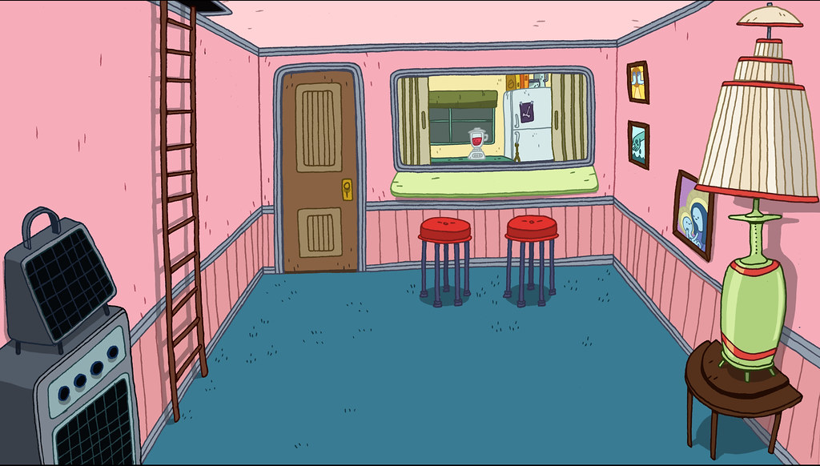

1. How many objects with legs are present? 6 (physical) (stools)

2. How many objects are on top of other objects? 3 (relational) (pictures on wall, lamp on table)

3. If the ladder were made of glass instead of metal, how many objects would be fragile? 1 (physical) (ladder)

## Image 38 (home setup)

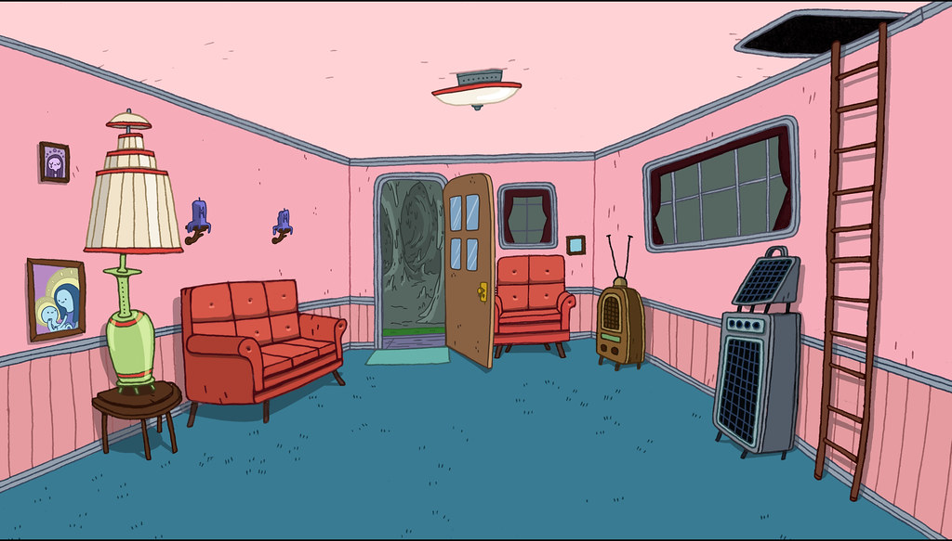

1. How many pieces of furniture are present? 5 (taxonomic) (sofas, table, chairs)

2. How many objects are positioned on top of another object? 2 (relational) (lamp on table, lamp on sofa)

3. If the television was replaced with a plant, how many electronic devices would be visible? 1 (functional) (radio)

## Image 39 (home setup)

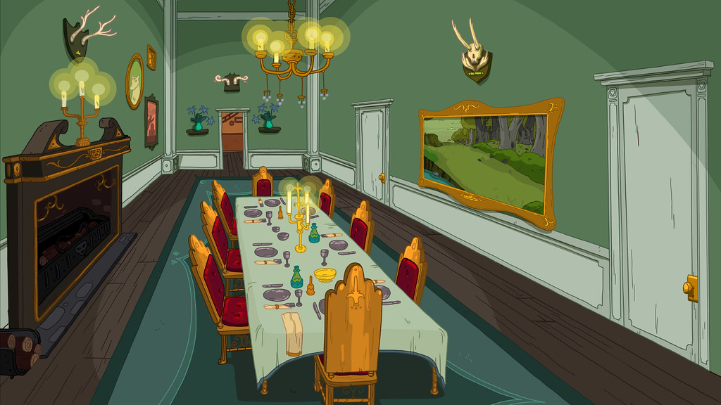

1. How many chairs are present? 10 (taxonomic) (furniture)

2. How many items are on top of the table? 15 (relational) (plates, glasses, cutlery)

3. If all the paintings were replaced with mirrors, how many reflective surfaces would be visible? 3 (physical) (mirrors)

## Image 40 (kitchen)

[ERROR: Could not add image image40.jpg - ]

## Image 41 (wardrobe)

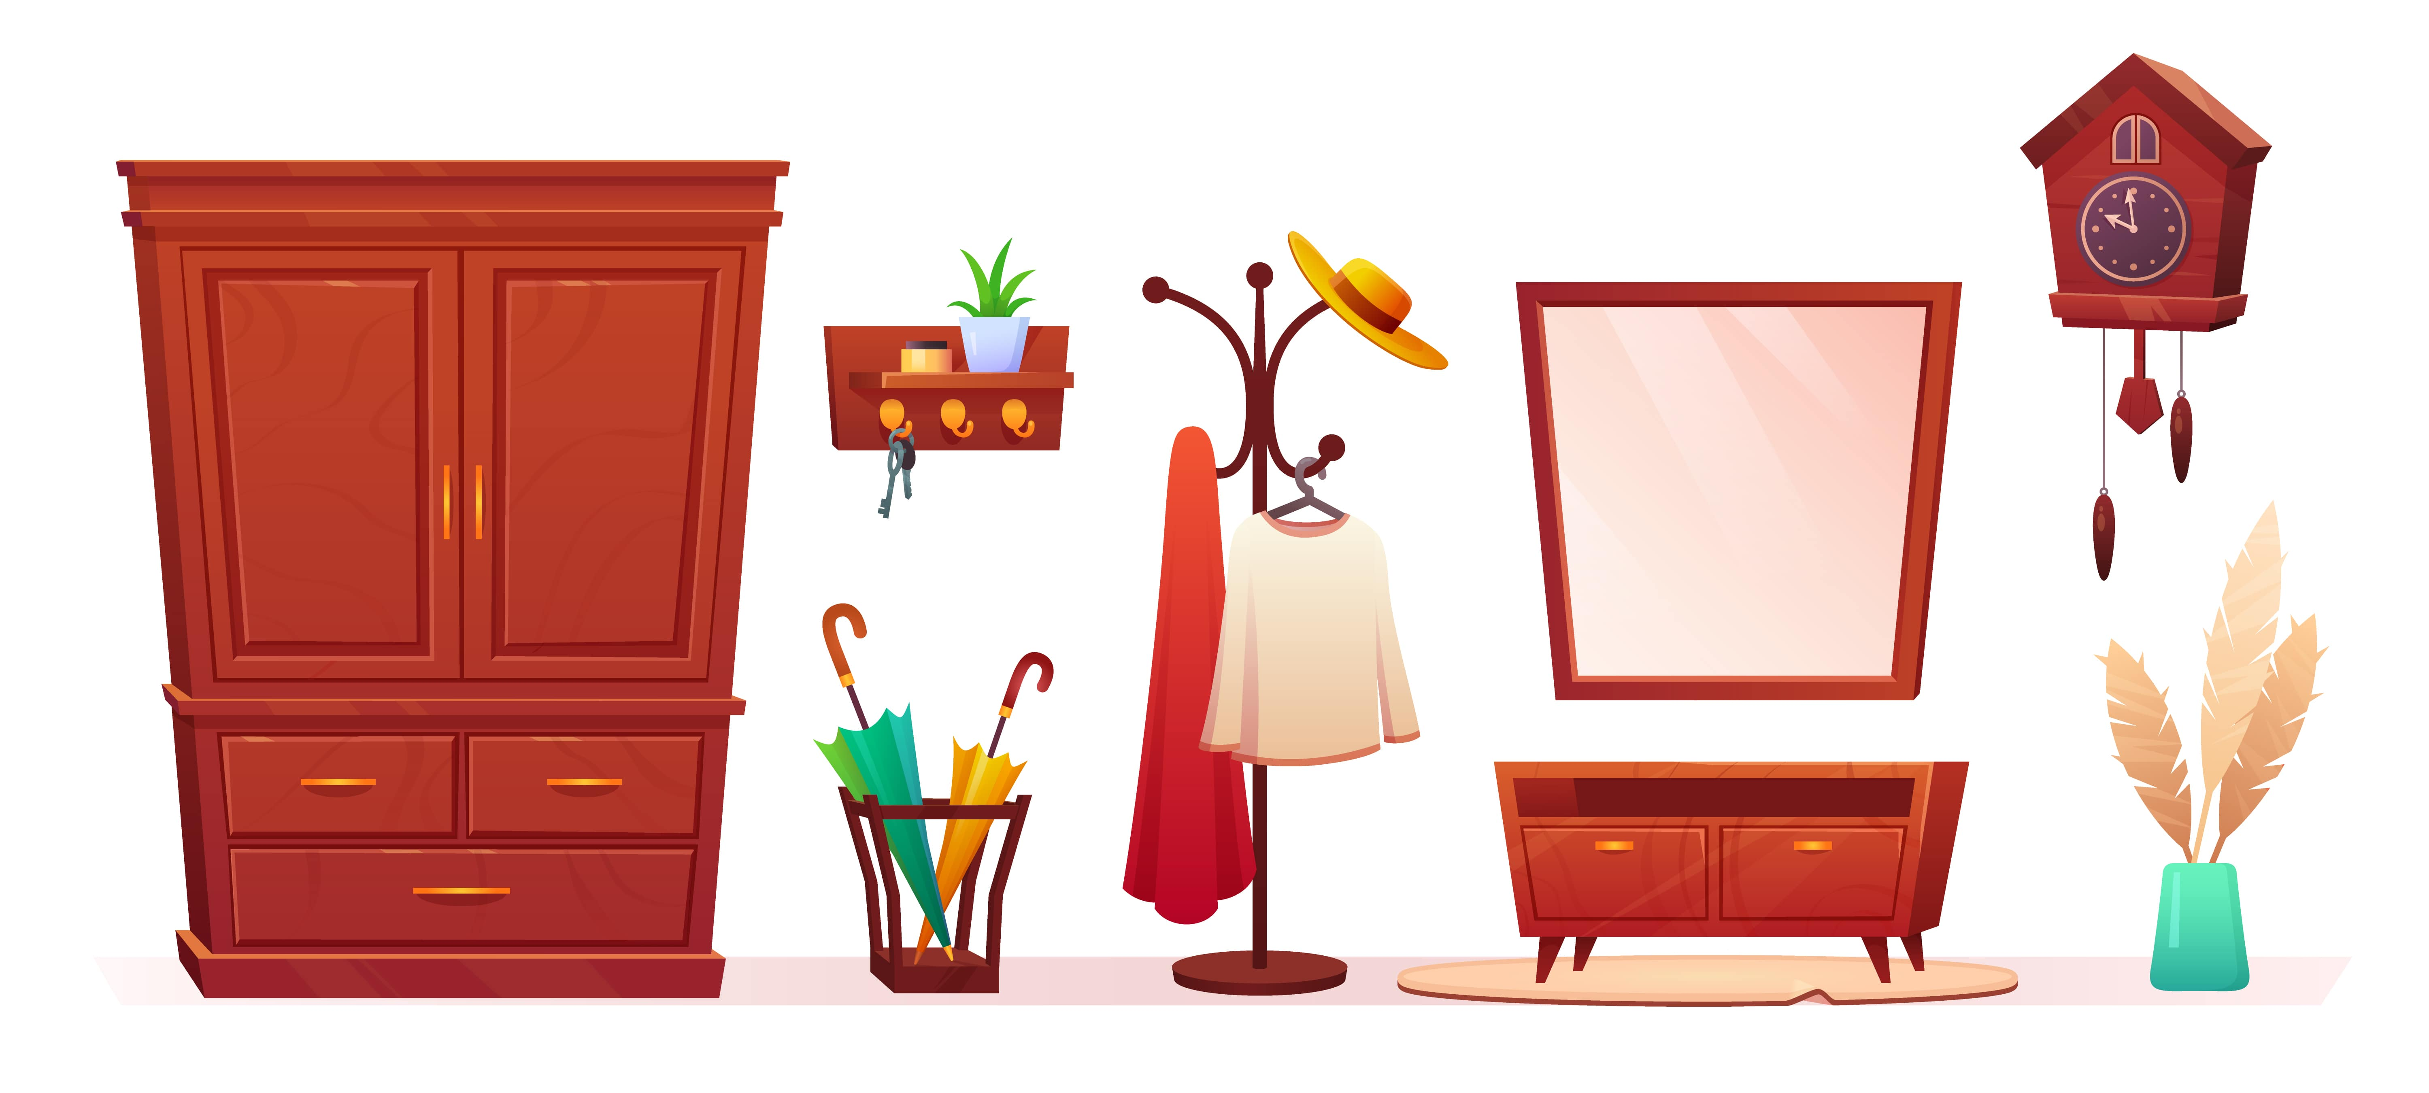

1. How many items are made of wood? 6 (physical) (furniture pieces)

2. How many items are hanging on the wall? 5 (relational) (decorations)

3. If the umbrellas were not in the basket, how many umbrellas would be visible? 0 (taxonomic) (umbrellas)

## Image 42 (market)

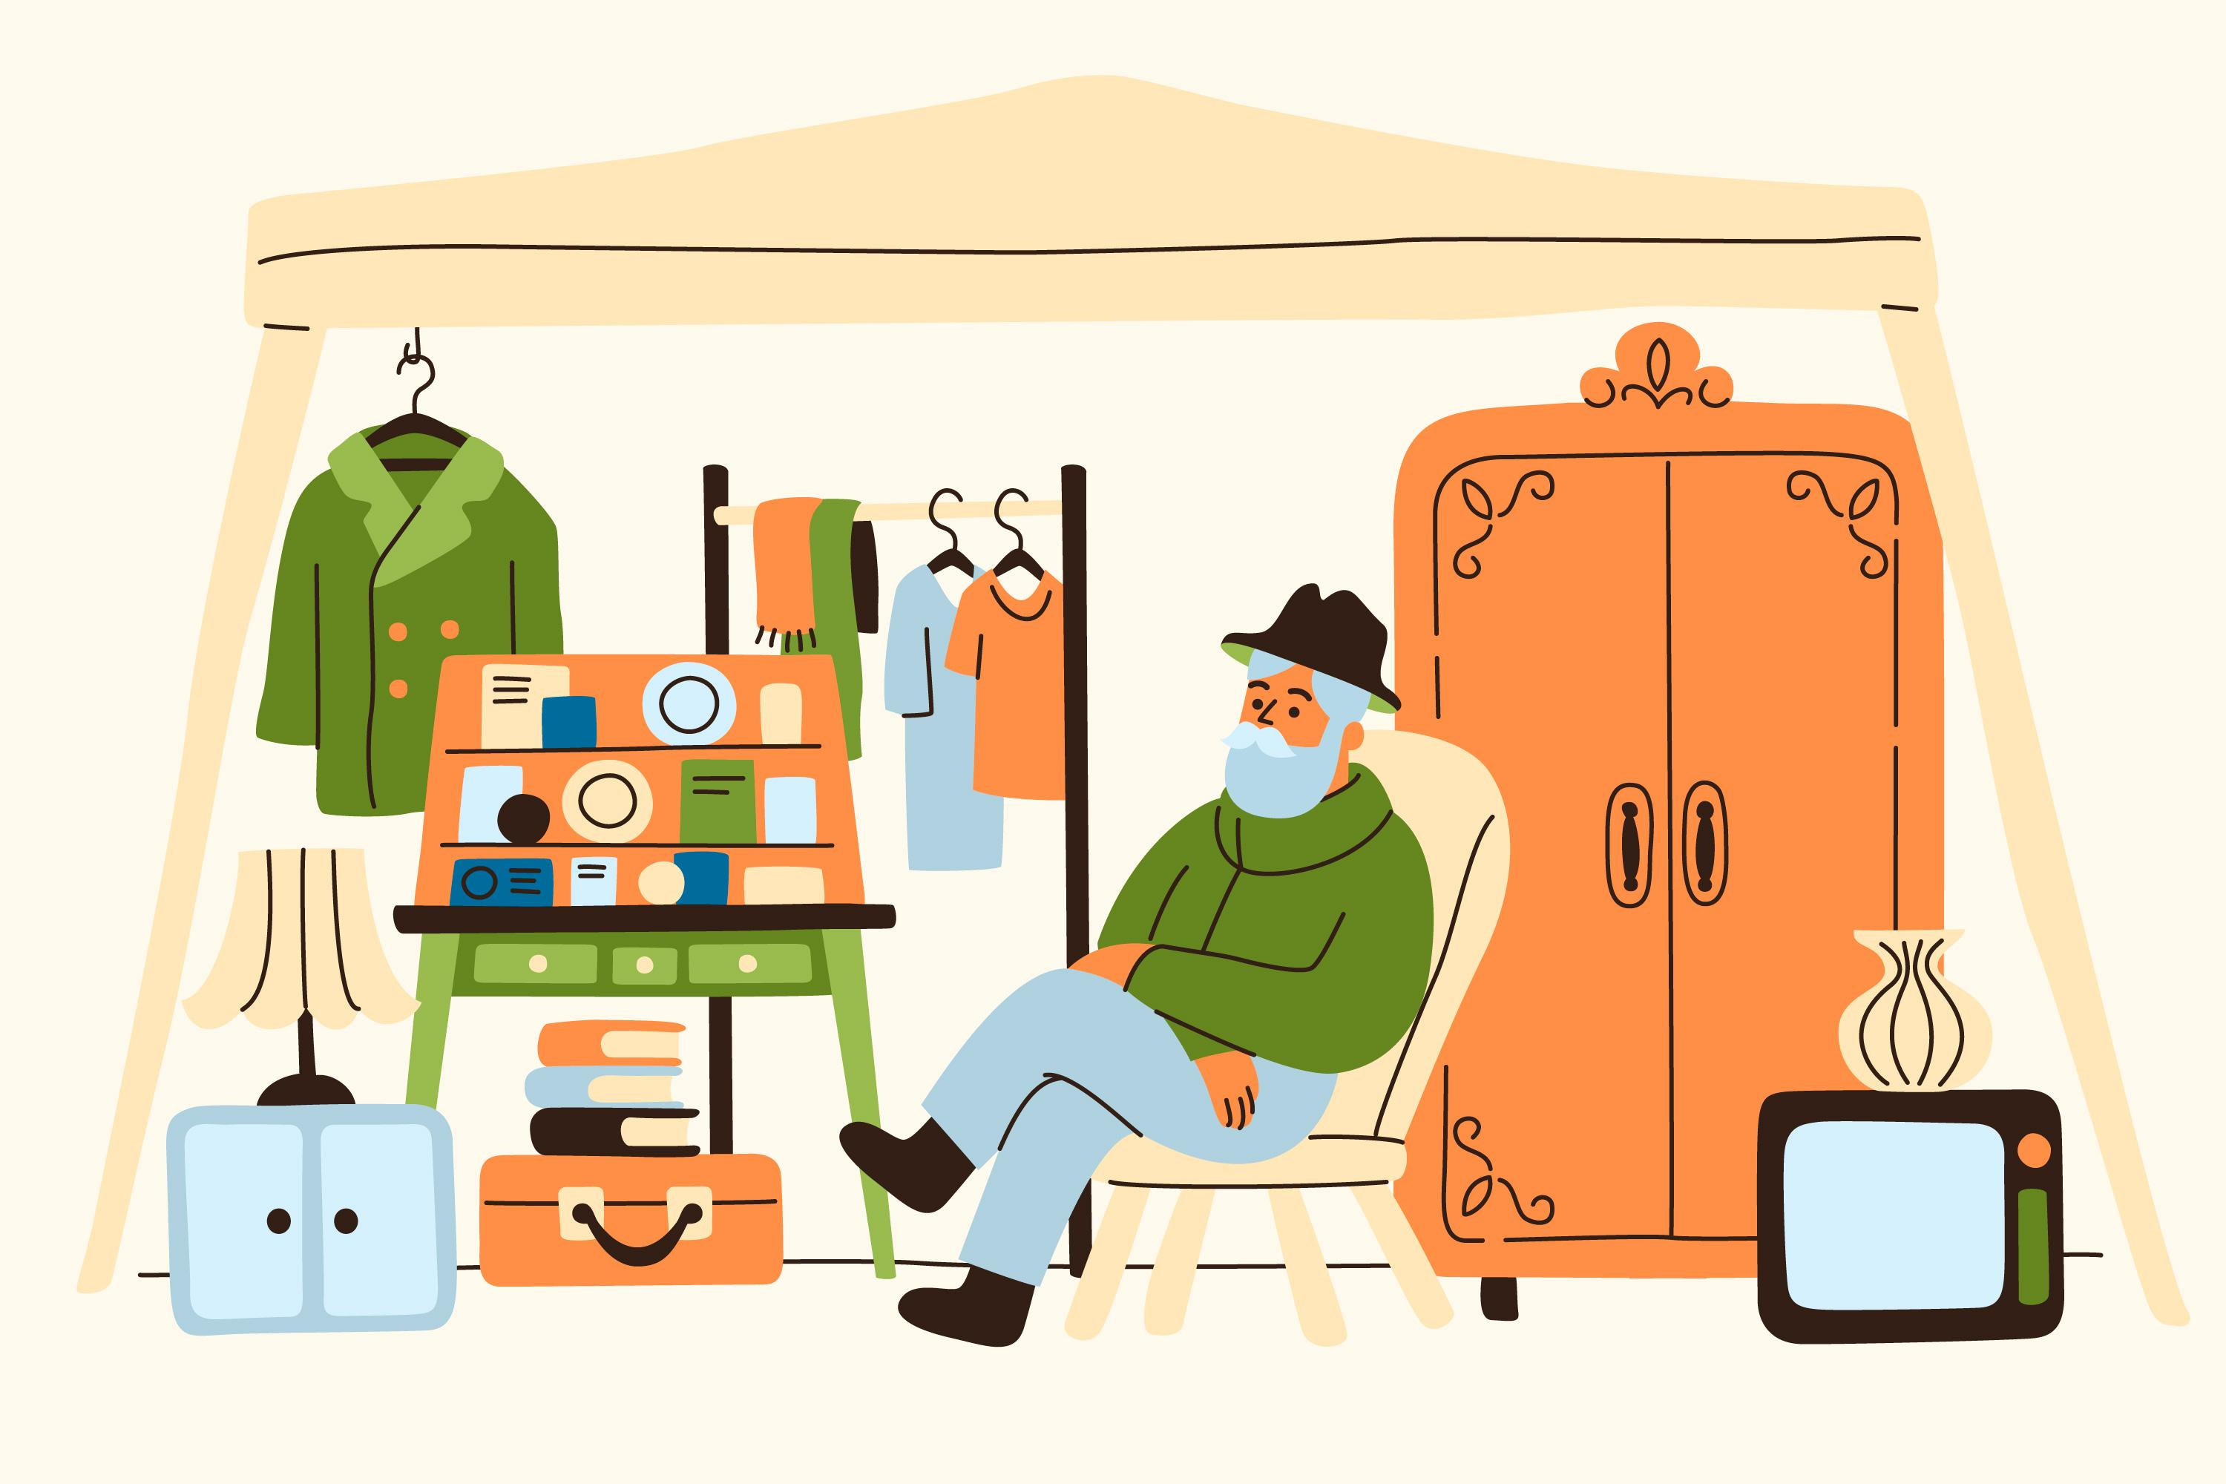

1. How many pieces of furniture are visible? 3 (taxonomic) (chair, dresser, table)

2. How many items are stacked on top of each other? 3 (relational) (suitcases)

3. If the clothes on the rack were all hats, how many hats would there be? 4 (taxonomic) (clothes)

## Image 43 (salon)

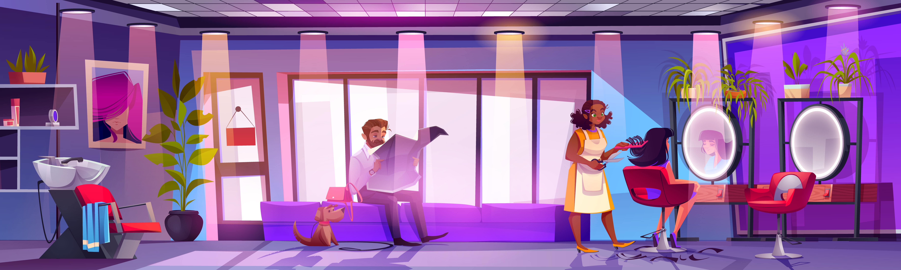

1. How many chairs are visible? 4 (taxonomic) (furniture)

2. How many people are interacting with each other? 2 (relational) (individuals)

3. If all the plants were removed, how many potted objects would remain? 0 (taxonomic) (pots)

## Image 44 (salon)



1. How many chairs are visible? 2 (taxonomic) (furniture)

2. How many people are holding tools? 1 (functional) (scissors)

3. If the plant was not present, how many green objects would be visible? 0 (taxonomic) (plants)

## Image 45 (salon)

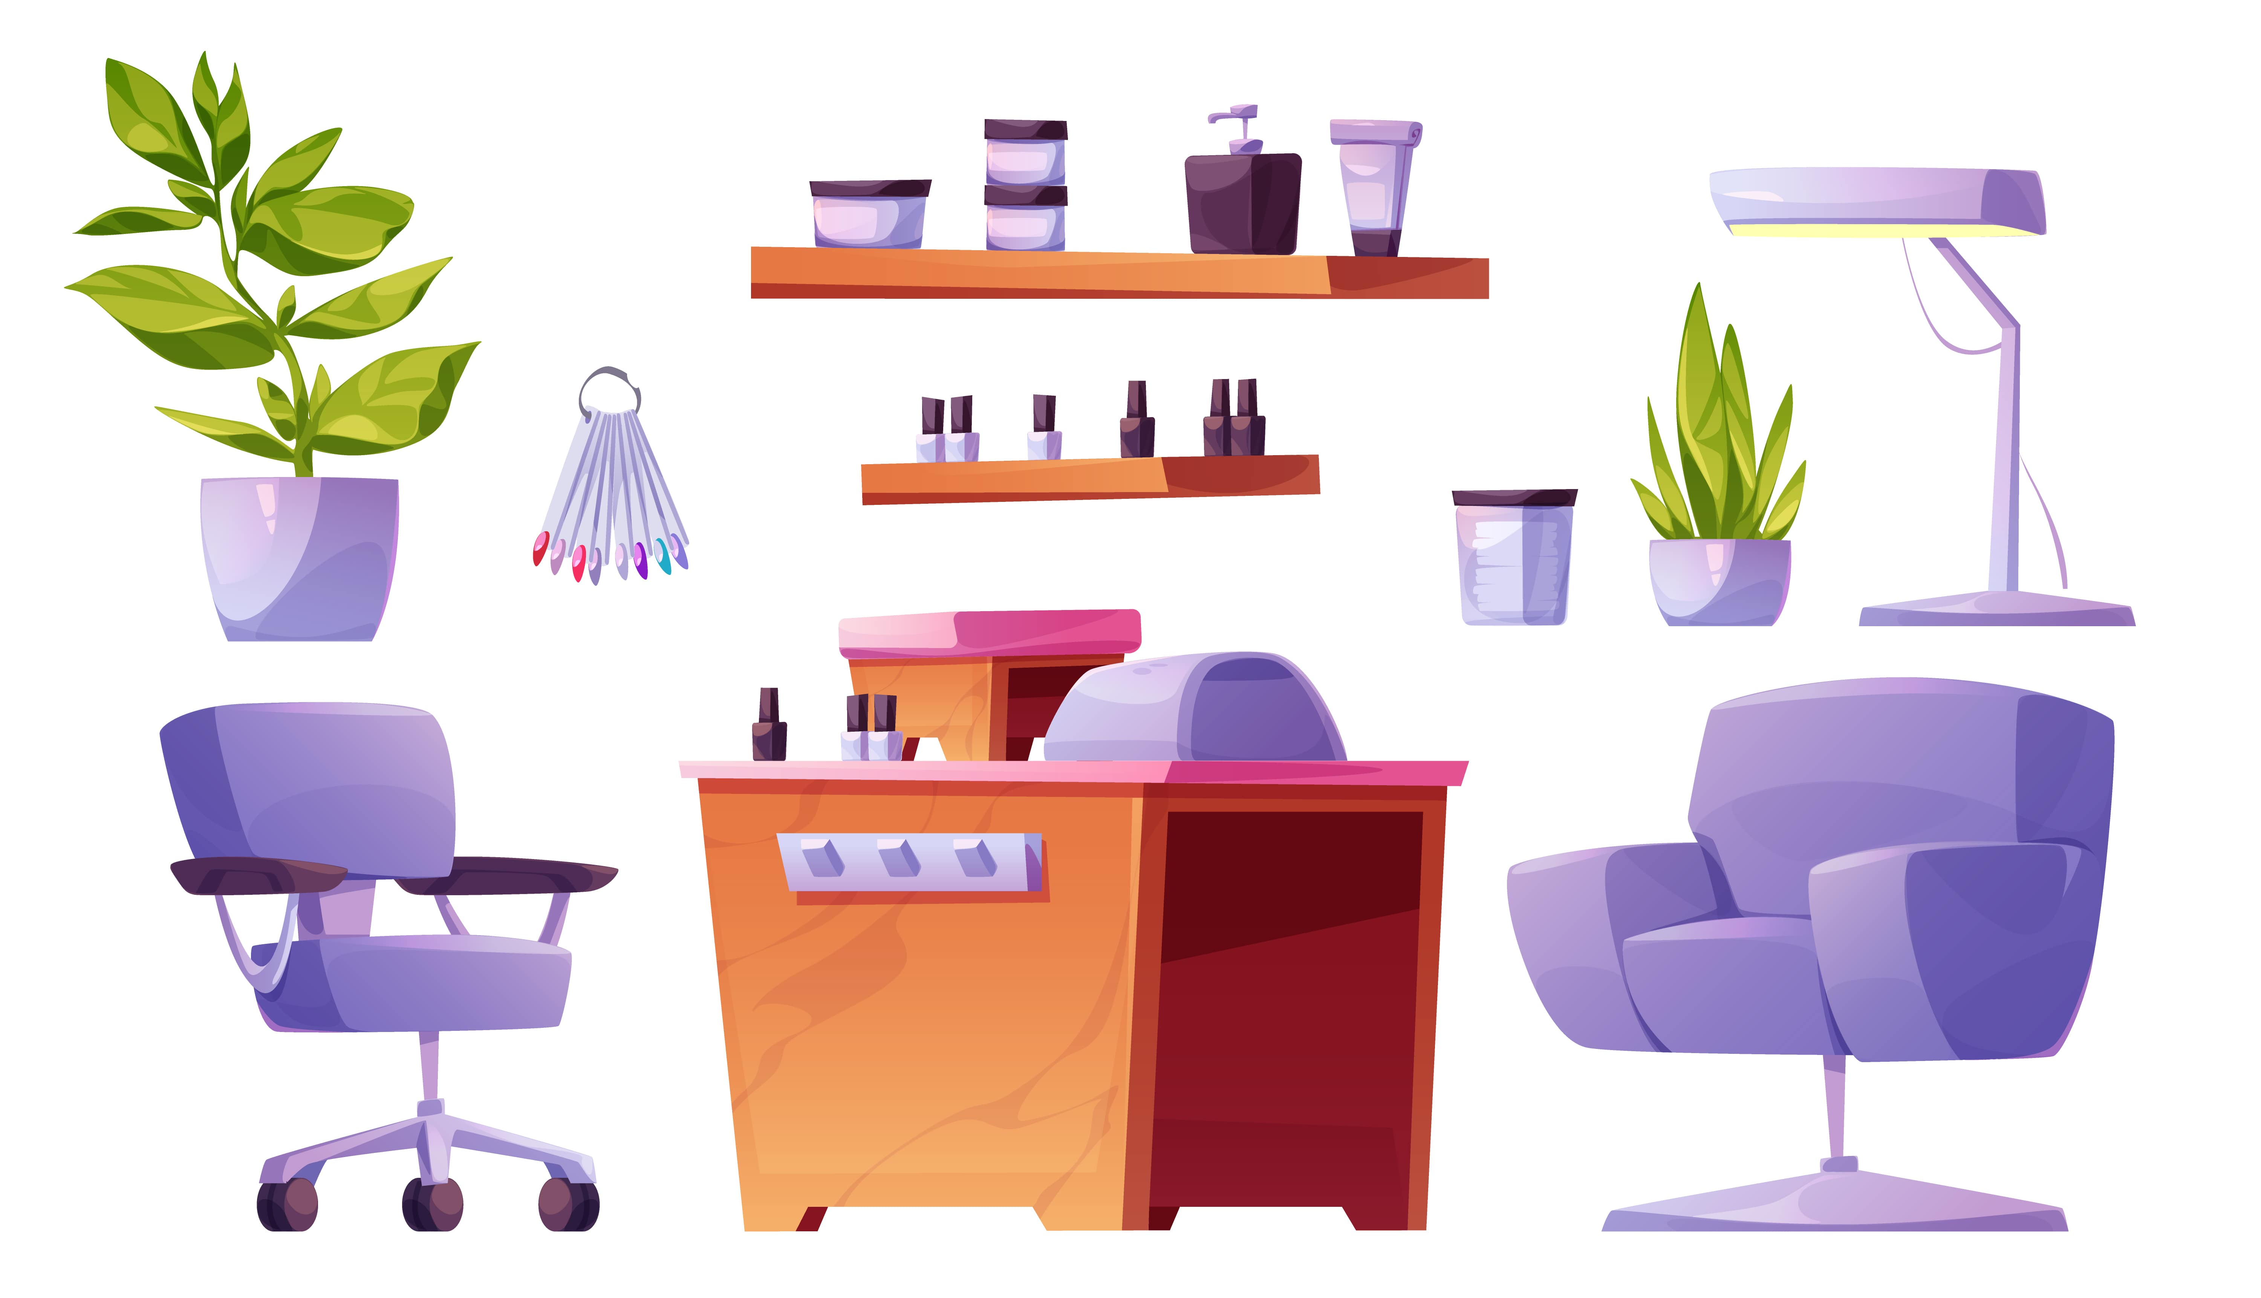

1. How many chairs are present? 2 (taxonomic) (furniture)

2. How many items are on top of the wooden desk? 3 (relational) (bottles)

3. If the plants were removed, how many potted plants would be visible? 0 (taxonomic) (plants)

## Image 46 (salon)



1. How many pieces of furniture are present? 6 (taxonomic) (sofa, reception desk, cabinets, chair, side table, stool)

2. How many people are actively receiving a service? 2 (relational) (hair styling)

3. If all the plants were removed, how many biological objects would remain? 7 (taxonomic) (people)

## Image 47 (beach cleanup)

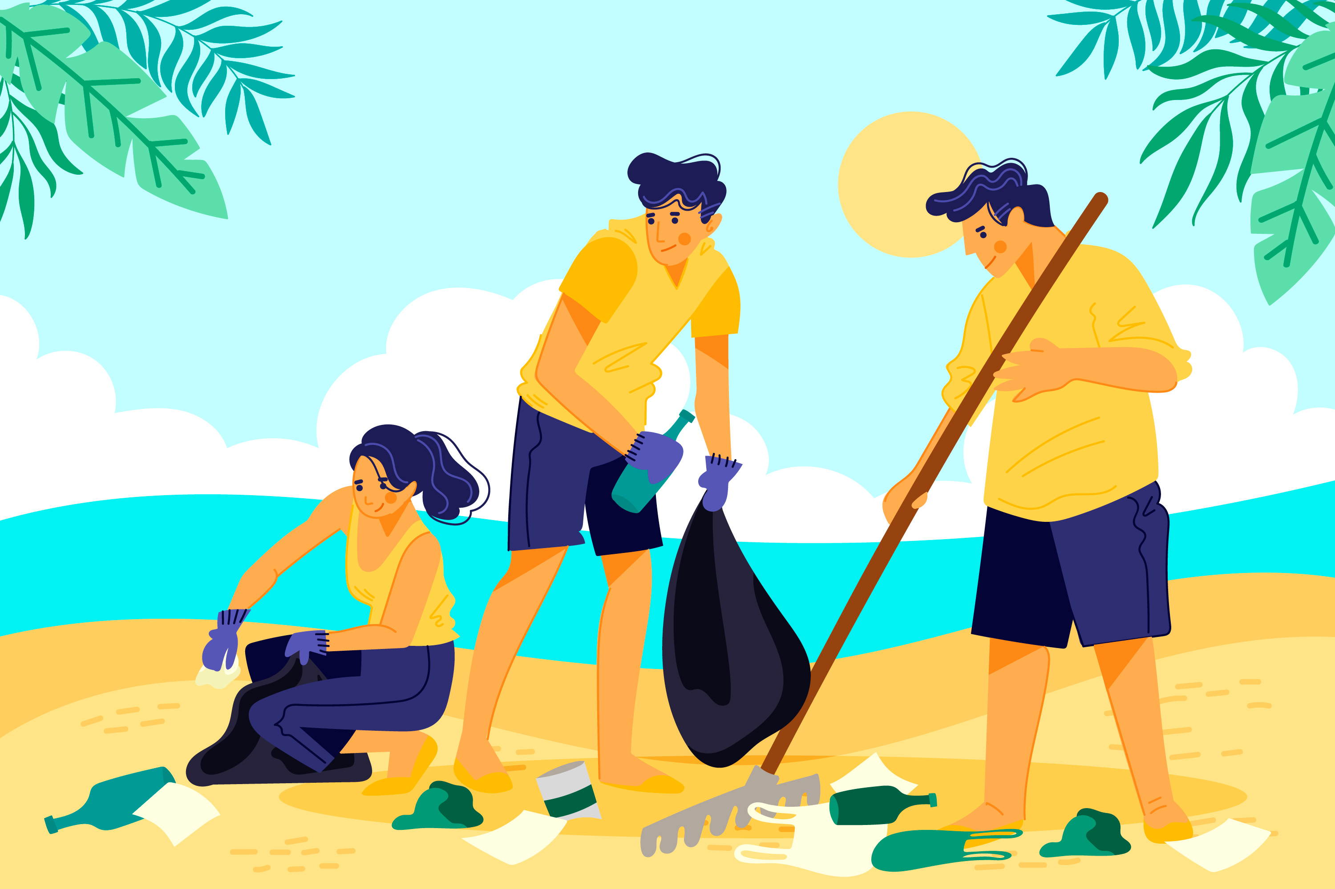

1. How many people are wearing dark-colored shorts? 2 (taxonomic) (people)

2. How many objects are being used to collect trash? 2 (functional) (trash bag, grabber tool)

3. If the palm leaves were not present, how many people would be fully visible? 3 (relational) (people)

## Image 48 (beach cleanup)

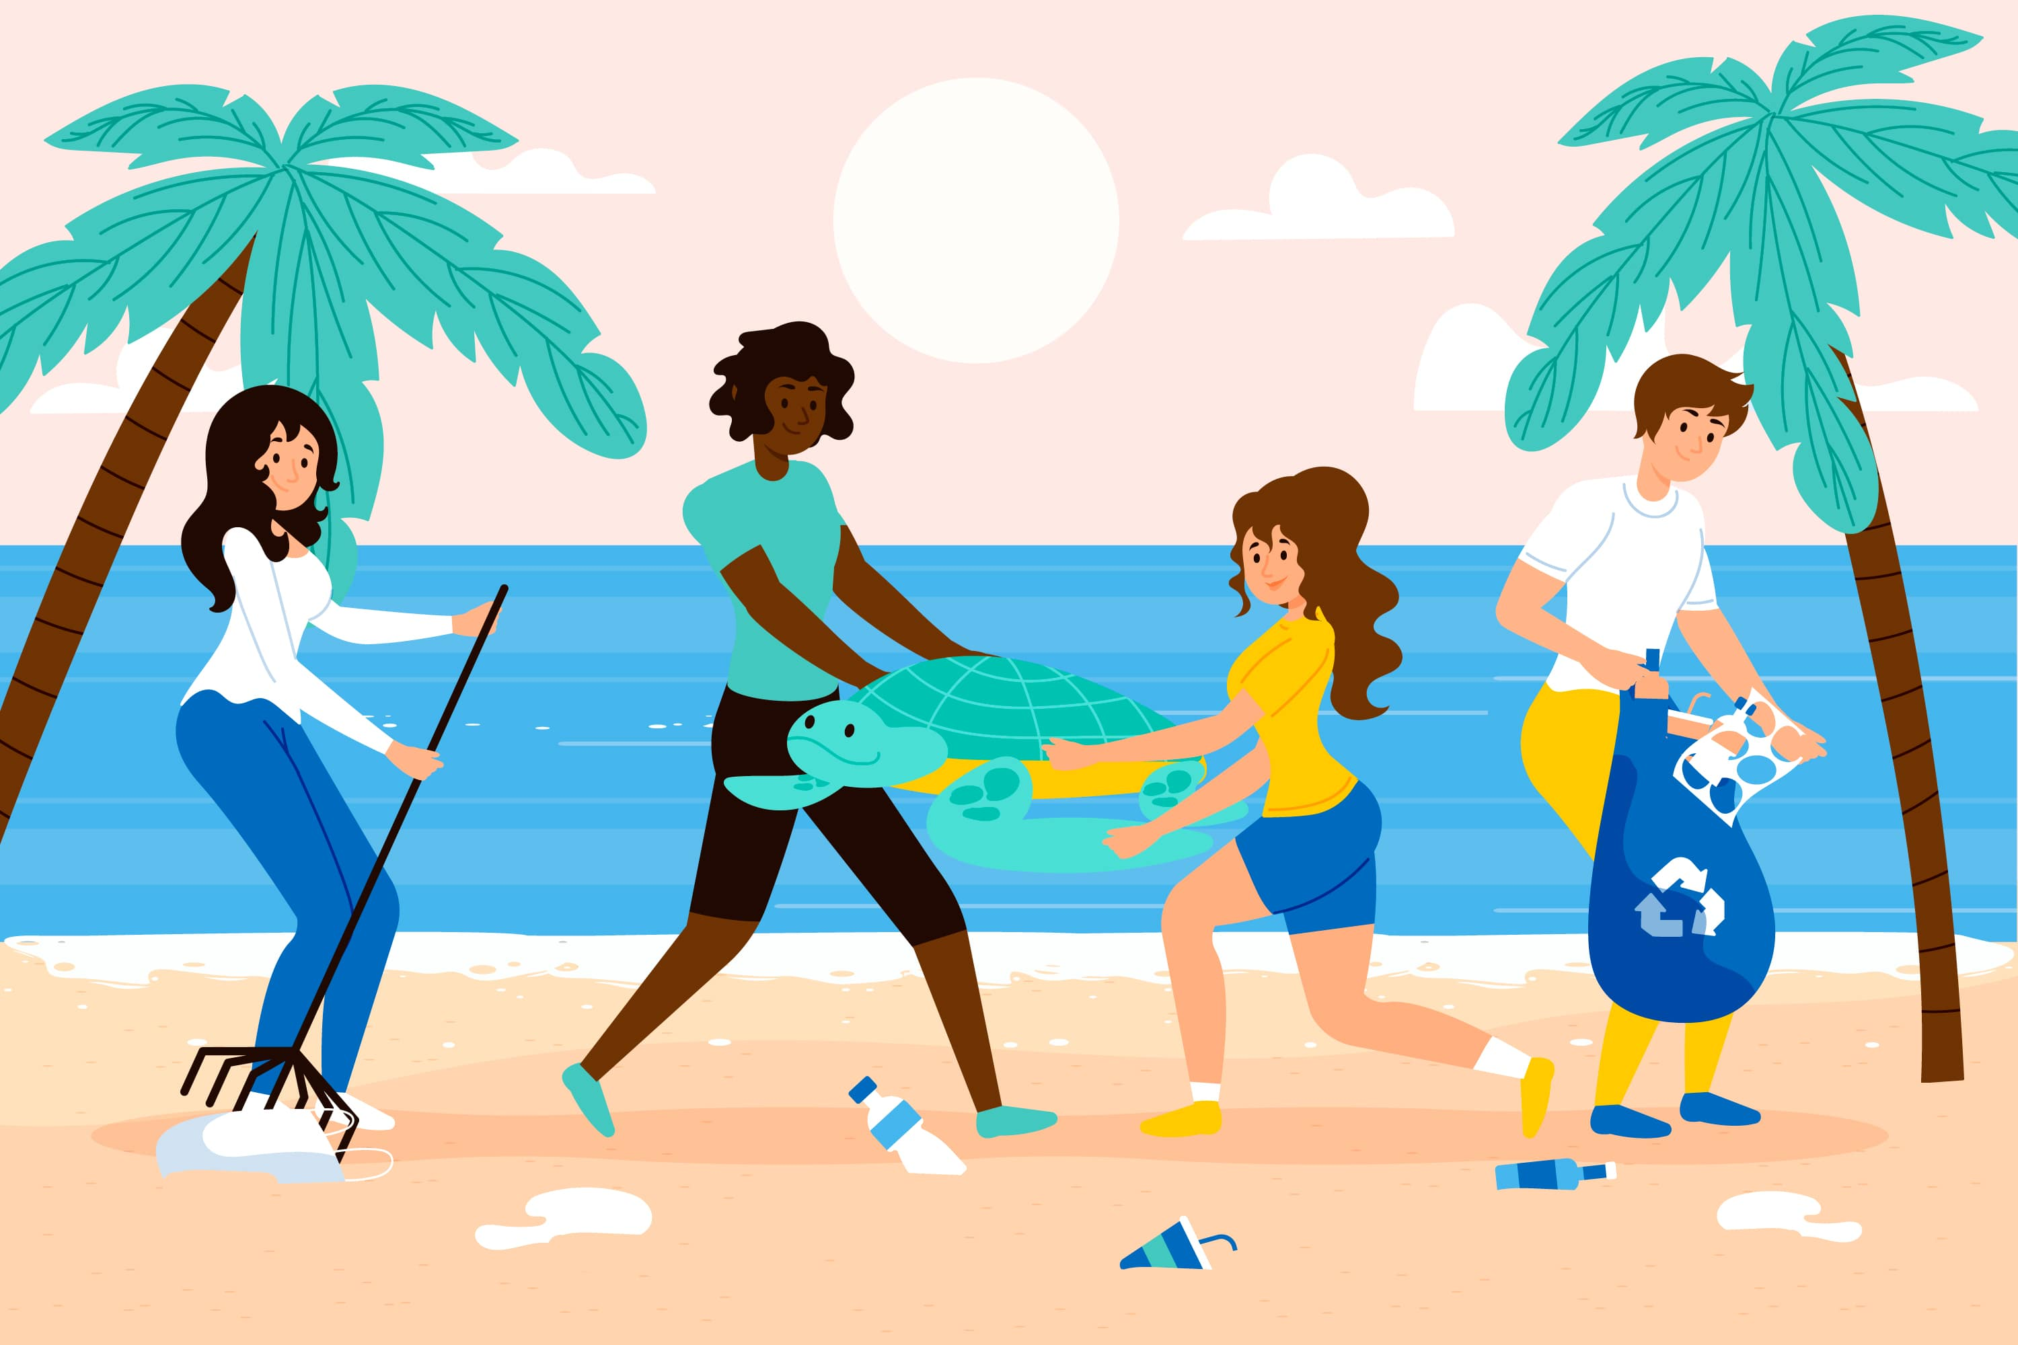

1. How many reptiles are present? 1 (taxonomic) (sea turtle)

2. How many people are holding something? 3 (relational) (people)

3. If the plastic bottles were not present, how many plastic items would be visible? 1 (physical) (trash bag)

## Image 49 (beach cleanup)

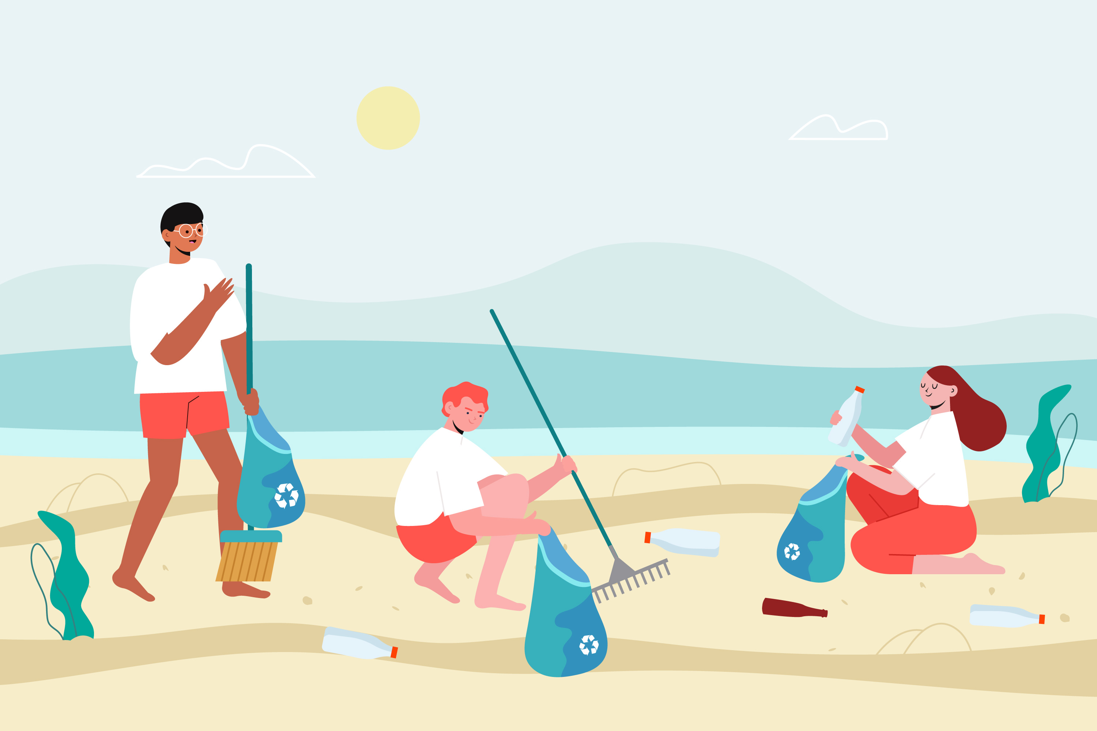

1. How many objects made of plastic are present? 6 (physical) (bottles)

2. How many people are holding bags? 3 (relational) (people)

3. If the rake was not present, how many tools would be visible? 1 (functional) (trash grabber)

## Image 50 (beach cleanup)

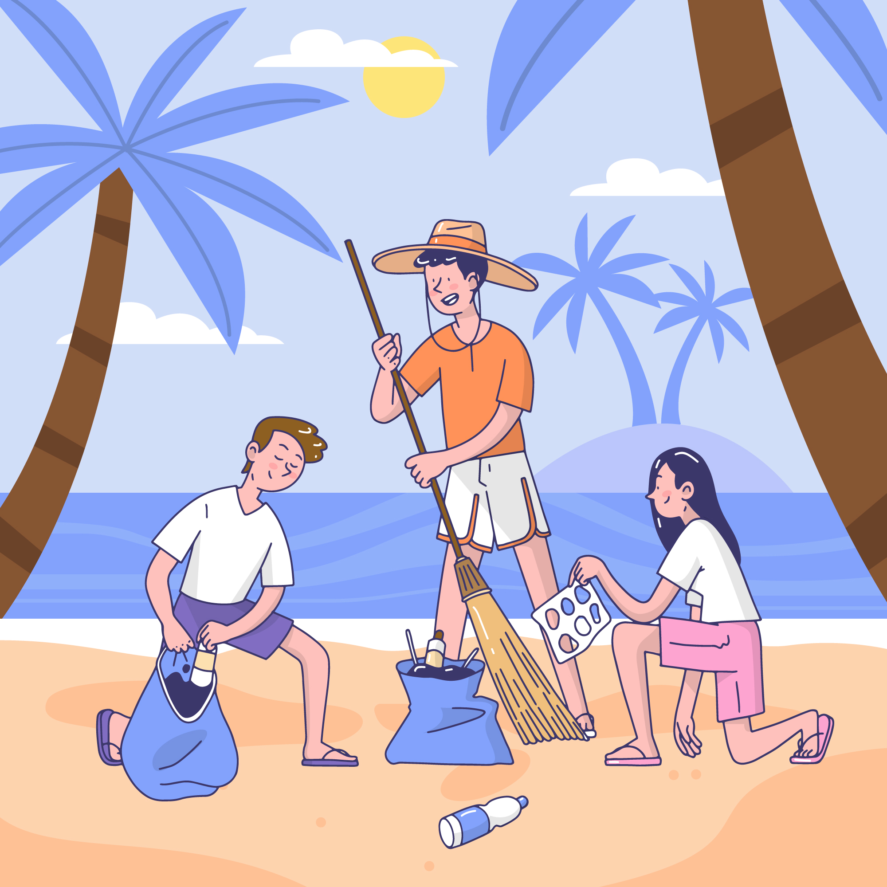

1. How many palm trees are visible? 3 (taxonomic) (trees)

2. How many people are holding something? 3 (relational) (people and objects)

3. If the trash bags were empty, how many plastic bottles would be visible on the sand? 2 (physical) (bottles)

## Image 51 (garage)

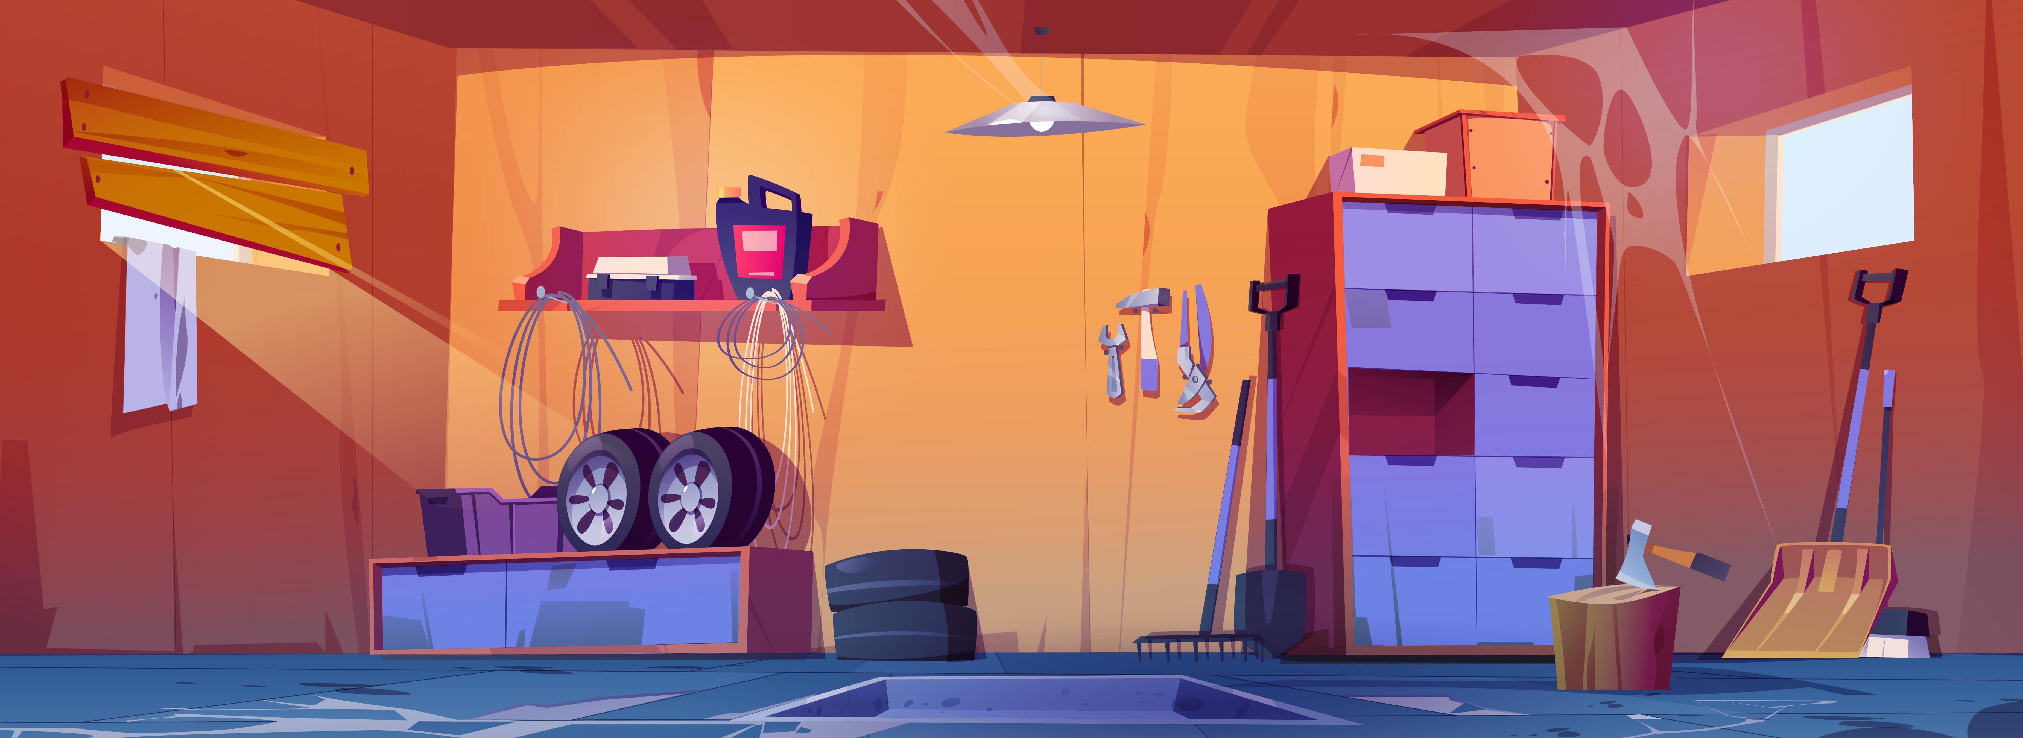

1. How many tools are visible? 6 (taxonomic) (hand tools and chainsaw)

2. How many items are leaning against the wall? 3 (relational) (brooms and mop)

3. If the tires were red instead of black, how many tires would be visible? 2 (physical) (tires)

## Image 52 (garage)

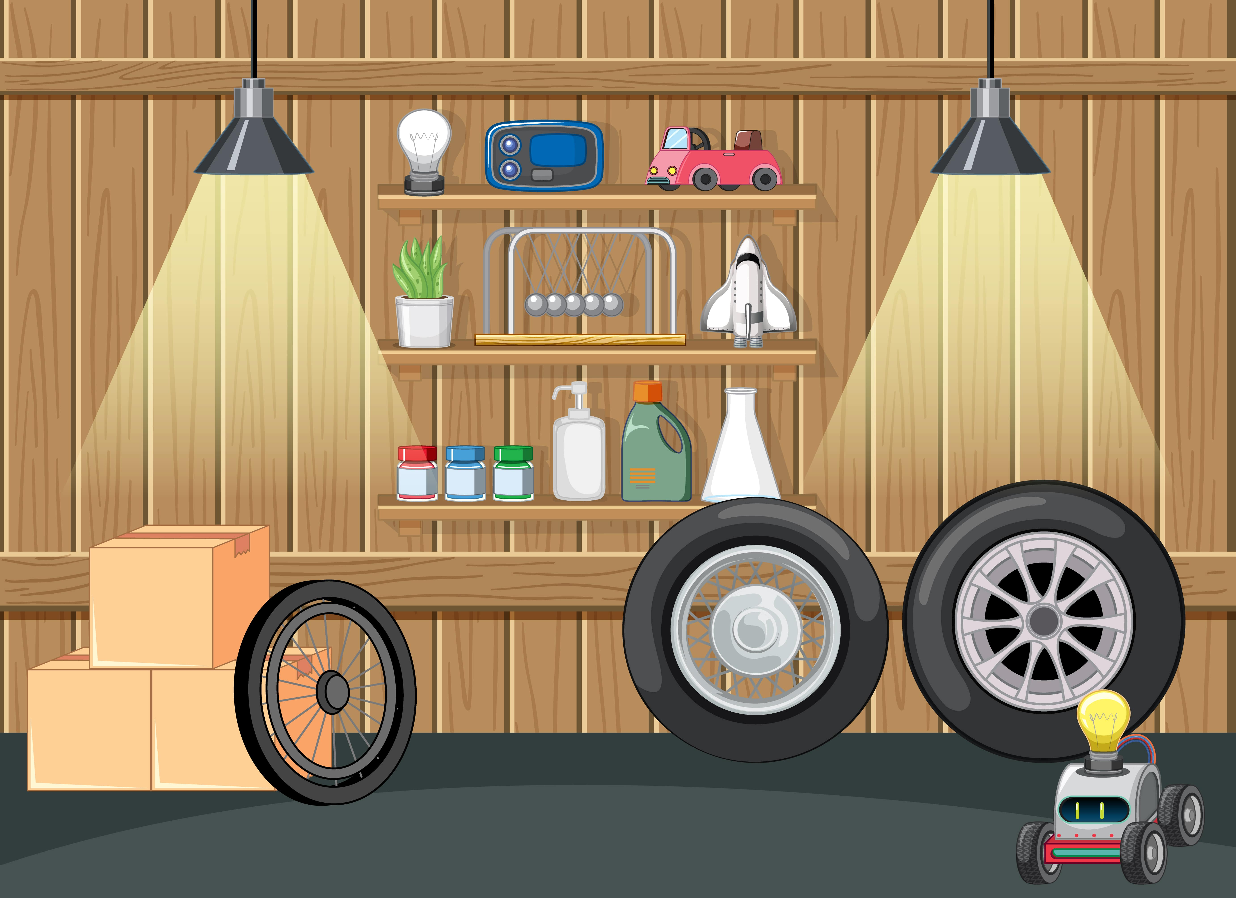

1. How many vehicles are present? 3 (taxonomic) (car, rocket, robot car)

2. How many items are on the shelves? 11 (relational) (items)

3. If all the bottles were full of liquid, how many containers could hold liquid? 4 (functional) (bottles)

## Image 53 (biking)

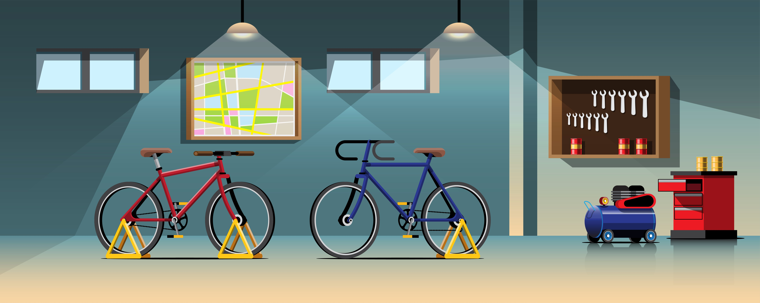

1. How many vehicles are present? 2 (taxonomic) (bicycles)

2. How many objects with wheels are visible? 3 (physical) (bicycles and air compressor)

3. If the tool cabinet was empty, how many tools would be visible on the wall? 10 (relational) (tools)

## Image 54 (home setup)

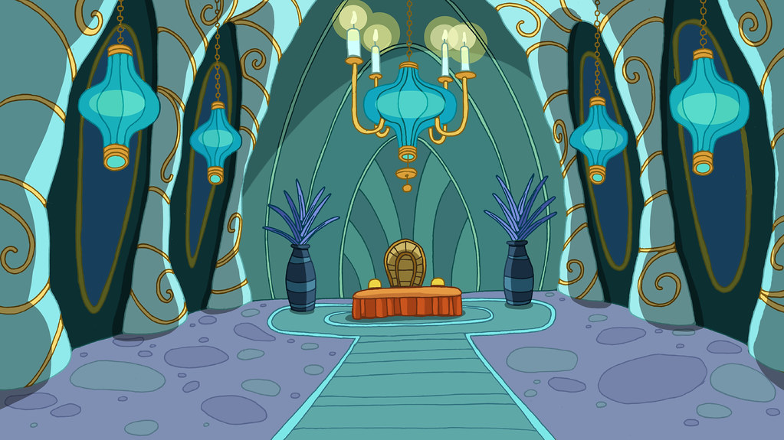

1. How many objects that appear to be made of metal are present? 2 (physical) (chandeliers)

2. How many objects are positioned on top of the red platform? 1 (relational) (sun-shaped object)

3. If all the lanterns were removed, how many lanterns would be visible? 0 (taxonomic) (lanterns)

## Image 55 (urban)

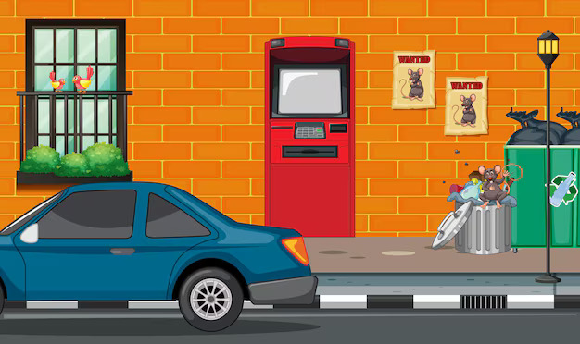

1. How many vehicles are present? 1 (taxonomic) (car)

2. How many containers are overflowing with items? 1 (relational) (trash cans)

3. If the birds were not on the window sill, how many birds would be visible? 0 (taxonomic) (birds)

## Image 56 (garage)

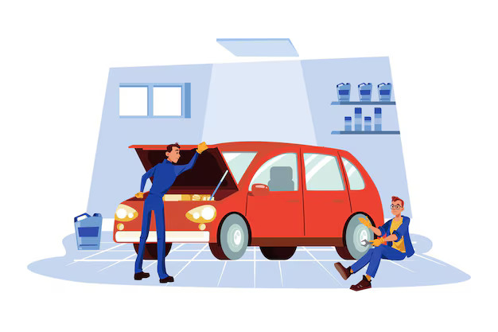

1. How many vehicles are present? 1 (taxonomic) (car)

2. How many people are working on the car? 2 (relational) (mechanics)

3. If the shelves were empty, how many containers would be visible? 0 (physical) (bottles)

## Image 57 (garage)

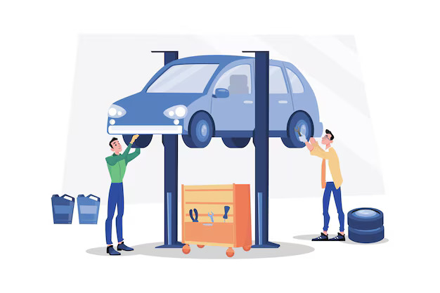

1. How many vehicles are present? 1 (taxonomic) (car)

2. How many items are positioned on top of other items? 1 (relational) (car on lift)

3. If the tires were all inflated, how many tires would be visible? 4 (physical) (tires)

## Image 58 (meeting room)

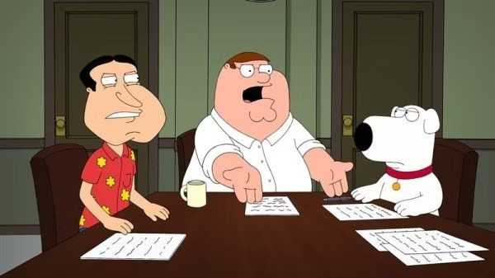

1. How many mammals are visible? 2 (taxonomic) (Brian and Stewie)

2. How many papers are on the table? 4 (relational) (sheets of paper)

3. If the chairs were made of glass, how many fragile objects would be present? 3 (physical) (chairs)

## Image 59 (home setup)

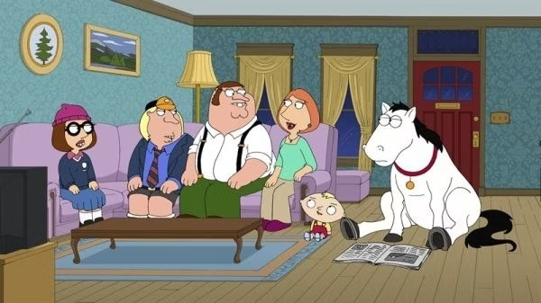

1. How many mammals are visible? 6 (taxonomic) (people and horse)

2. How many items are used for sitting? 1 (functional) (sofa)

3. If the horse was a different color, how many white objects would be visible? 1 (physical) (horse)

## Image 60 (bedroom)

[ERROR: Could not add image image60.jpg - ]

## Image 61 (bedroom)

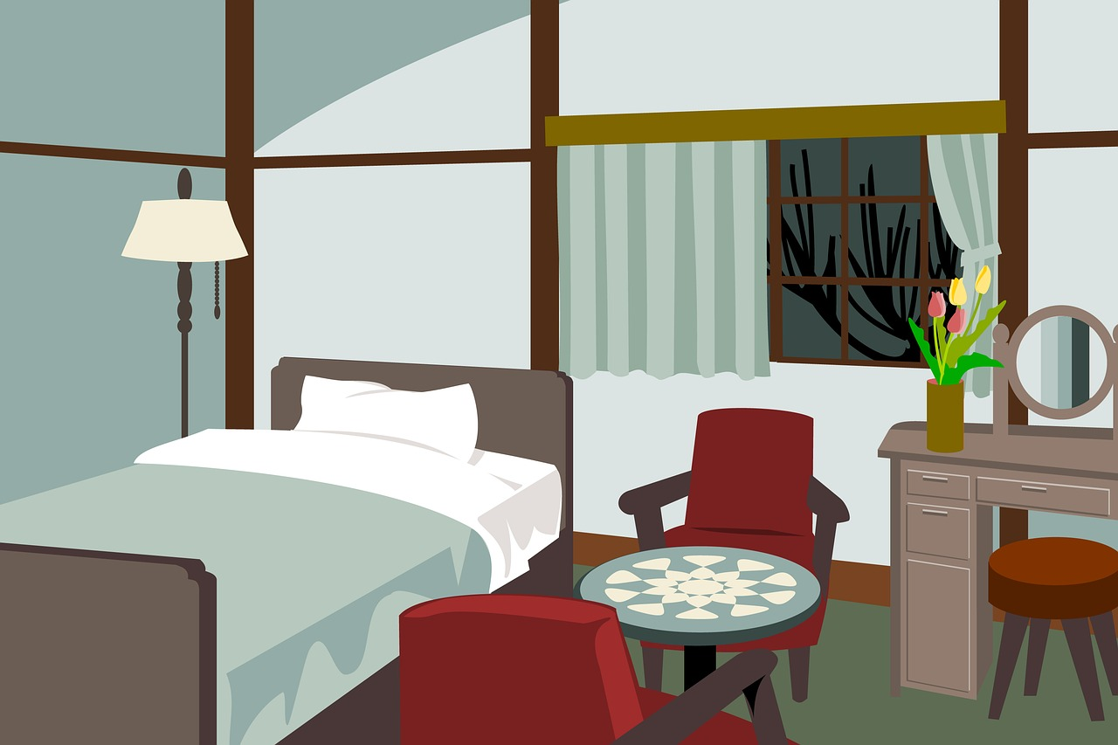

1. How many pieces of furniture are present? 5 (taxonomic) (bed, chairs, table, dresser, stool)

2. How many items are on top of other items? 1 (relational) (flowers on dresser)

3. If the window curtains were removed, how many window frames would be visible? 1 (physical) (window frame)

## Image 62 (bedroom)

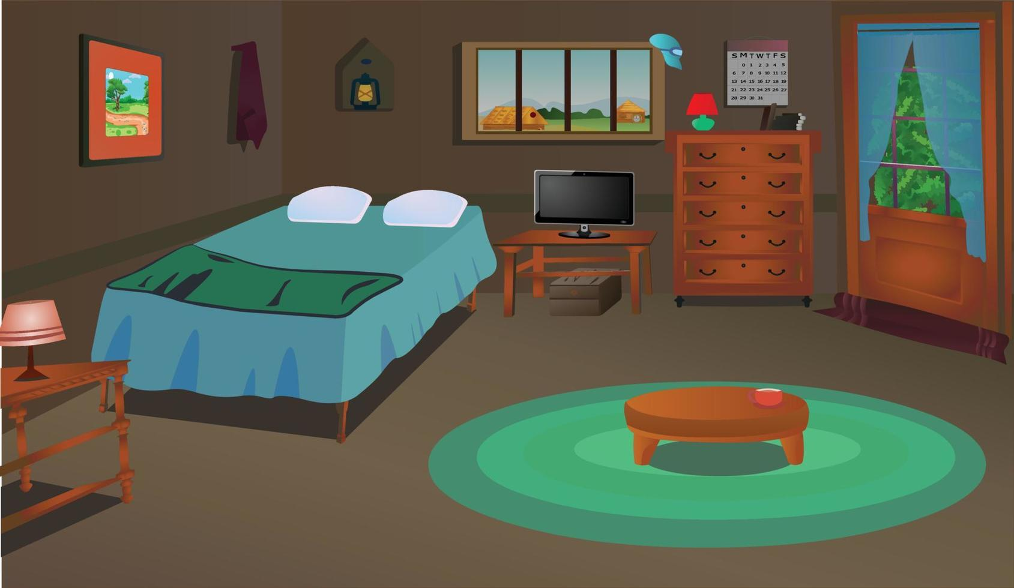

1. How many pieces of furniture are present? 6 (taxonomic) (bed, dresser, nightstand, TV stand, coffee table, wardrobe)

2. How many objects are on top of other objects? 3 (relational) (lamp on nightstand, TV on TV stand, object on coffee table)

3. If the rug was removed, how many objects would be directly on the floor? 4 (relational) (bed, wardrobe, dresser, TV stand)

## Image 63 (bedroom)

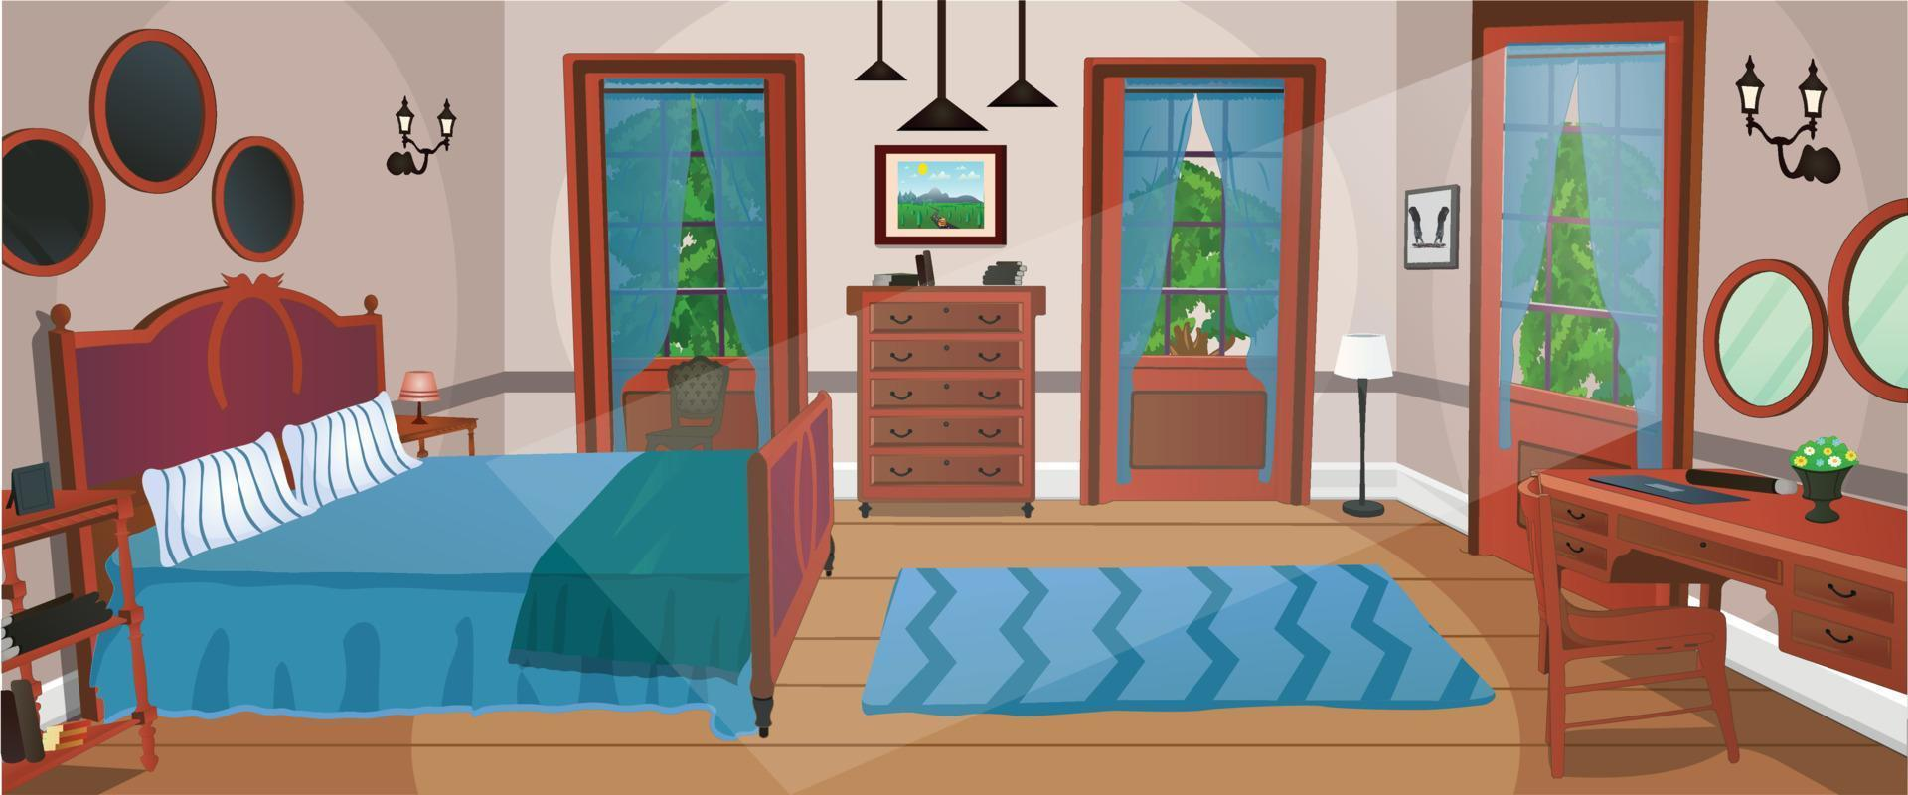

1. How many pieces of furniture are present? 7 (taxonomic) (bed, dresser, desk, 2 nightstands, chair, chest)

2. How many items are on top of other items? 4 (relational) (lamp on dresser, picture on dresser, book on desk, vase on desk)

3. If the windows were replaced with solid walls, how many windows would be visible? 0 (physical) (windows)

## Image 64 (bedroom)

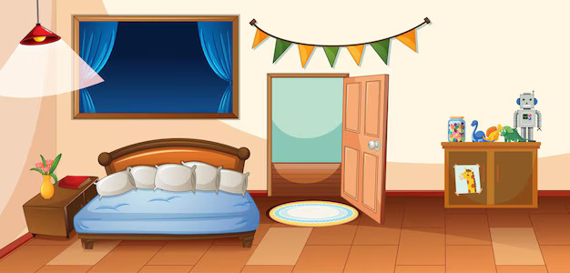

1. How many pieces of furniture are present? 4 (taxonomic) (bed, nightstand, dresser, door)

2. How many objects are on top of the dresser? 4 (relational) (toys)

3. If the bed had only one pillow, how many pillows would be visible? 1 (physical) (pillows)

## Image 65 (bedroom)

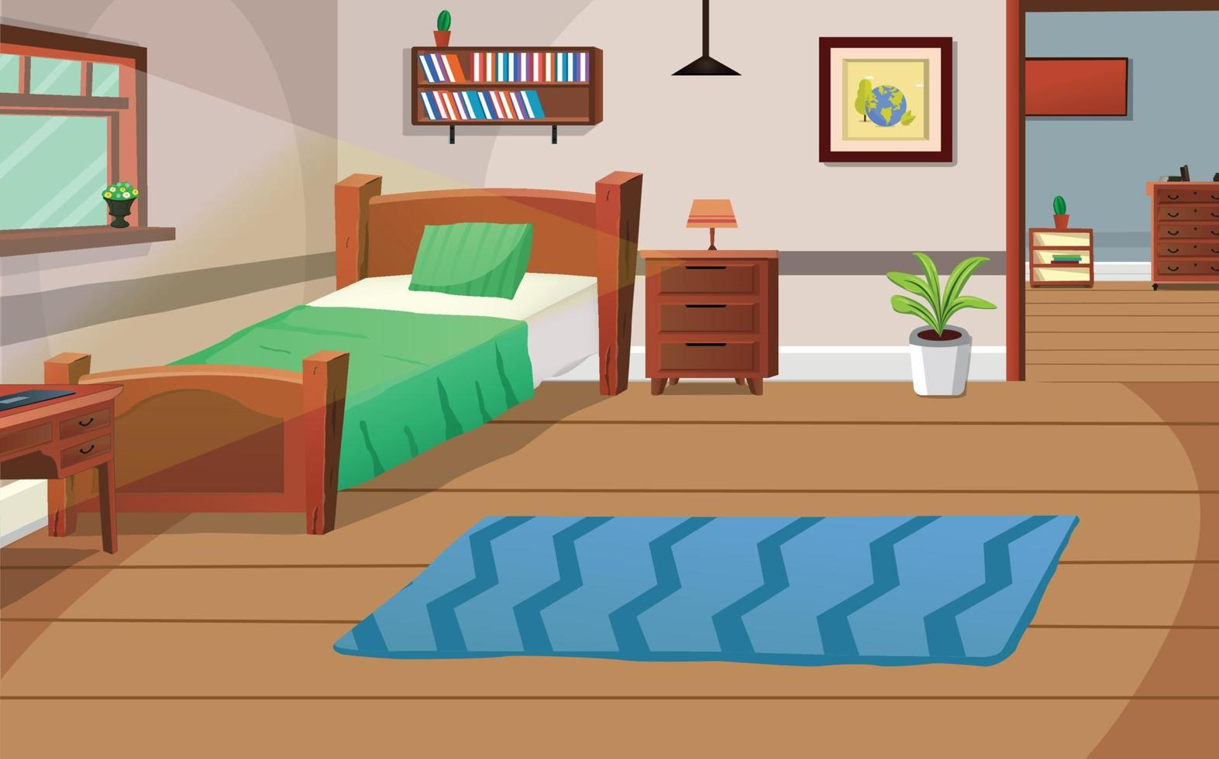

1. How many pieces of furniture are present? 6 (taxonomic) (bed, desk, dresser, nightstand, bookshelf, chest of drawers)

2. How many items are on top of other items? 4 (relational) (lamp on dresser, plant on dresser, books on bookshelf, picture on wall)

3. If the rug was replaced with three smaller rugs, how many rugs would there be? 3 (taxonomic) (rugs)

## Image 66 (bedroom)

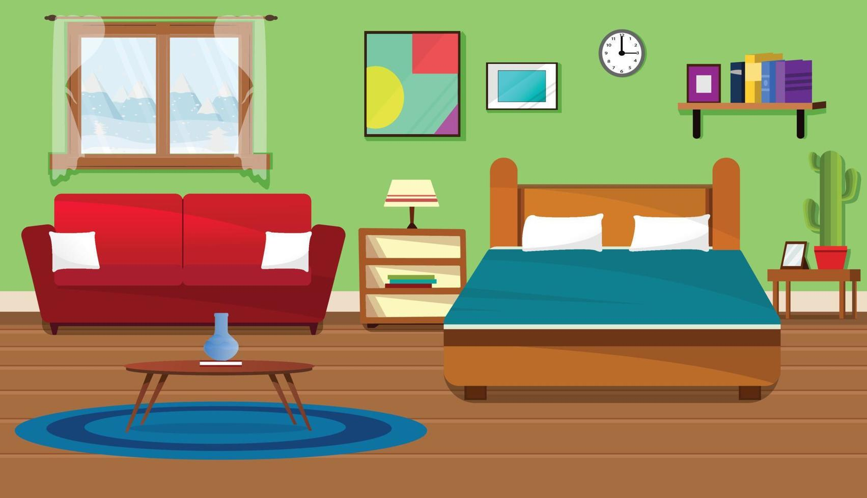

1. How many pieces of furniture are present? 5 (taxonomic) (sofa, bed, nightstand, side table, bookshelf)

2. How many items are on top of other items? 3 (relational) (lamp on nightstand, vase on table, books on bookshelf)

3. If the cactus was replaced with a small tree, how many plants would be visible? 1 (taxonomic) (tree)

## Image 67 (bedroom)

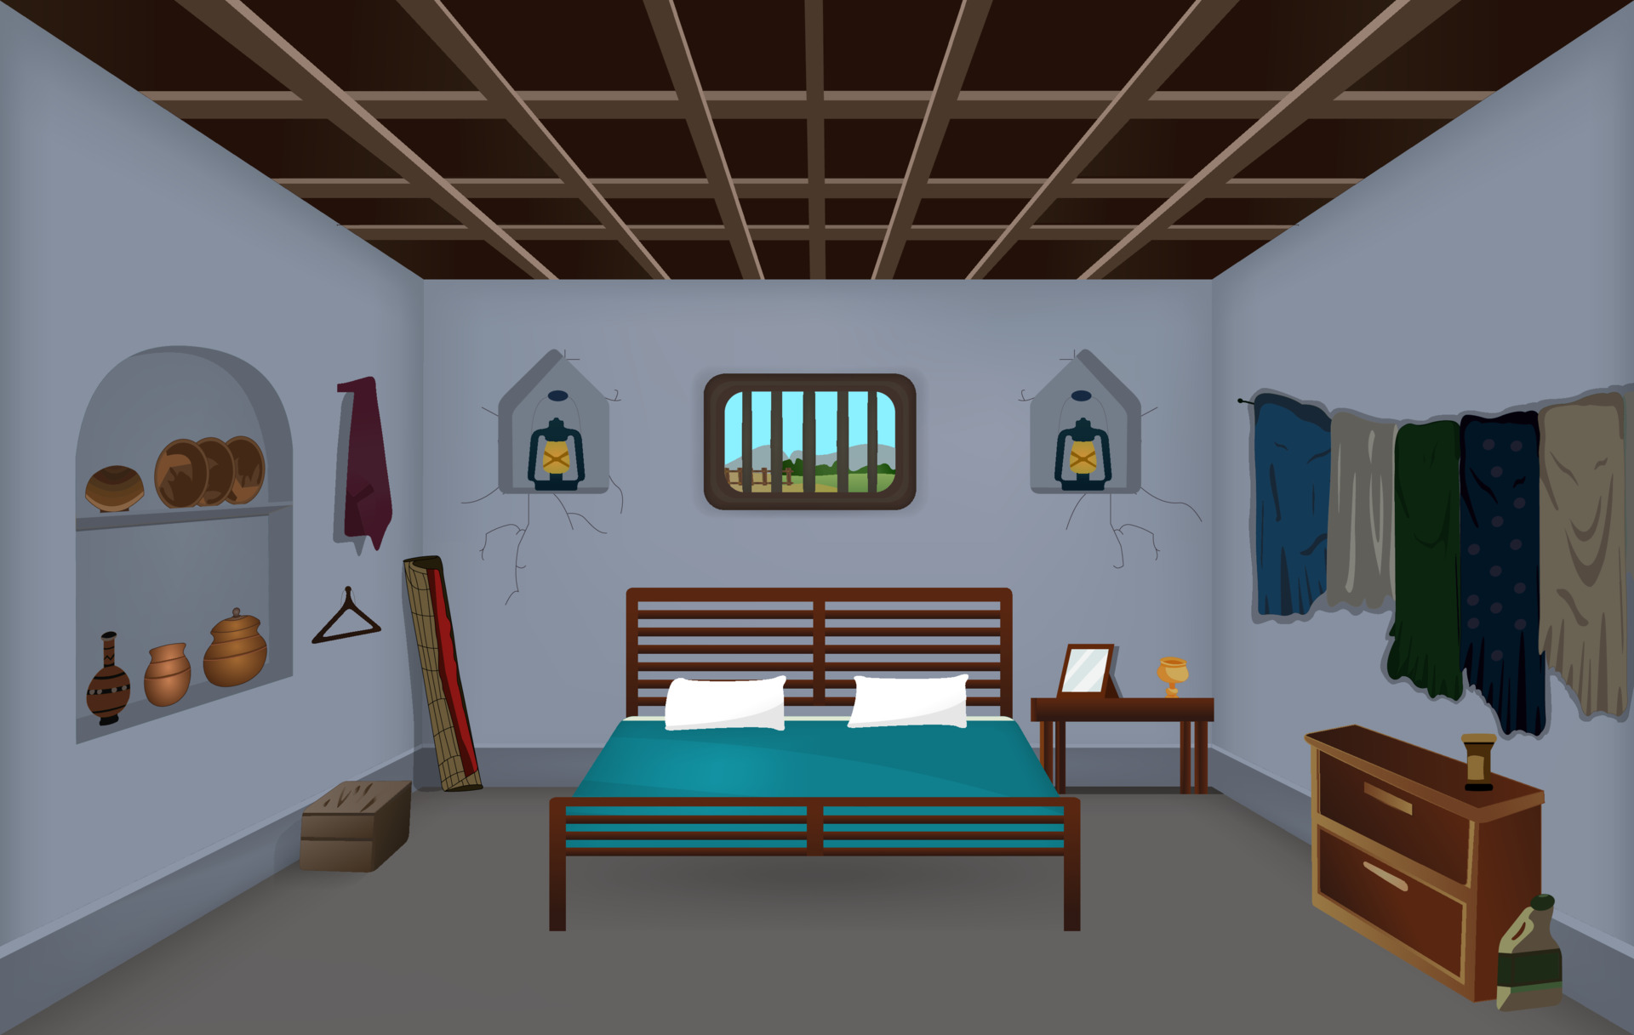

1. How many pieces of furniture are present? 4 (taxonomic) (bed, dresser, table, shelf)

2. How many objects are on top of other objects? 2 (relational) (glass on table, candle on dresser)

3. If the curtains were removed, how many wall-mounted objects would be visible? 4 (physical) (windows, lanterns)

## Image 68 (bedroom)

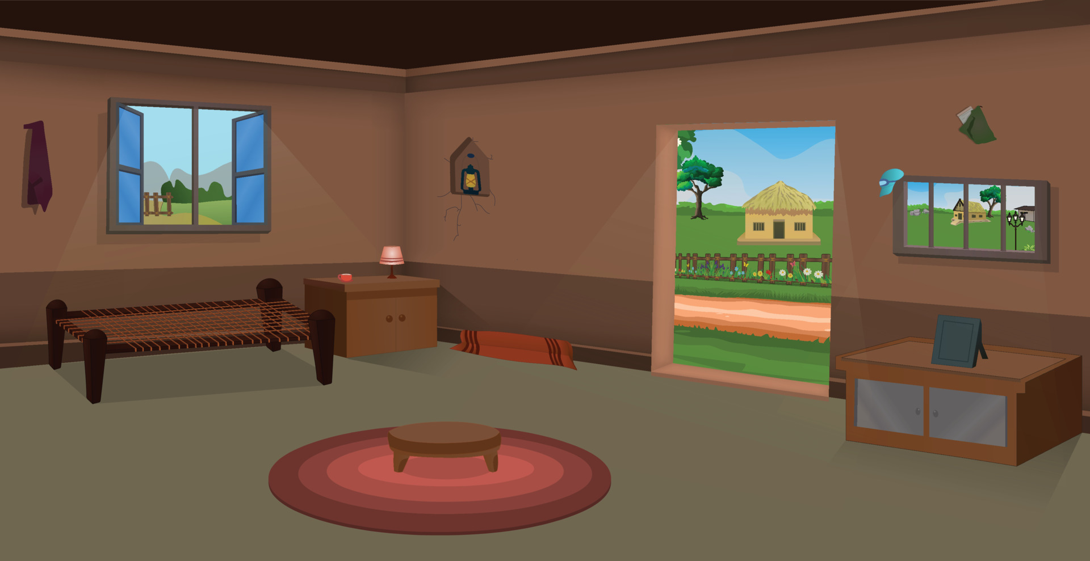

1. How many pieces of furniture are present? 5 (taxonomic) (bed, cabinet, stool, cabinet, rug)

2. How many objects are on top of other objects? 2 (relational) (lamp on cabinet, frame on cabinet)

3. If the windows were removed, how many openings would be visible? 2 (physical) (doorway, window)

## Image 69 (home setup)

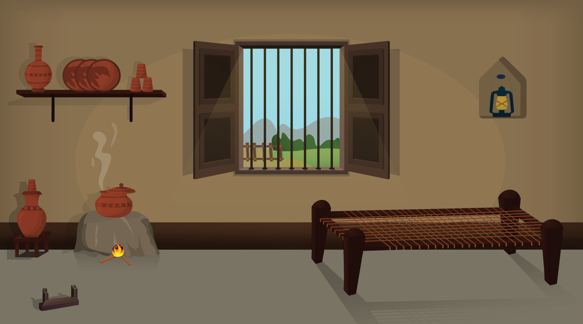

1. How many artifacts categorized as furniture are present? 2 (taxonomic) (bed, shelf)

2. How many objects are positioned on top of other objects? 4 (relational) (pots on shelf, pots on stones)

3. If the window was not barred, how many visible objects would be outside? 5 (physical) (mountains, trees, fence posts)

## Image 70 (farm)

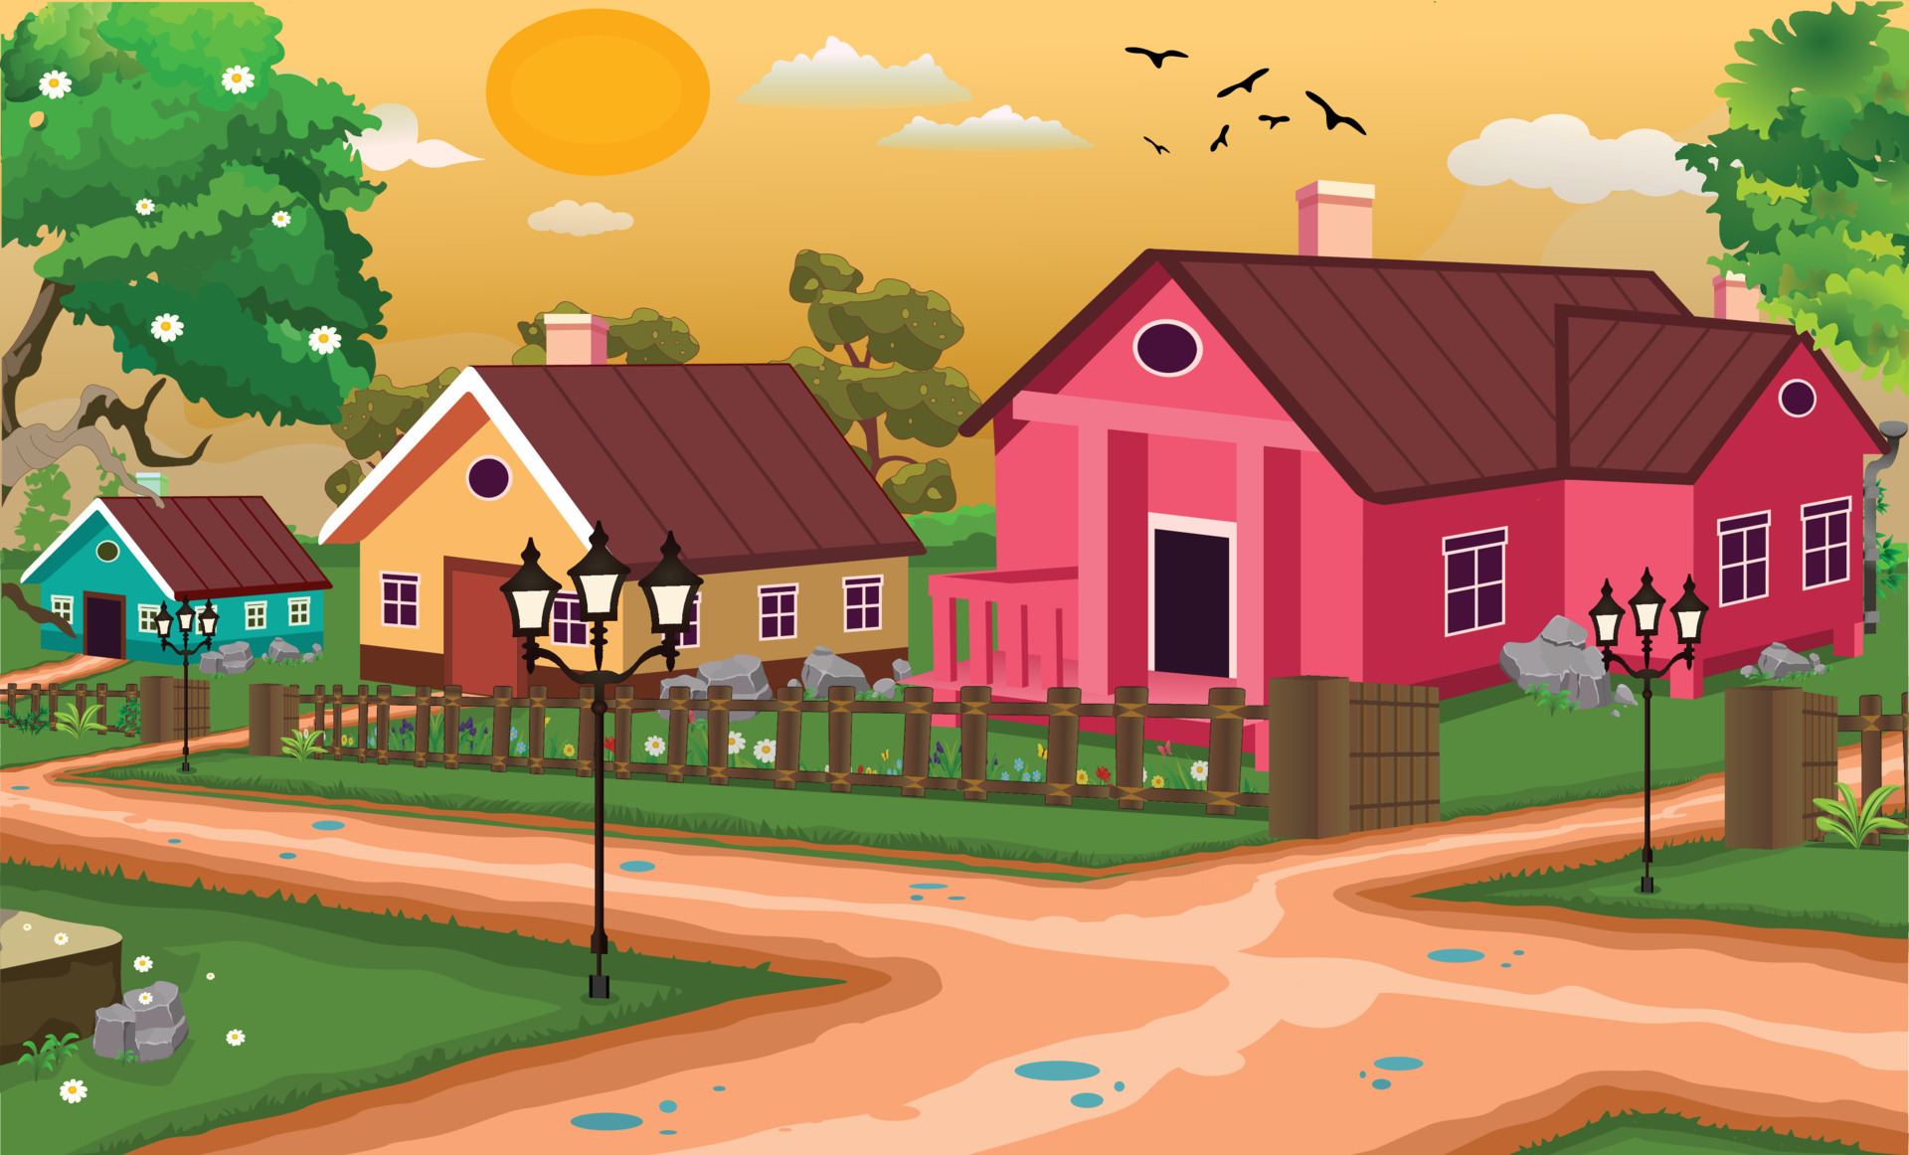

1. How many houses are visible? 3 (taxonomic) (buildings)

2. How many lamp posts are present? 3 (functional) (light sources)

3. If all the birds flew away, how many birds would be visible? 0 (taxonomic) (avian creatures)

## Image 71 (farm)

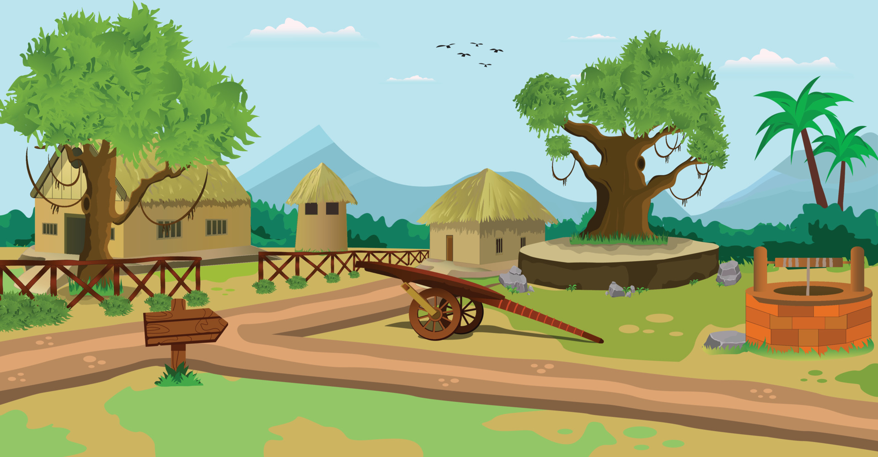

1. How many houses are visible? 3 (taxonomic) (buildings)

2. How many objects with handles are present? 1 (functional) (well)

3. If all the birds flew away, how many birds would be visible? 0 (taxonomic) (birds)

## Image 72 (bedroom)

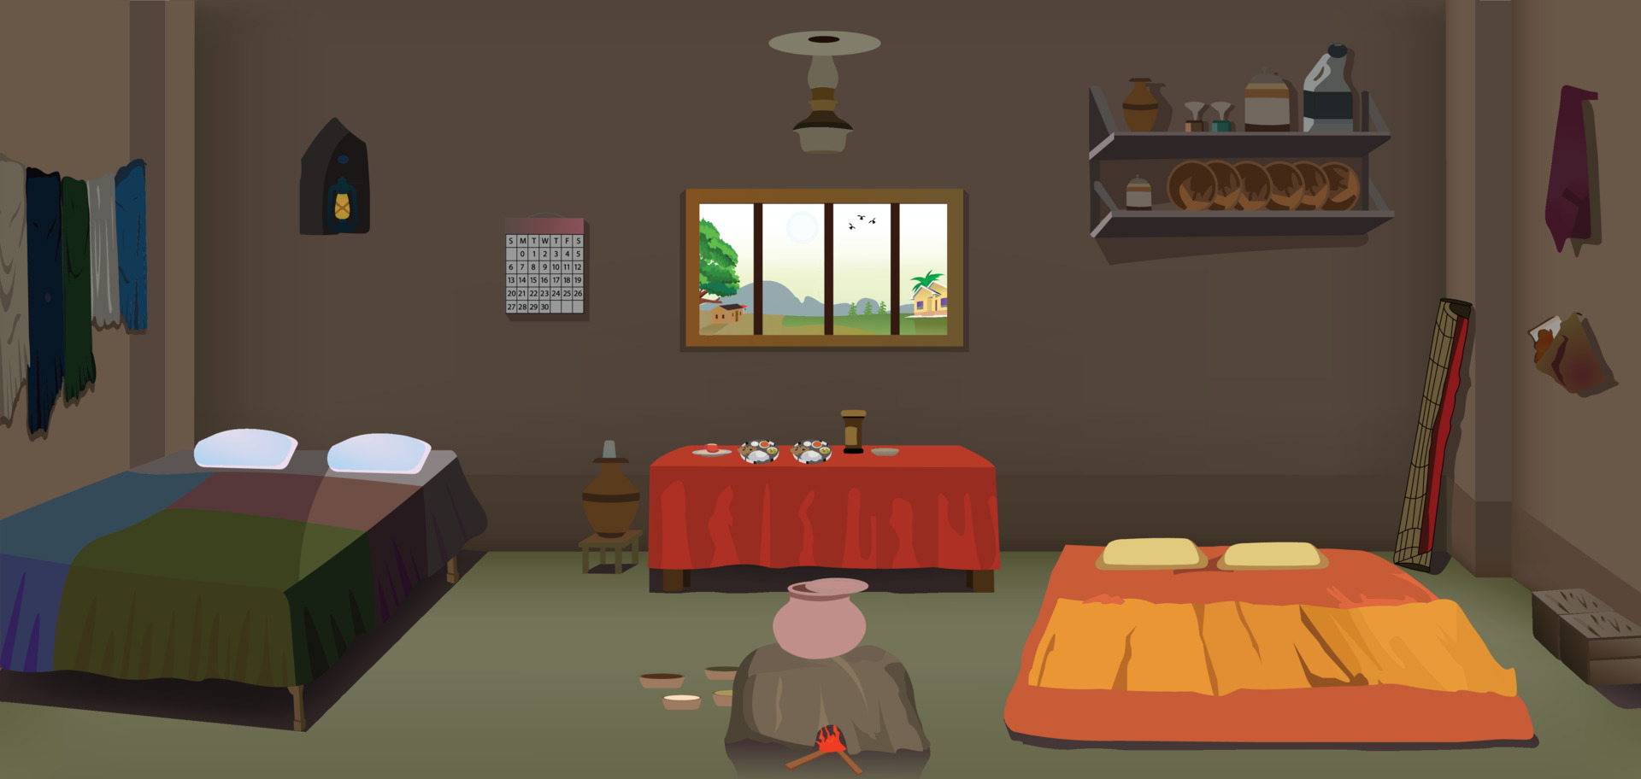

1. How many pieces of furniture are present? 5 (taxonomic) (beds, table, shelf)

2. How many items are on top of the table? 6 (relational) (objects)

3. If the calendar was removed from the wall, how many wall decorations would be visible? 2 (relational) (lantern, picture frame)

## Image 73 (bedroom)

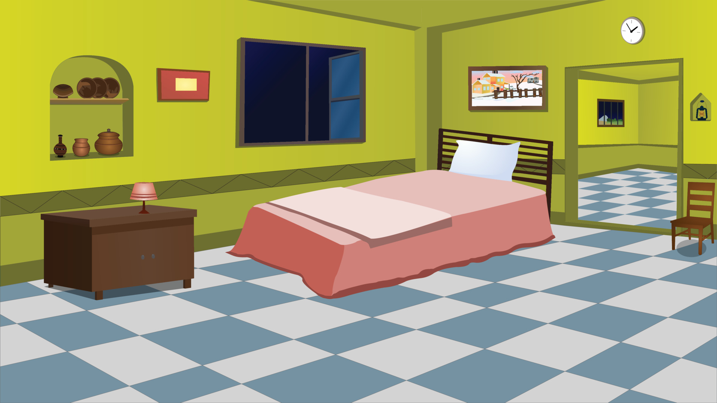

1. How many pieces of furniture are present? 4 (taxonomic) (bed, nightstand, chair, wall shelf)

2. How many objects are on top of other objects? 3 (relational) (lamp on nightstand, picture on wall, items on shelf)

3. If the bed was replaced with two chairs, how many chairs would be visible? 3 (taxonomic) (chairs)

## Image 74 (urban)

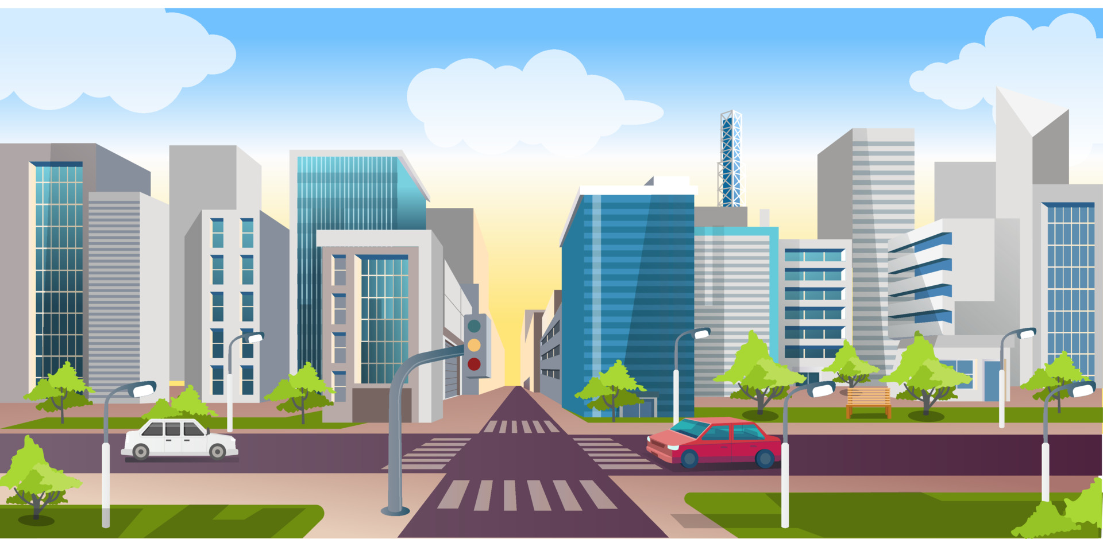

1. How many vehicles are present? 3 (taxonomic) (cars)

2. How many objects are positioned on the sidewalk? 2 (relational) (benches)

3. If all the trees were removed, how many green objects would remain? 0 (taxonomic) (trees)

## Image 75 (urban)

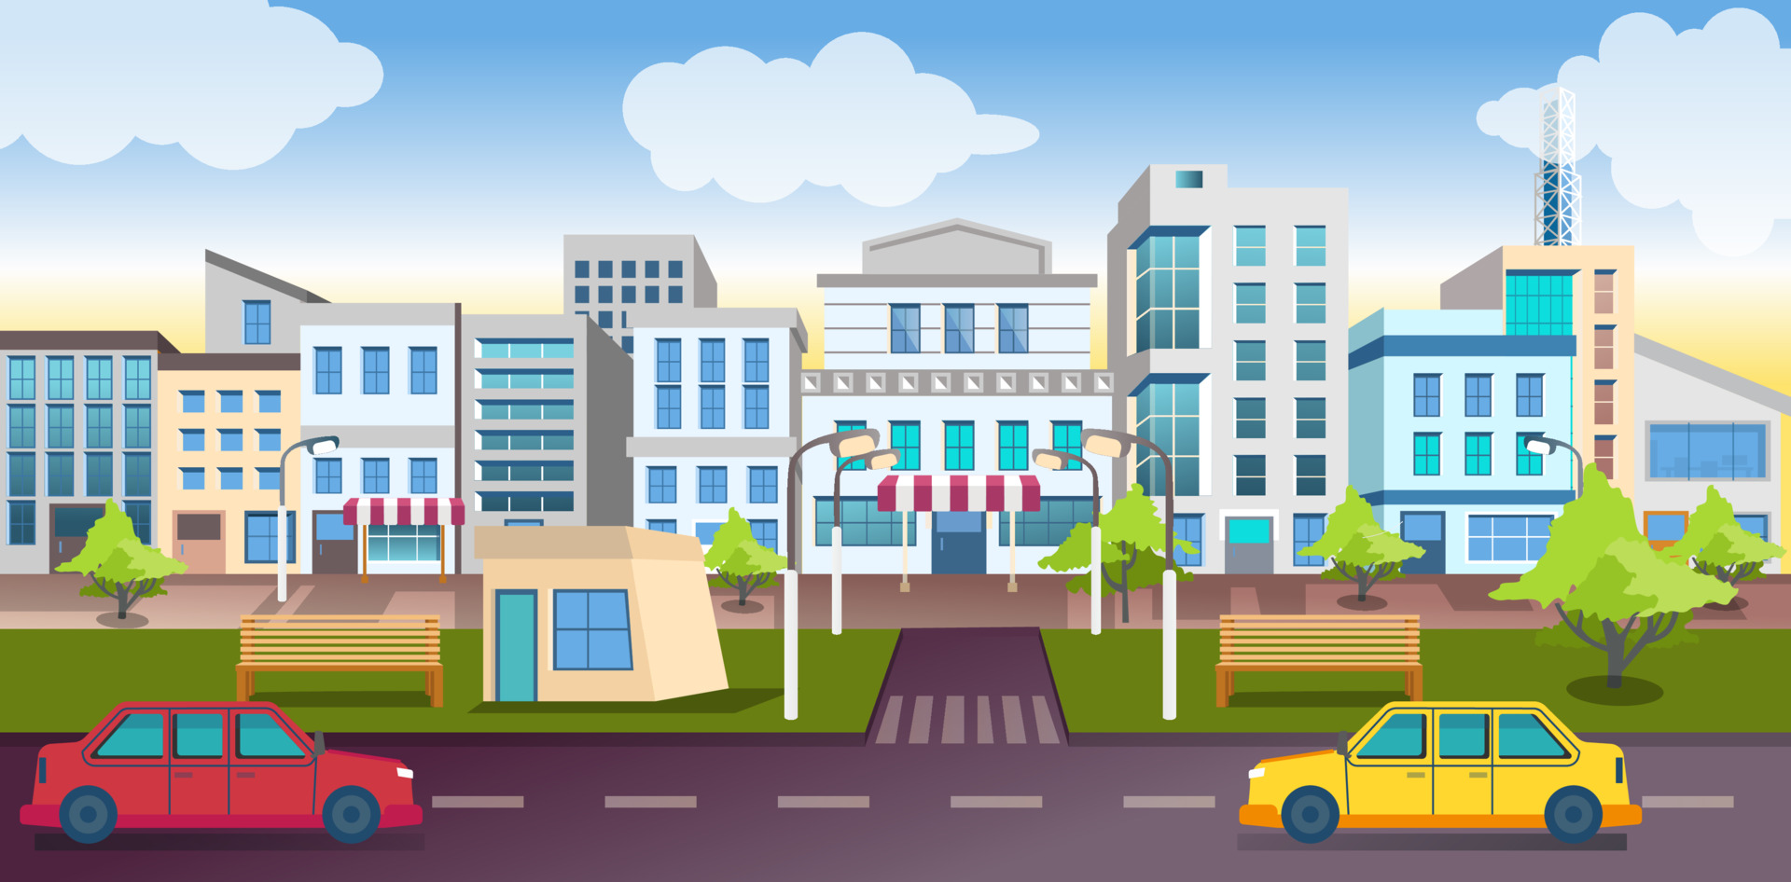

1. How many vehicles are present? 2 (taxonomic) (cars)

2. How many benches are visible for people to sit on? 2 (functional) (benches)

3. If all the trees were removed, how many green objects would remain? 0 (taxonomic) (trees)

## Image 76 (urban)

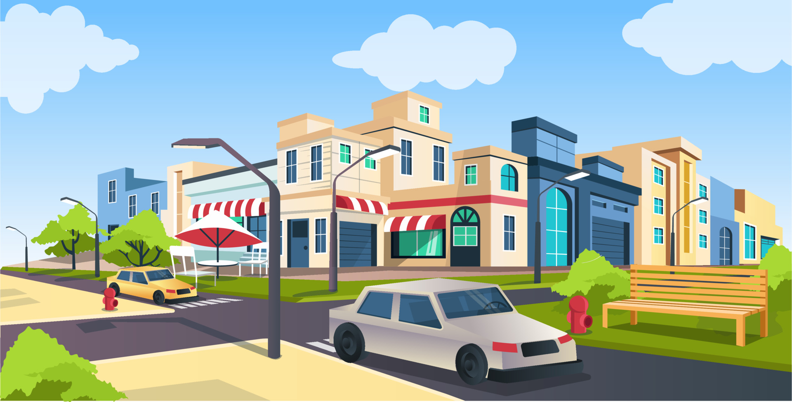

1. How many vehicles are present? 2 (taxonomic) (cars)

2. How many objects that provide seating are visible? 2 (functional) (bench, chairs)

3. If all the trees were removed, how many green bushes would be visible? 2 (taxonomic) (bushes)

## Image 77 (tools)

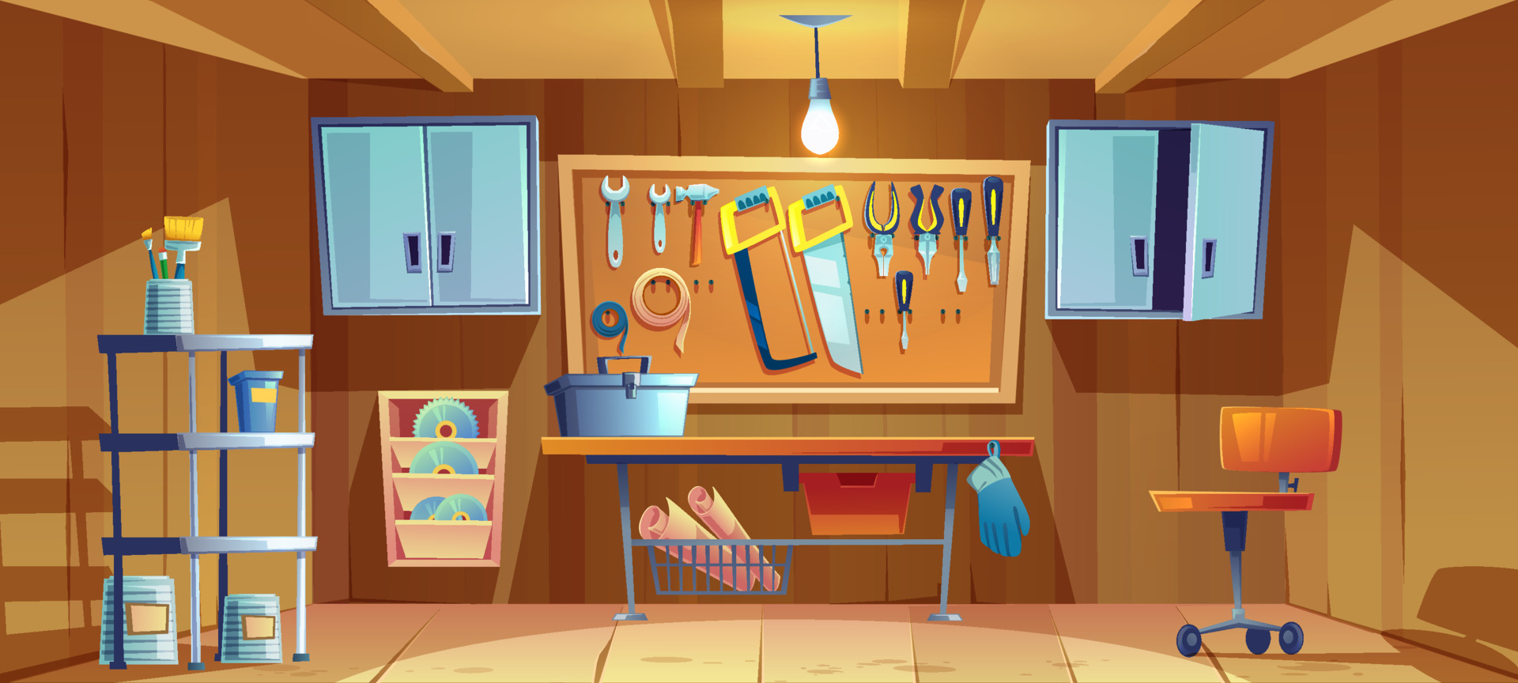

1. How many tools are hanging on the wall? 9 (taxonomic) (tools)

2. How many items are located on top of the workbench? 4 (relational) (items)

3. If the metal shelving unit was removed, how many shelving units would be visible? 1 (physical) (shelving unit)

## Image 78 (tools)

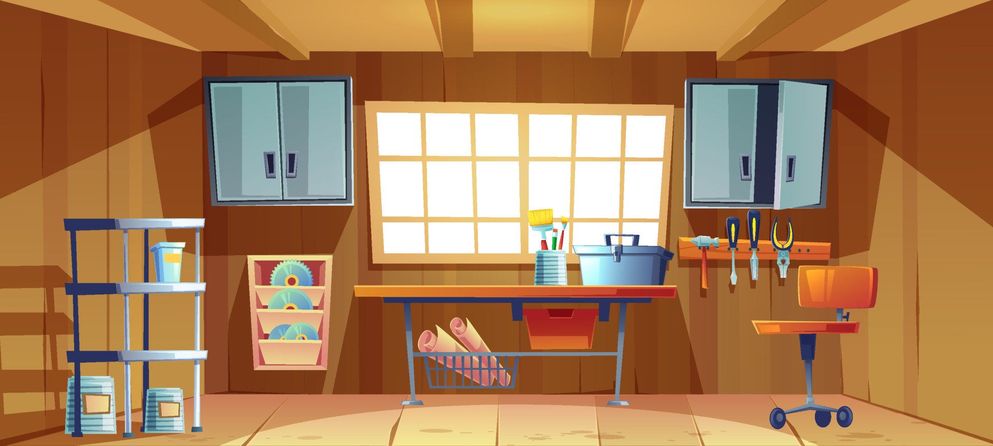

1. How many items made of metal are present? 8 (physical) (tools)

2. How many items are on top of the workbench? 5 (relational) (items)

3. If the shelves were empty, how many items would be on the left side of the image? 0 (taxonomic) (items)

## Image 79 (garage)

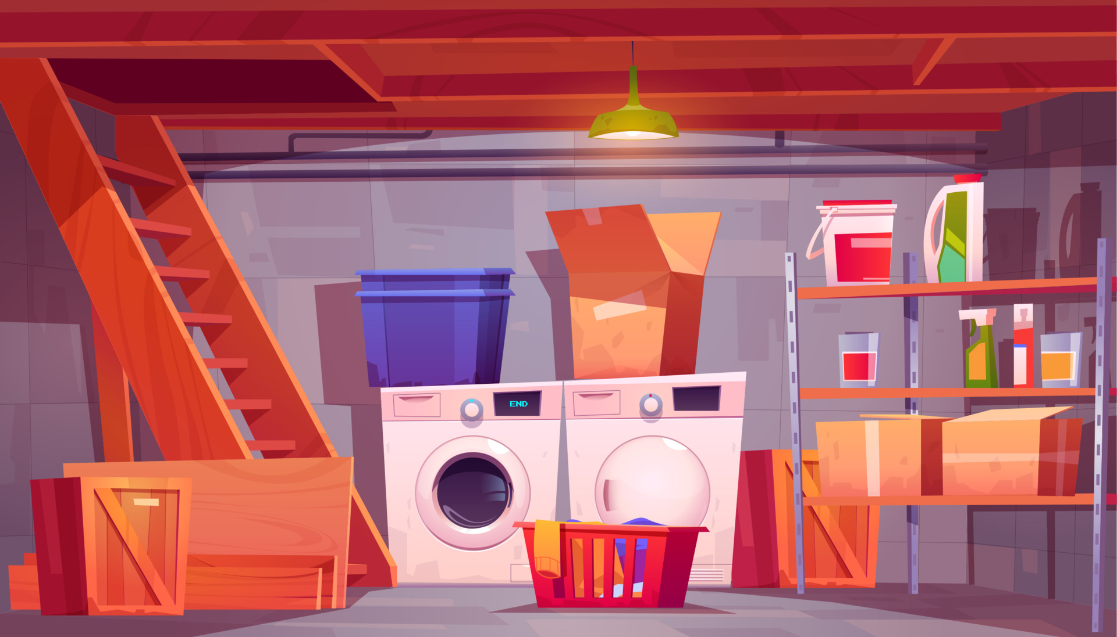

1. How many objects made of metal are present? 2 (physical) (washing machines)

2. How many objects are on top of other objects? 4 (relational) (boxes, laundry basket, jars)

3. If the blue plastic bins were removed, how many containers would remain? 5 (functional) (boxes, laundry basket, jars)

## Image 80 (home setup)

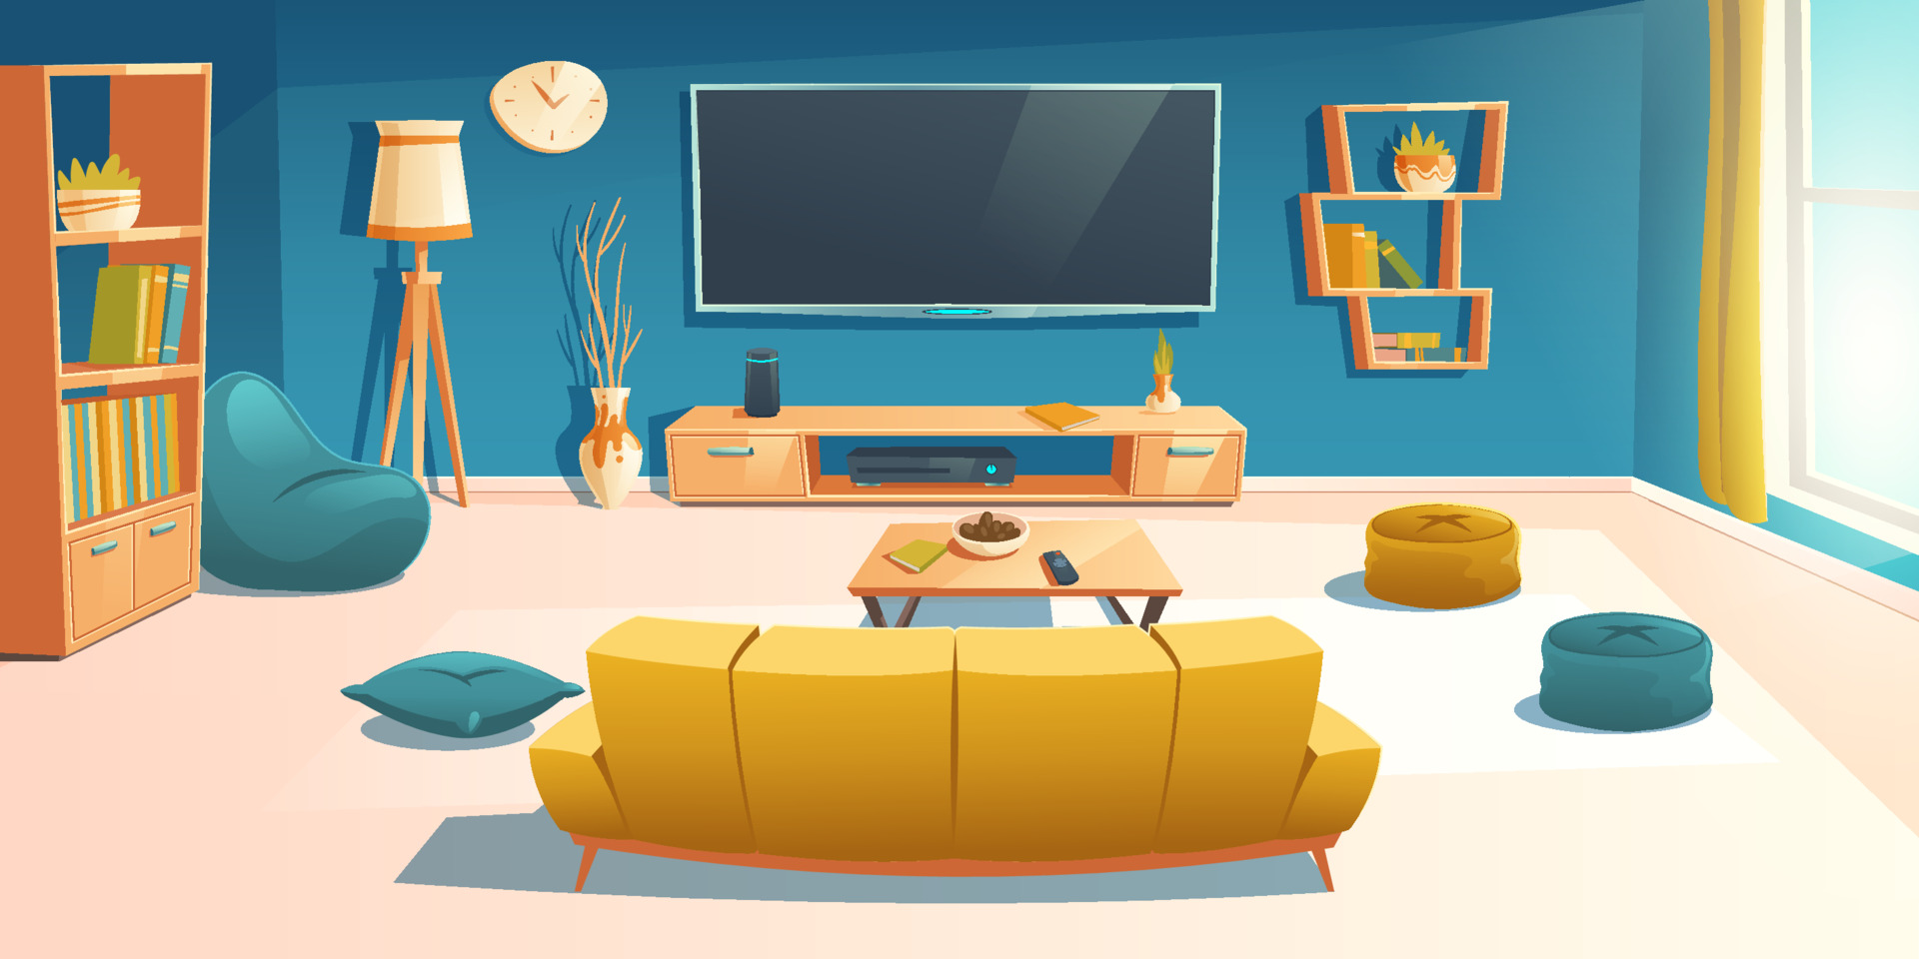

1. How many pieces of furniture are present? 6 (taxonomic) (sofa, bookshelf, TV stand, coffee table, poufs)

2. How many objects are on top of other objects? 5 (relational) (books on bookshelf, items on TV stand, items on coffee table, plant on shelf, books on shelf)

3. If the poufs were replaced with chairs, how many objects with legs would be visible? 5 (physical) (sofa, bookshelf, TV stand, coffee table, floor lamp)

## Image 81 (urban)

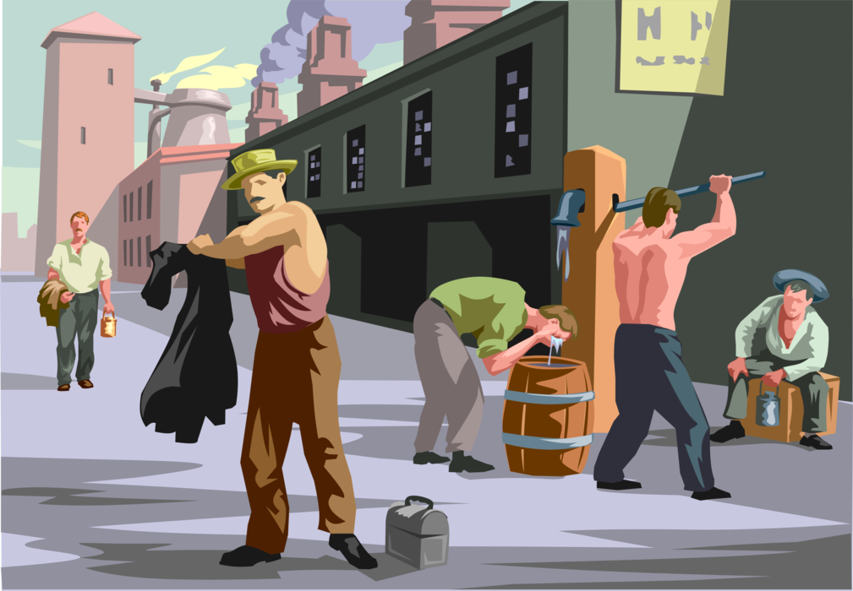

1. How many people are wearing hats? 3 (taxonomic) (people)

2. How many objects are being used to hold or contain something? 2 (functional) (bag, barrel)

3. If the building in the background was painted blue, how many buildings would be visible? 2 (physical) (buildings)

## Image 82 (urban)

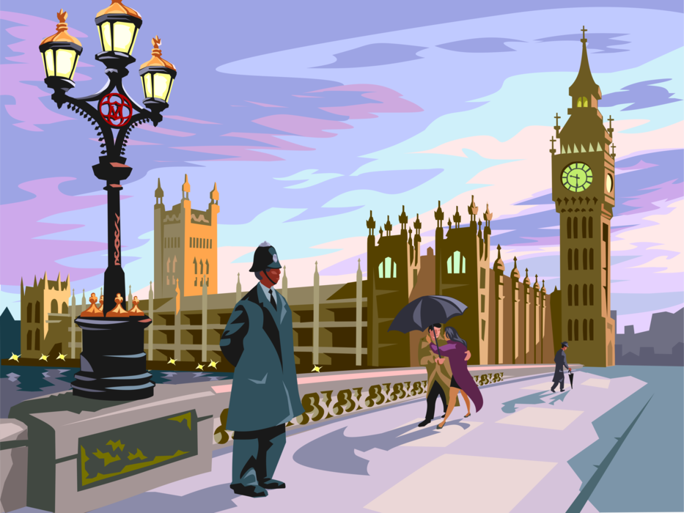

1. How many buildings are visible? 4 (taxonomic) (buildings)

2. How many people are holding umbrellas? 2 (relational) (people)

3. If the lamp post had only one light, how many lights would be visible? 1 (physical) (lights)

## Image 83 (urban)

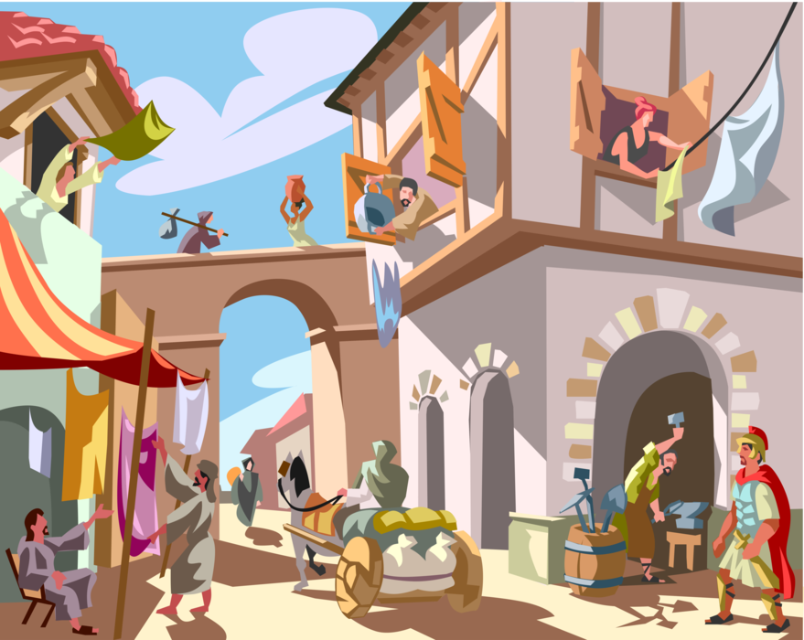

1. How many people are visible? 13 (taxonomic) (humans)

2. How many objects are being held by someone? 4 (relational) (objects)

3. If all the jars were filled with liquid, how many containers holding liquid would there be? 3 (functional) (jars)

## Image 84 (construction)

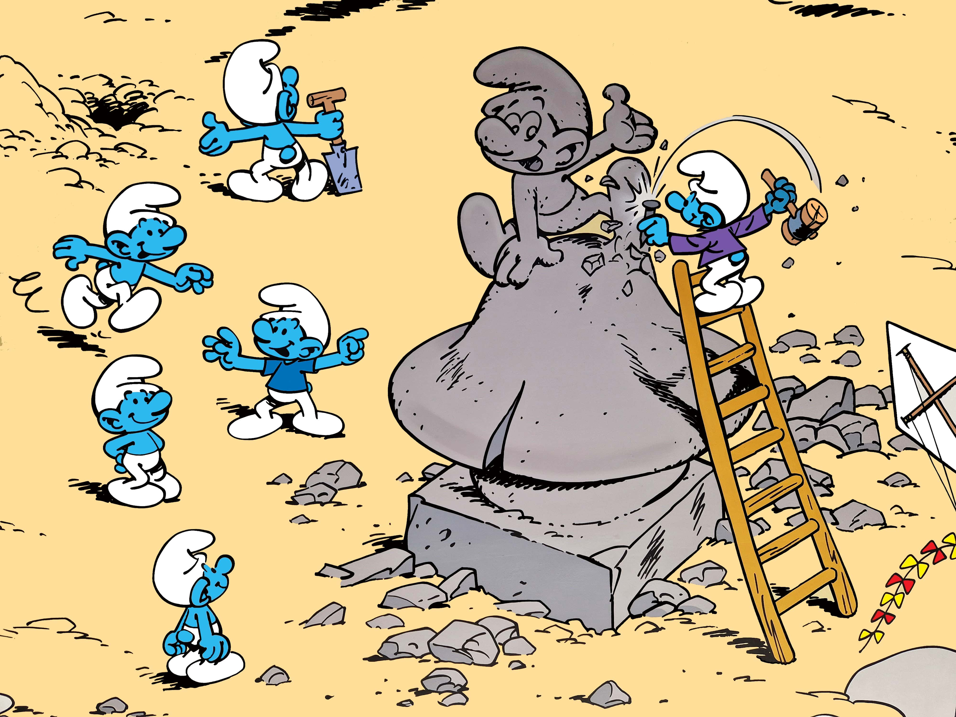

1. How many Smurfs are present? 8 (taxonomic) (characters)

2. How many Smurfs are positioned on top of something? 3 (relational) (statue/ladder)

3. If the large stone statue were made of glass, how many fragile objects would be visible? 1 (physical) (statue)

## Image 85 (urban)

[ERROR: Could not add image image85.jpg - ]

## Image 86 (kitchen)

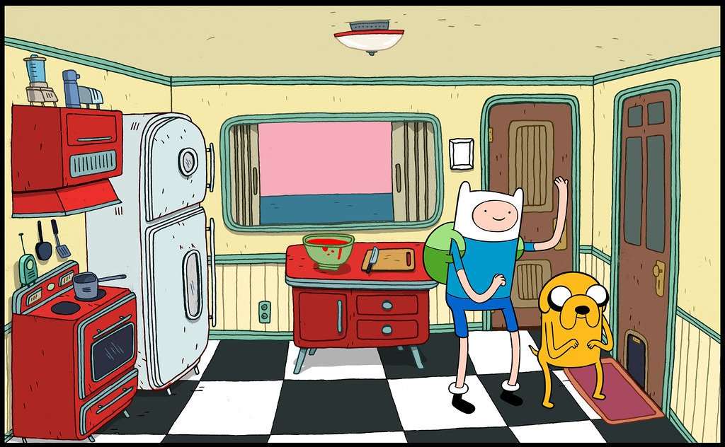

1. How many objects made of metal are present? 8 (physical) (pots, pans, stove knobs, refrigerator handle, light fixture, outlet covers)

2. How many objects are on top of other objects? 3 (relational) (items on the counter, items on the stove)

3. If the refrigerator was made of wood instead of metal, how many wooden objects would be visible? 5 (physical) (refrigerator, cabinets, doors)

## Image 87 (home setup)

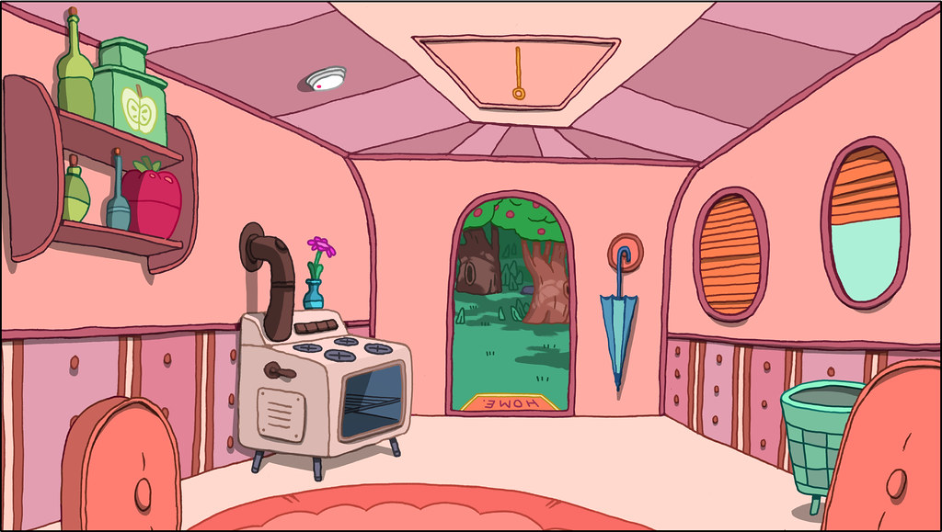

1. How many objects are artifacts? 11 (taxonomic) (stove, umbrella, rug, trash can, bottles, flower vase, shelves, windows, door, and rug label)

2. How many objects are on top of other objects? 3 (relational) (bottles on shelf, flower in vase, rug on floor)

3. If the stove had wheels, how many objects with wheels would be visible? 1 (physical) (stove)

## Image 88 (home setup)

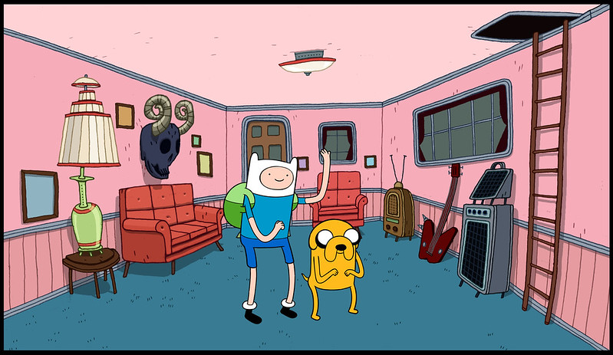

1. How many pieces of furniture are present? 5 (taxonomic) (sofas, table, stereo cabinet)

2. How many objects are positioned on top of other objects? 3 (relational) (lamp on table, stereo on cabinet, picture on wall)

3. If the television was replaced with a plant, how many biological entities would be visible? 2 (taxonomic) (Finn, Jake)

## Image 89 (laboratory)

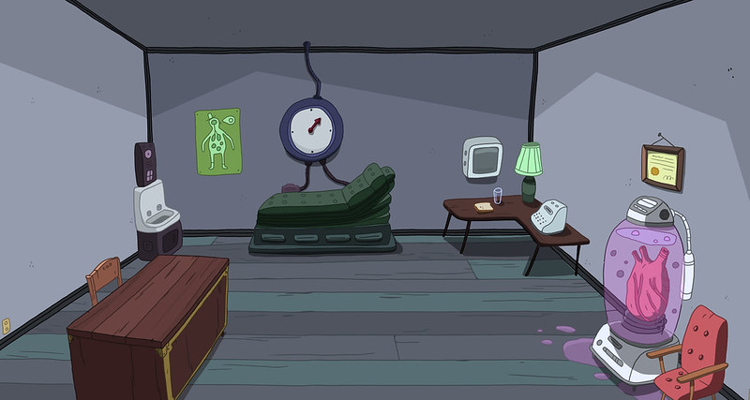

1. How many objects made of wood are present? 2 (physical) (tables)

2. How many objects are on top of other objects? 3 (relational) (books, telephone, certificate)

3. If the robot in the tank were removed, how many chairs would be visible? 1 (taxonomic) (chair)

## Image 90 (home setup)

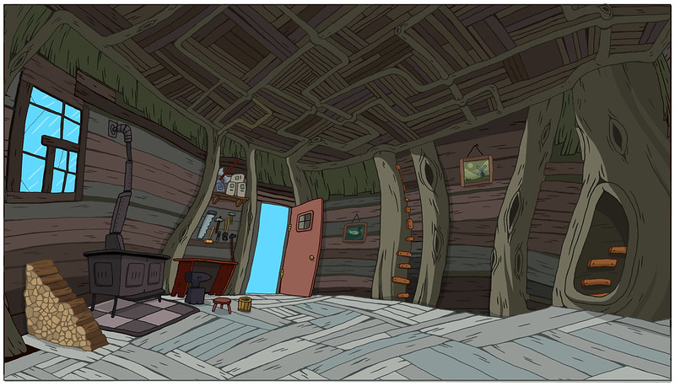

1. How many objects made of wood are present? 8 (physical) (tree trunks)

2. How many objects that can be opened are visible? 3 (functional) (doors and cabinet)

3. If the woodpile was removed, how many stacks of wood would be visible? 0 (relational) (woodpile)

## Image 91 (home setup)

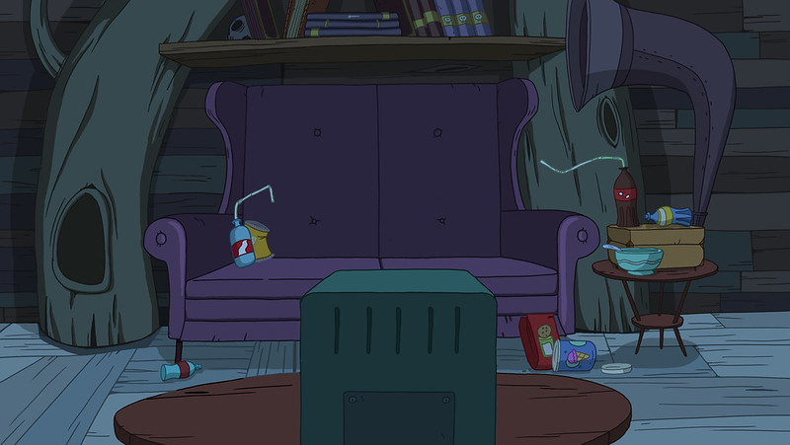

1. How many pieces of furniture are present? 3 (taxonomic) (couch, table, box-like structure)

2. How many items are on top of the couch? 2 (relational) (spray can, snack)

3. If all the books on the shelf were removed, how many empty spaces would be visible on the shelf? 5 (physical) (spaces)

## Image 92 (home setup)

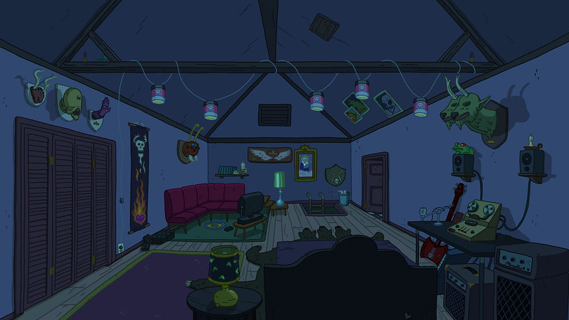

1. How many animal heads are mounted on the wall? 2 (taxonomic) (animal heads)

2. How many items are placed on top of the green rug? 3 (relational) (items)

3. If all the lamps were removed, how many light sources would remain? 0 (functional) (light sources)

## Image 93 (bedroom)

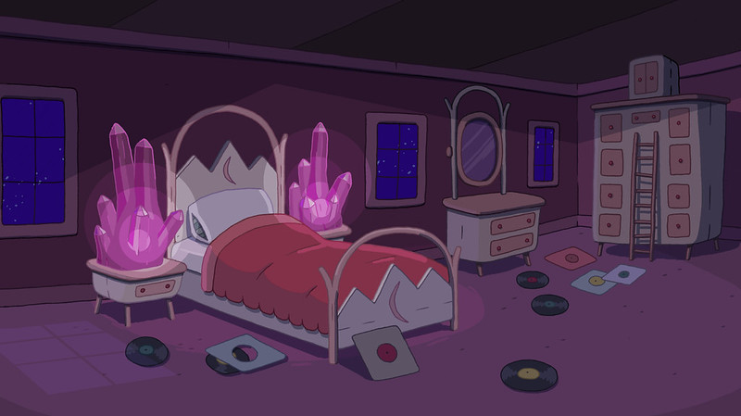

1. How many pieces of furniture are present? 4 (taxonomic) (bed, dresser, nightstand, wardrobe)

2. How many items are lying on the floor? 7 (relational) (records/vinyls)

3. If the crystals were replaced with lamps, how many light sources would be visible? 2 (functional) (lamps/windows)

## Image 94 (home setup)

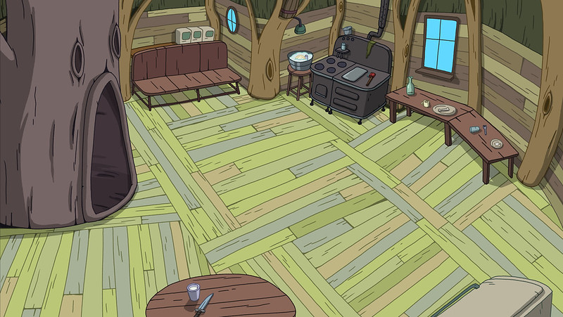

1. How many pieces of furniture are present? 4 (taxonomic) (sofa, stove, table, small table)

2. How many items are on top of other items? 3 (relational) (bottle on table, cup on table, items on stove)

3. If the trees were not part of the structure, how many legs would be visible? 6 (physical) (furniture legs)

## Image 95 (kitchen)

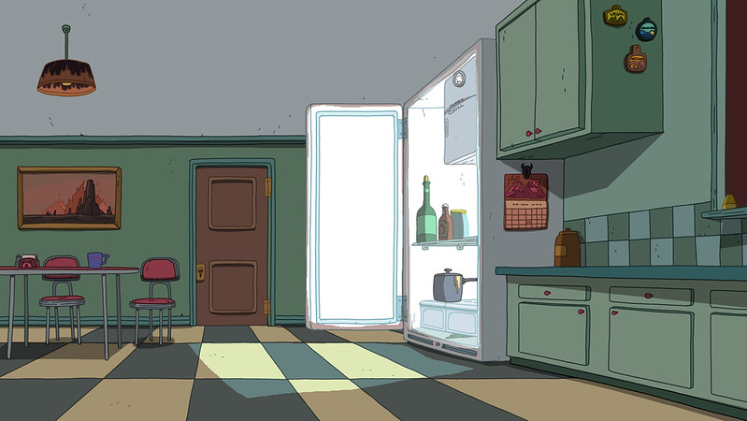

1. How many chairs are visible? 2 (taxonomic) (furniture)

2. How many items are located inside the refrigerator? 3 (relational) (bottles and pot)

3. If the calendar was removed from the refrigerator, how many items would be directly attached to the refrigerator’s surface? 2 (relational) (magnets)

## Image 96 (meeting room)

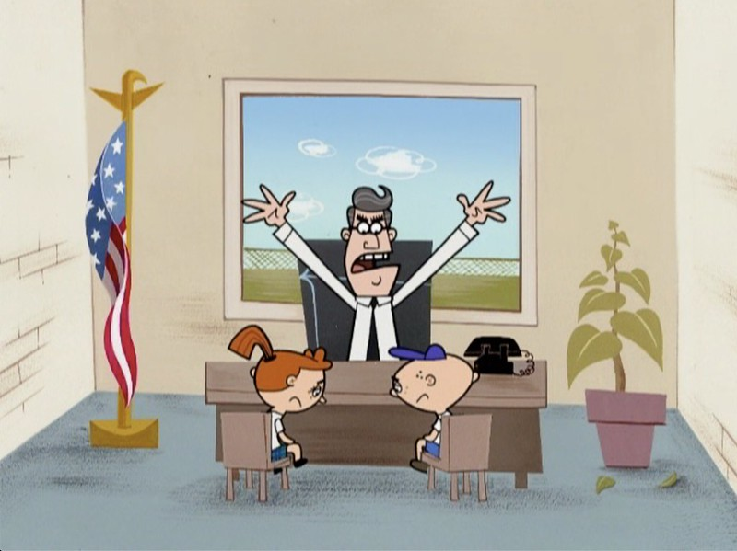

1. How many chairs are visible? 2 (taxonomic) (furniture)

2. How many items are on top of the desk? 2 (relational) (objects)

3. If the plant was a different color, how many green objects would be visible? 1 (physical) (leaves)

## Image 97 (classroom)

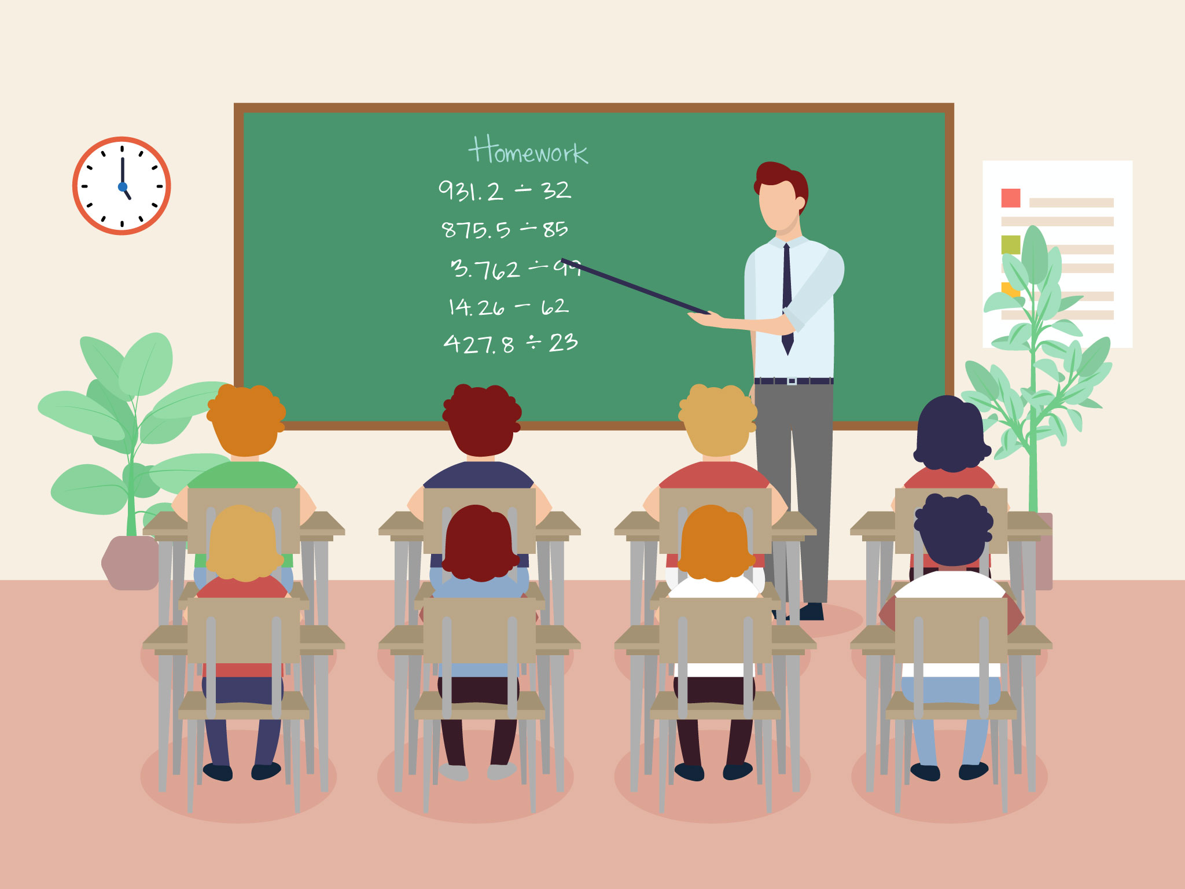

1. How many students are present? 6 (taxonomic) (people)

2. How many chairs are occupied by students? 6 (relational) (chairs)

3. If the plants were removed from the room, how many plants would be visible? 0 (taxonomic) (plants)

## Image 98 (laboratory)



1. How many people are visible? 3 (taxonomic) (humans)

2. How many items are on top of the table? 3 (relational) (objects)

3. If the screen was not present, how many people would be visible pointing? 1 (functional) (people)

## Image 99 (classroom)

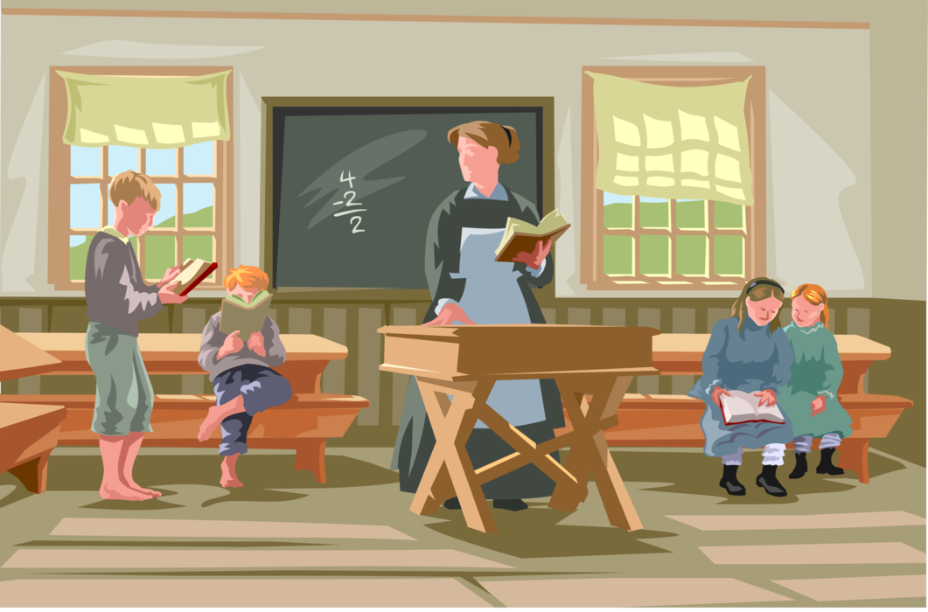

1. How many people are visible? 4 (taxonomic) (humans)

2. How many desks are supporting books? 2 (relational) (desks)

3. If the chalkboard was replaced with a window, how many windows would be visible? 4 (physical) (windows)

## Image 100 (classroom)

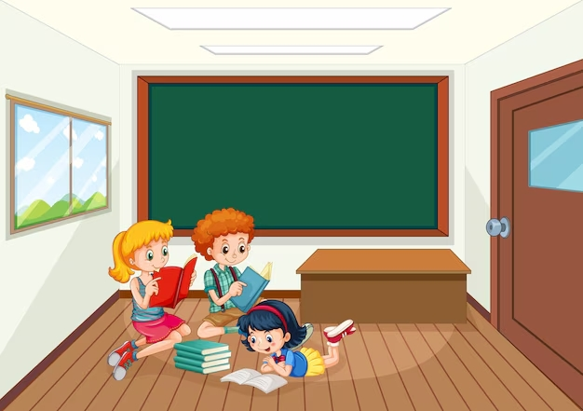

1. How many children are present? 3 (taxonomic) (people)

2. How many items are stacked on top of other items? 1 (relational) (books)

3. If the door was open, how many openings would be visible? 2 (relational) (doorways/openings)

## Image 101 (classroom)

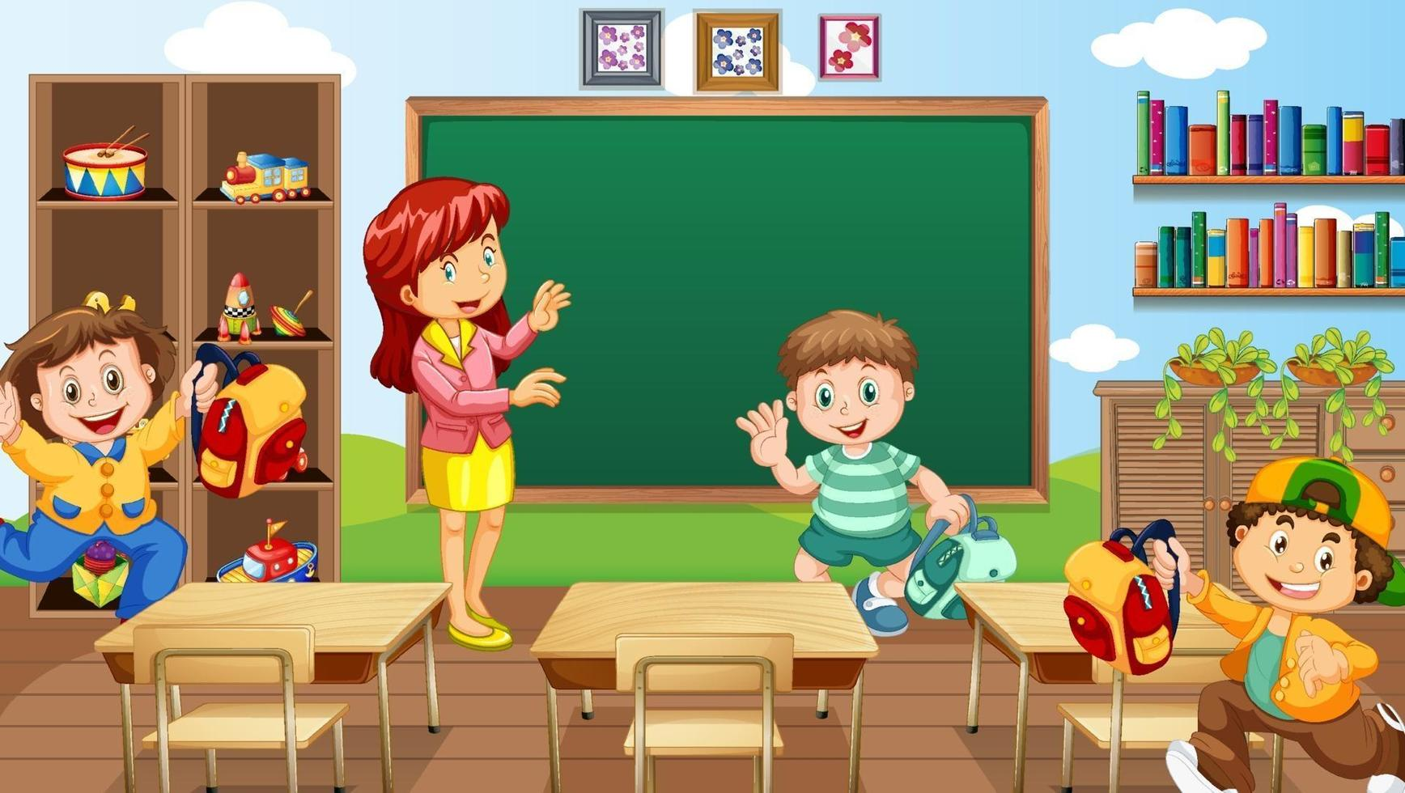

1. How many objects that are vehicles are present? 3 (taxonomic) (trains, car, fire truck)

2. How many objects are on top of the desks? 4 (relational) (books, toys)

3. If the bookshelves were empty, how many books would be visible? 0 (physical) (books)

## Image 102 (classroom)

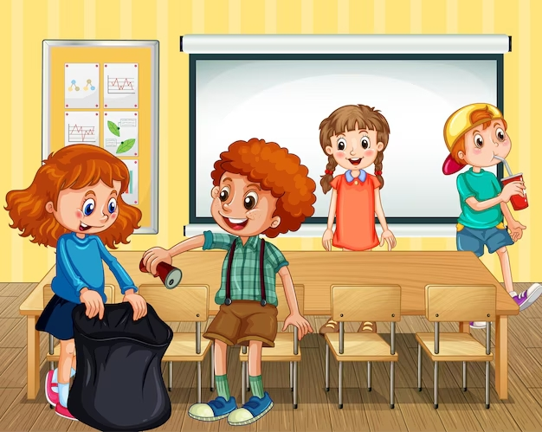

1. How many children are visible? 4 (taxonomic) (people)

2. How many chairs are under the table? 4 (relational) (furniture)

3. If the trash can was empty, how many items would be in it? 0 (functional) (waste)

## Image 103 (classroom)

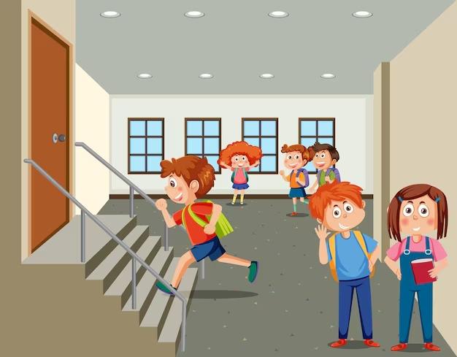

1. How many children are wearing backpacks? 5 (taxonomic) (students)

2. How many students are standing near each other? 3 (relational) (students)

3. If the door was open, how many openings would be visible? 2 (physical) (doorways)

## Image 104 (park)

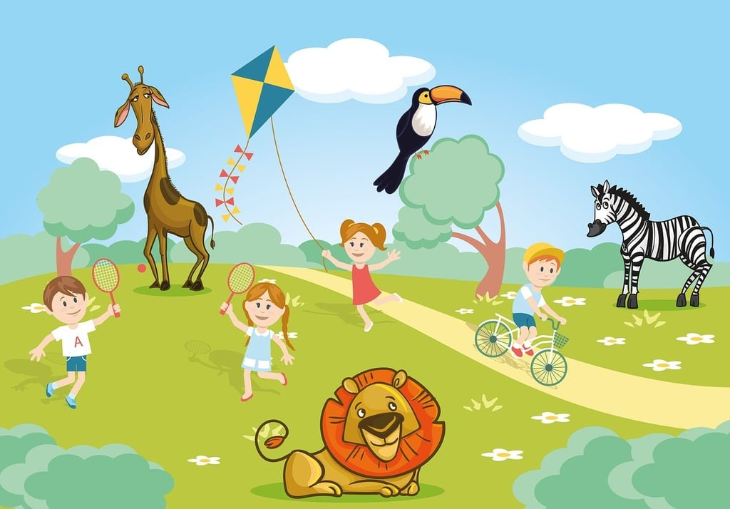

1. How many mammals are present? 4 (taxonomic) (giraffe, lion, zebra, child)

2. How many objects with wheels are visible? 1 (functional) (bicycle)

3. If the kite were a different color, how many kites would be visible? 1 (physical) (kite)

## Image 105 (zoo)

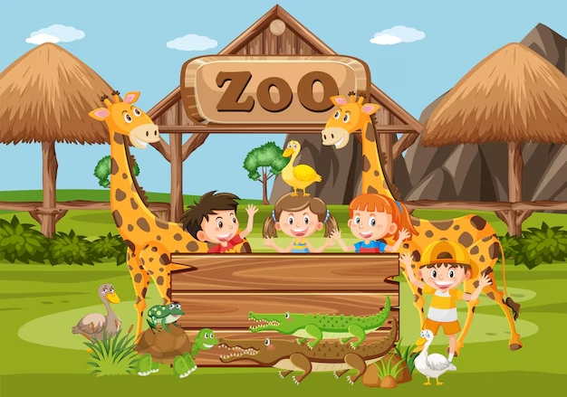

1. How many animals are visible? 9 (taxonomic) (giraffes, ducks, crocodiles, ostrich, goose)

2. How many children are waving? 4 (relational) (children)

3. If the thatched roofs were made of glass, how many transparent objects would be visible? 2 (physical) (roofs)

## Image 106 (zoo)

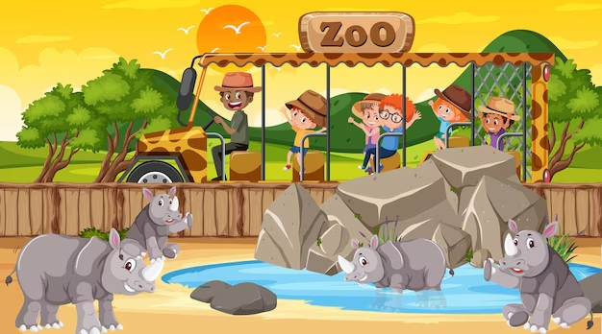

1. How many mammals are visible? 6 (taxonomic) (animals)

2. How many people are riding in the vehicle? 5 (relational) (passengers)

3. If the rocks were removed, how many rhinos would be drinking from the water? 3 (relational) (rhinos)

## Image 107 (zoo)

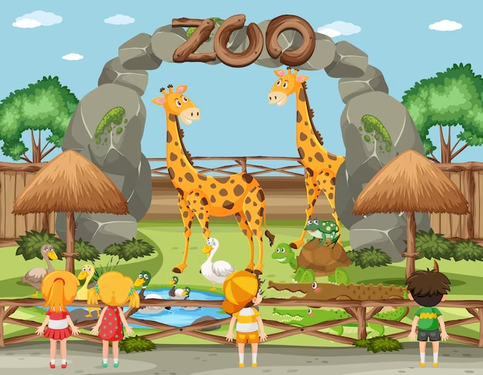

1. How many animals that are birds are present? 4 (taxonomic) (ostrich, ducks, goose, parrot)

2. How many children are looking at the animals? 3 (relational) (children)

3. If the giraffes were replaced with elephants, how many elephants would there be? 2 (taxonomic) (giraffes)

## Image 108 (zoo)

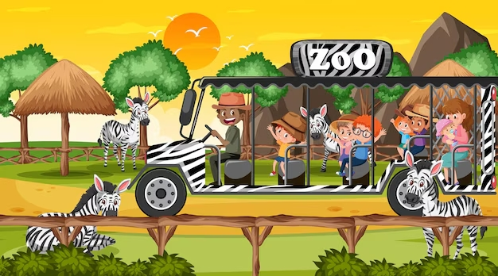

1. How many mammals are present? 8 (taxonomic) (zebras and people)

2. How many people are riding inside the vehicle? 6 (relational) (passengers)

3. If the vehicle had no wheels, how many wheels would be visible? 0 (physical) (wheels)

## Image 109 (zoo)

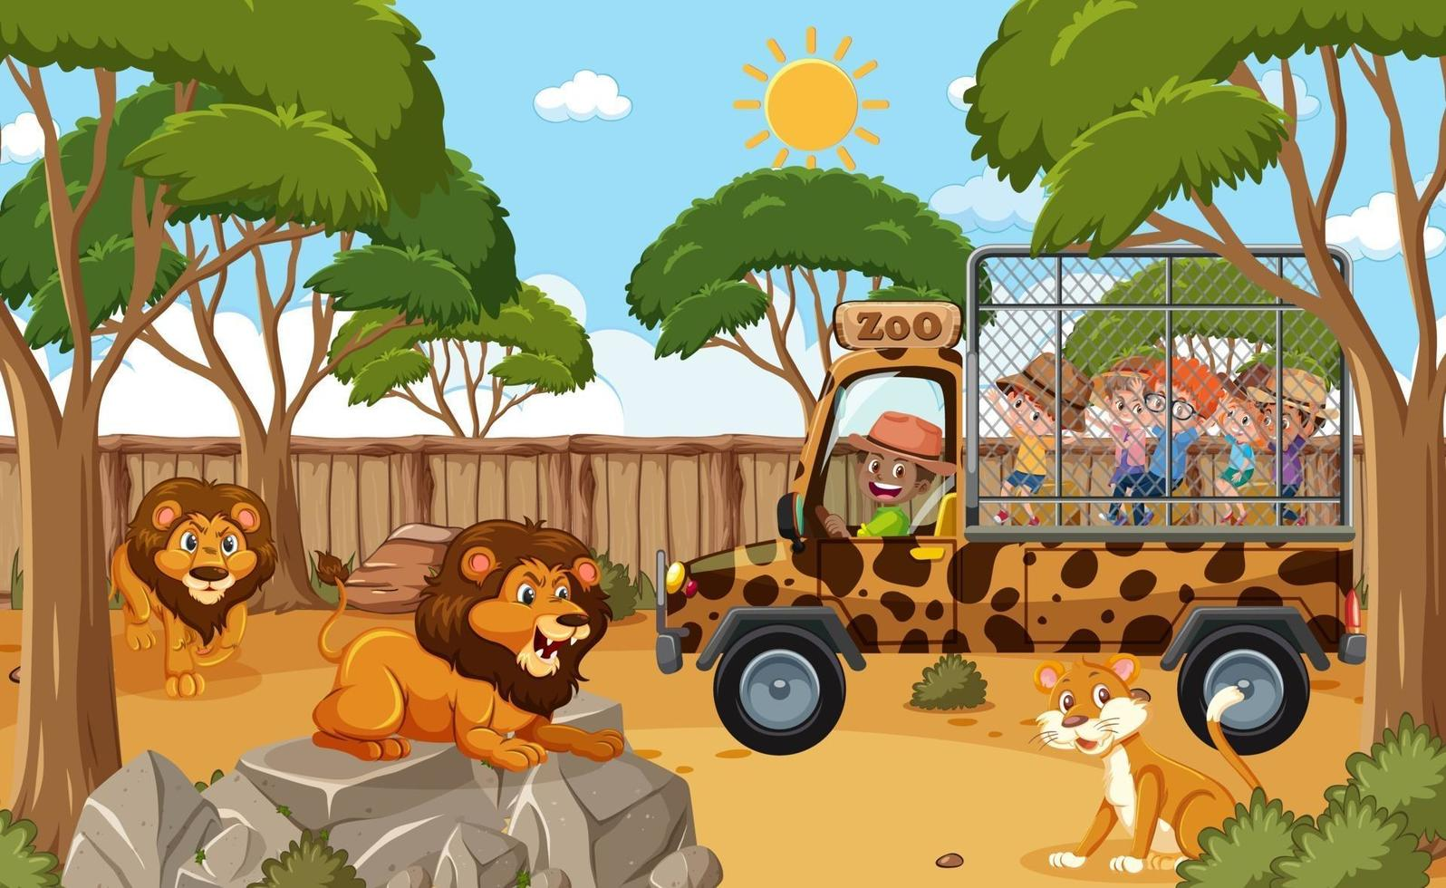

1. How many mammals are visible? 7 (taxonomic) (lions, cheetah, people)

2. How many people are riding inside the vehicle? 4 (relational) (people in the truck)

3. If the two large lions were replaced with zebras, how many striped animals would be visible? 2 (taxonomic) (zebras, truck)

## Image 110 (garage)

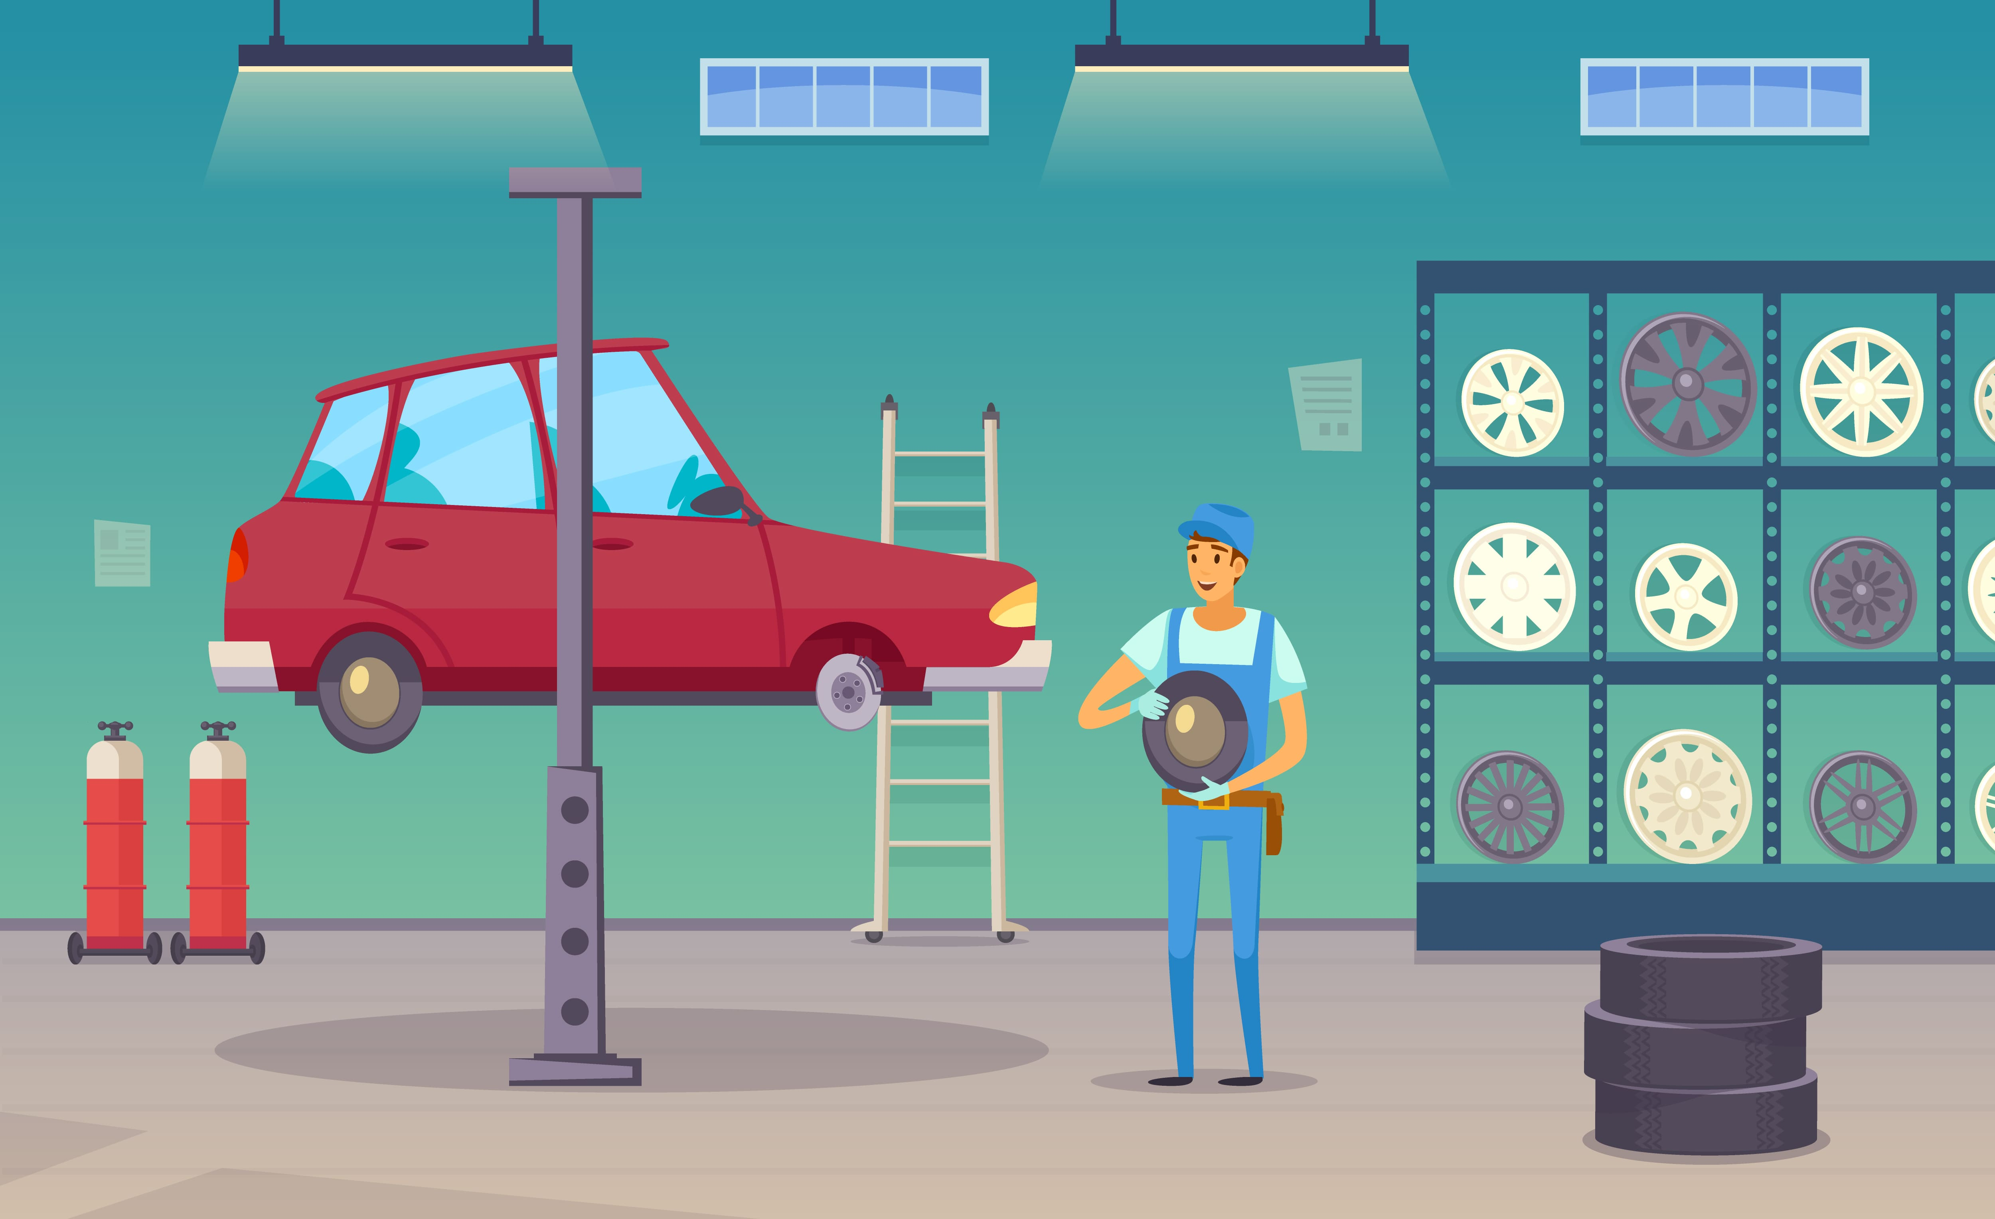

1. How many vehicles are present? 1 (taxonomic) (car)

2. How many items are stacked on top of each other? 3 (relational) (tires)

3. If the mechanic had two more tires in his hands, how many tires would he be holding? 2 (physical) (tires)

## Image 111 (urban)

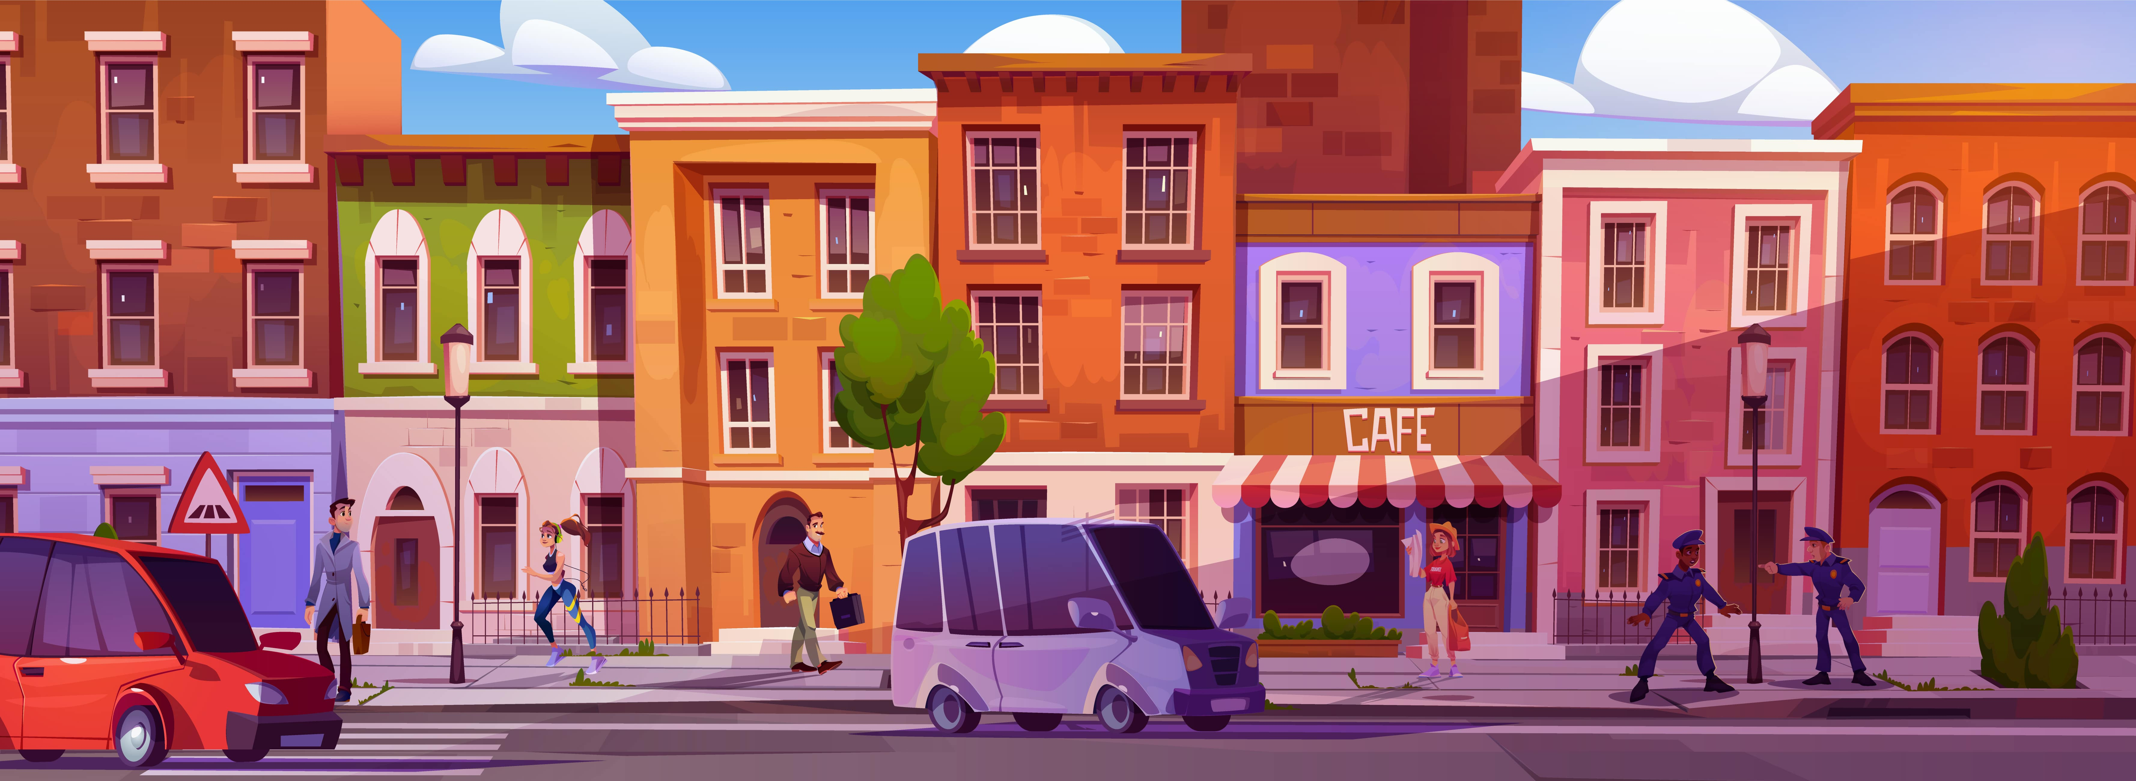

1. How many vehicles are present? 3 (taxonomic) (cars and van)

2. How many people are walking on the sidewalk? 5 (relational) (pedestrians)

3. If the cafe awning was removed, how many storefronts would be visible? 5 (physical) (building facades)

## Image 112 (urban)



1. How many vehicles are present? 2 (taxonomic) (planes)

2. How many boxes are stacked on top of other boxes? 3 (relational) (cardboard boxes)

3. If the forklift was not present, how many people would be carrying boxes? 4 (functional) (people)

## Image 113 (urban)

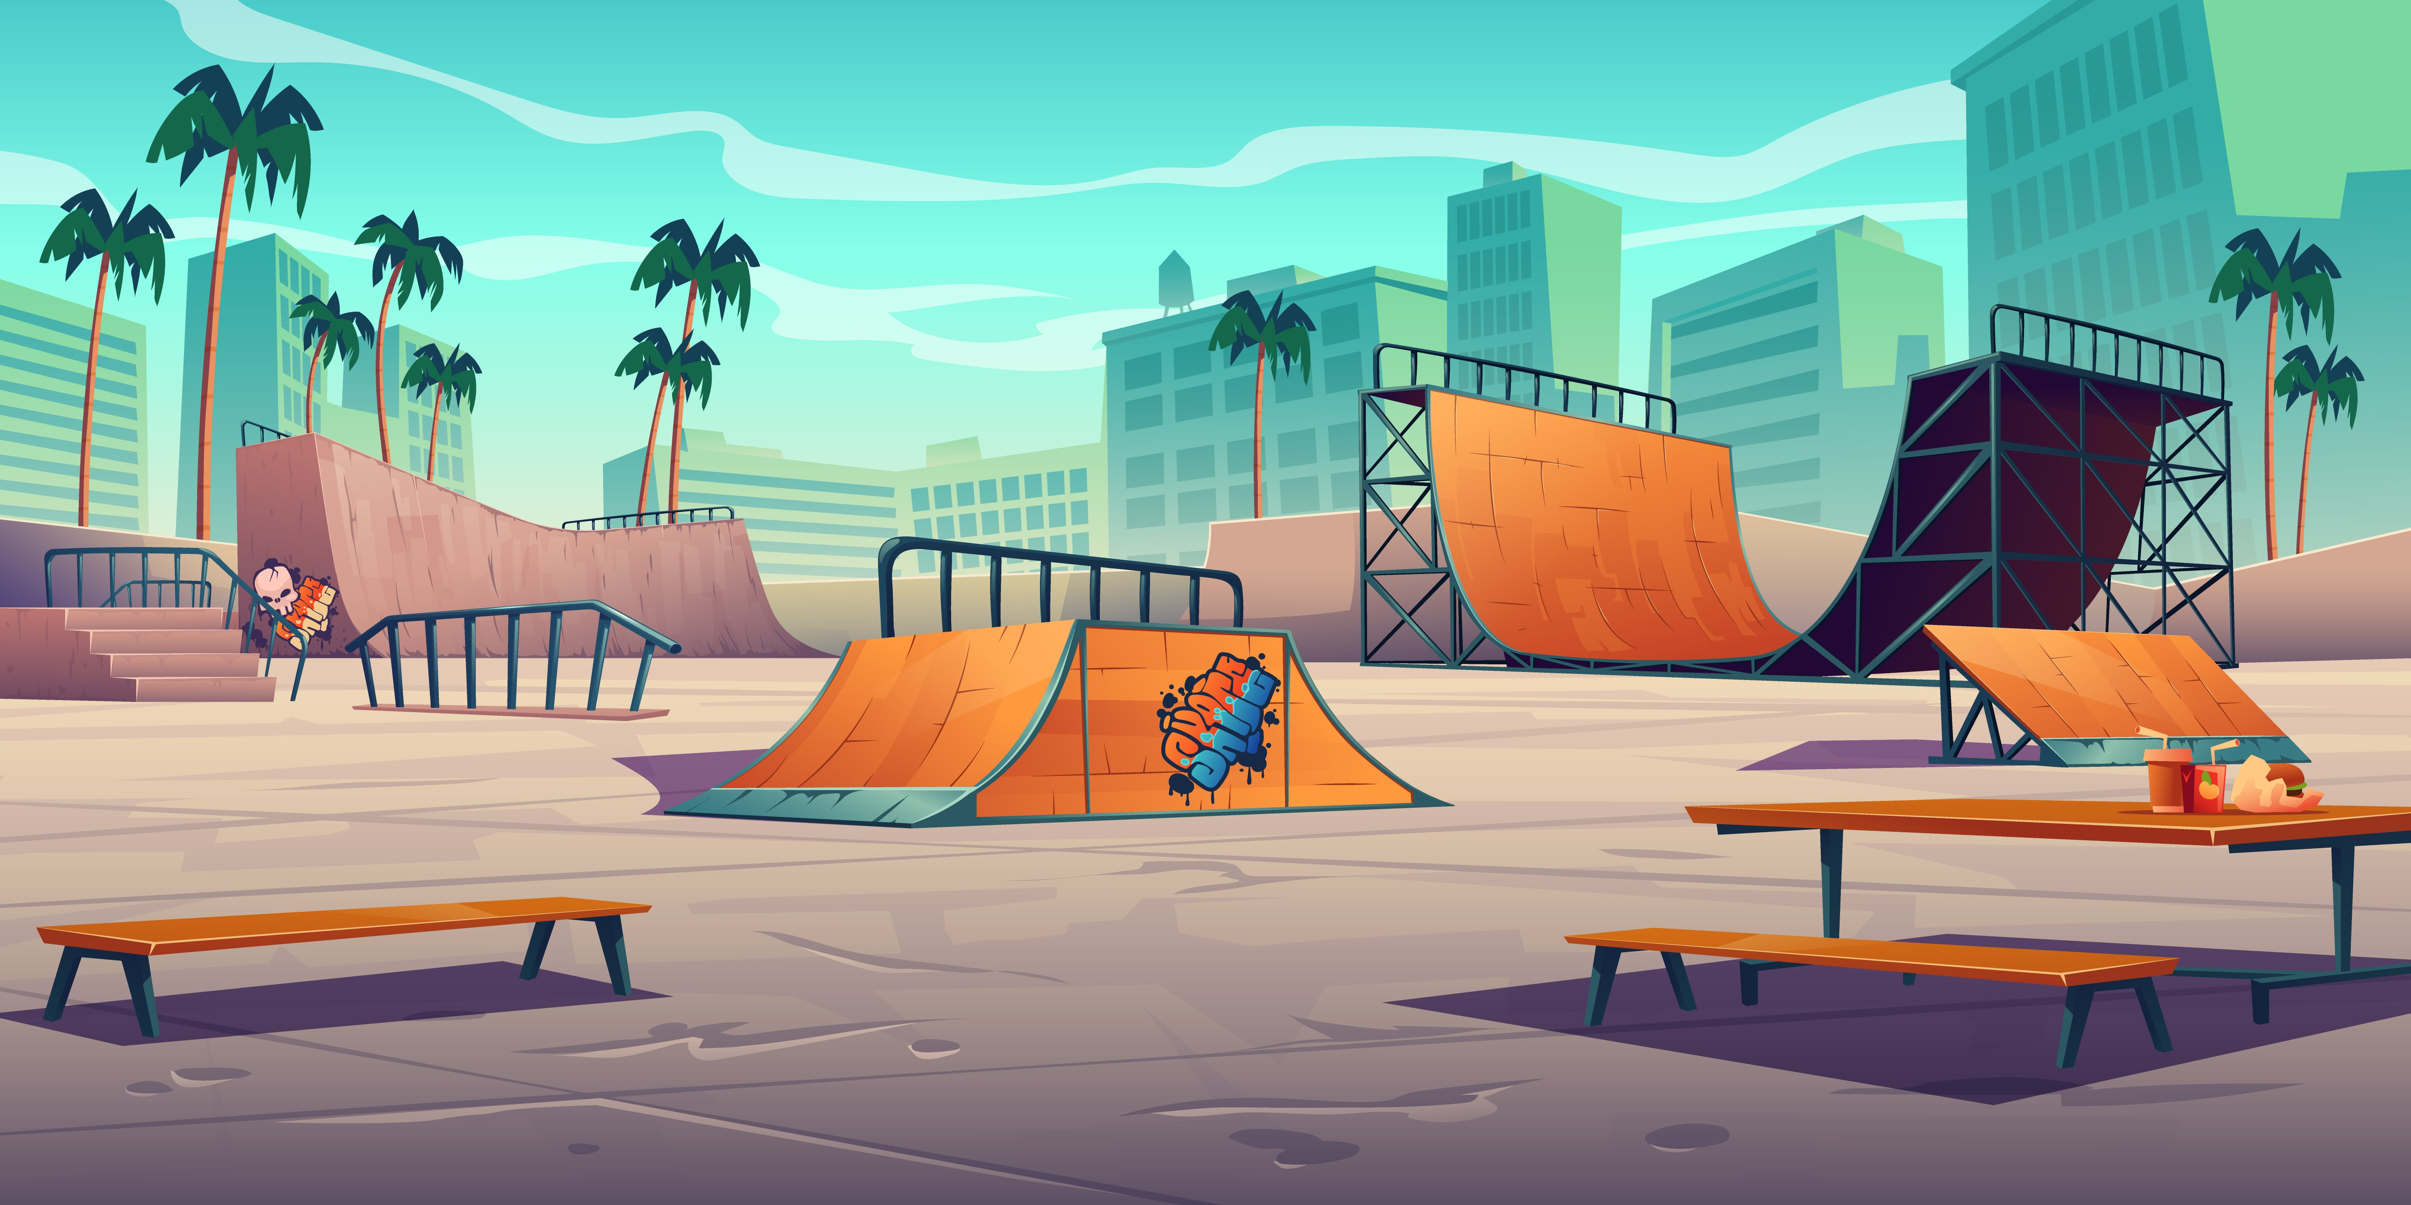

1. How many palm trees are visible? 6 (taxonomic) (trees)

2. How many benches are present for people to sit on? 2 (functional) (benches)

3. If all the ramps were made of glass instead of wood, how many ramps would be fragile? 4 (physical) (ramps)

## Image 114 (park)

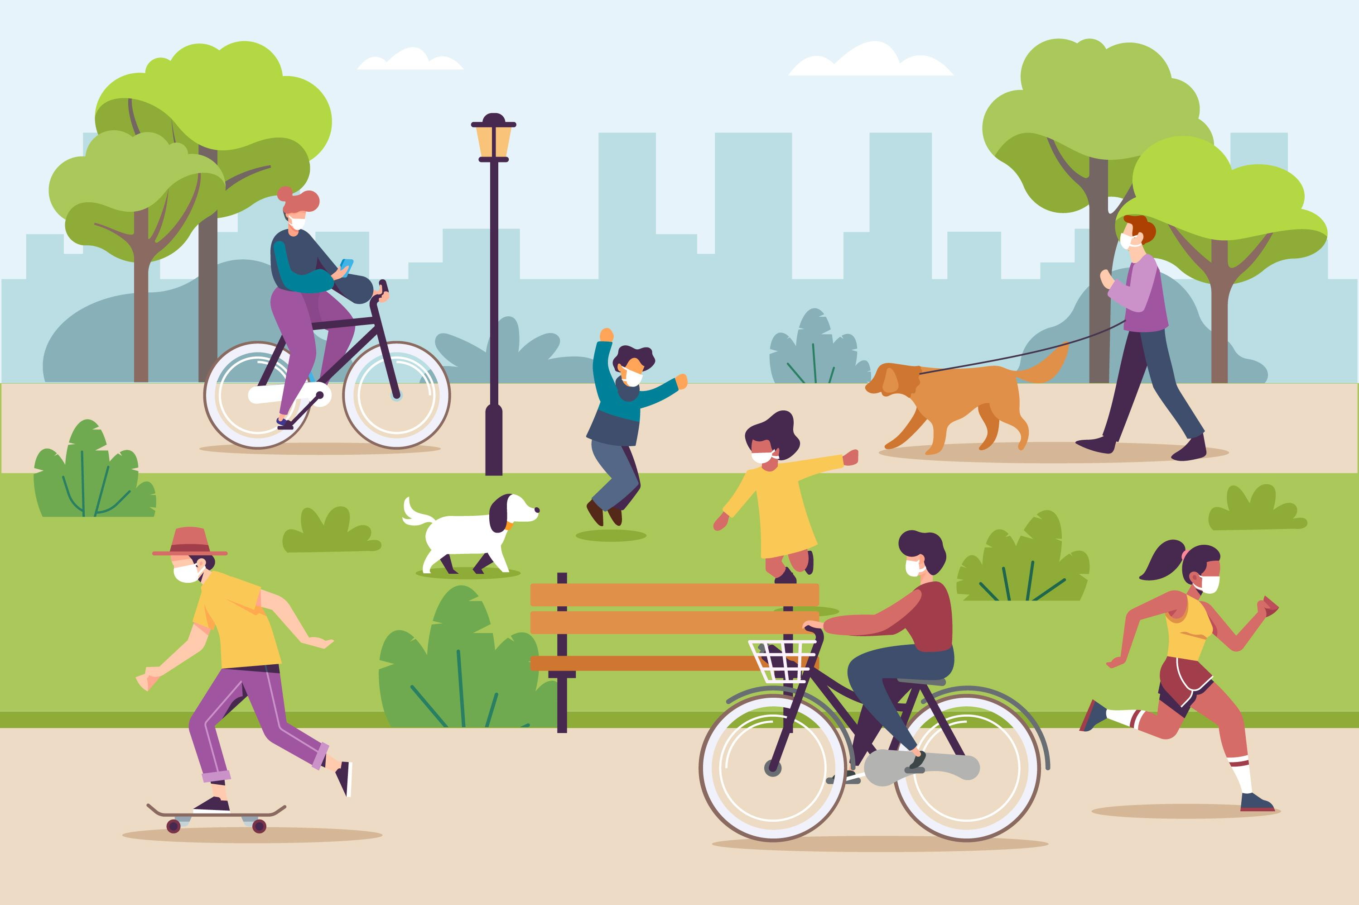

1. How many mammals are visible? 3 (taxonomic) (dogs)

2. How many people are wearing face masks? 6 (relational) (people)

3. If all the bicycles were red, how many red vehicles would there be? 2 (physical) (bicycles)

## Image 115 (park)

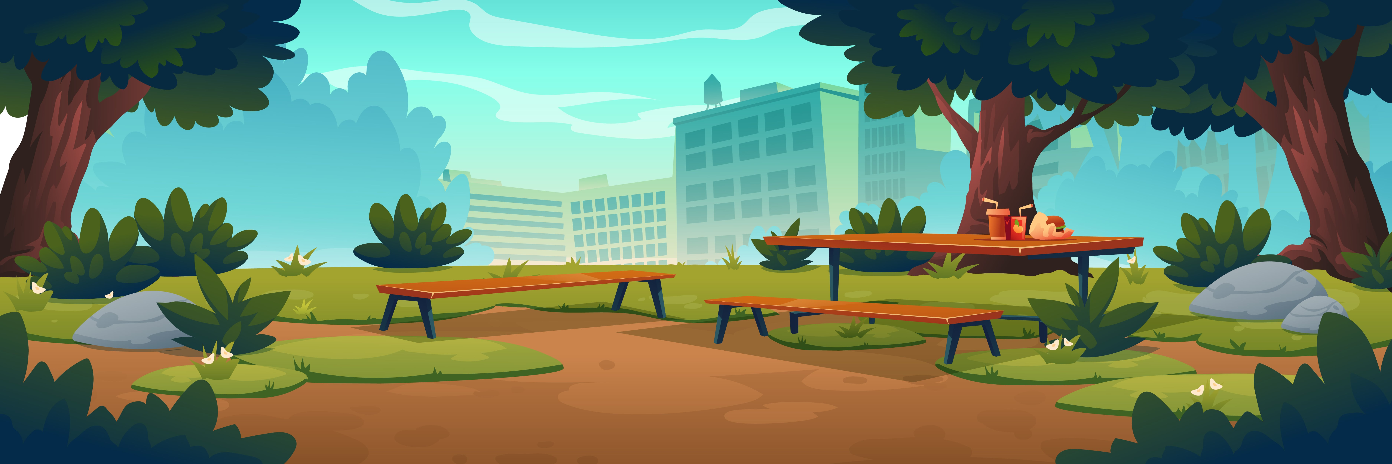

1. How many objects made of wood are present? 3 (physical) (picnic tables)

2. How many objects are positioned on top of a table? 4 (relational) (drinks and containers)

3. If the bushes were replaced with trees, how many trees would be visible? 5 (taxonomic) (trees)

## Image 116 (park)

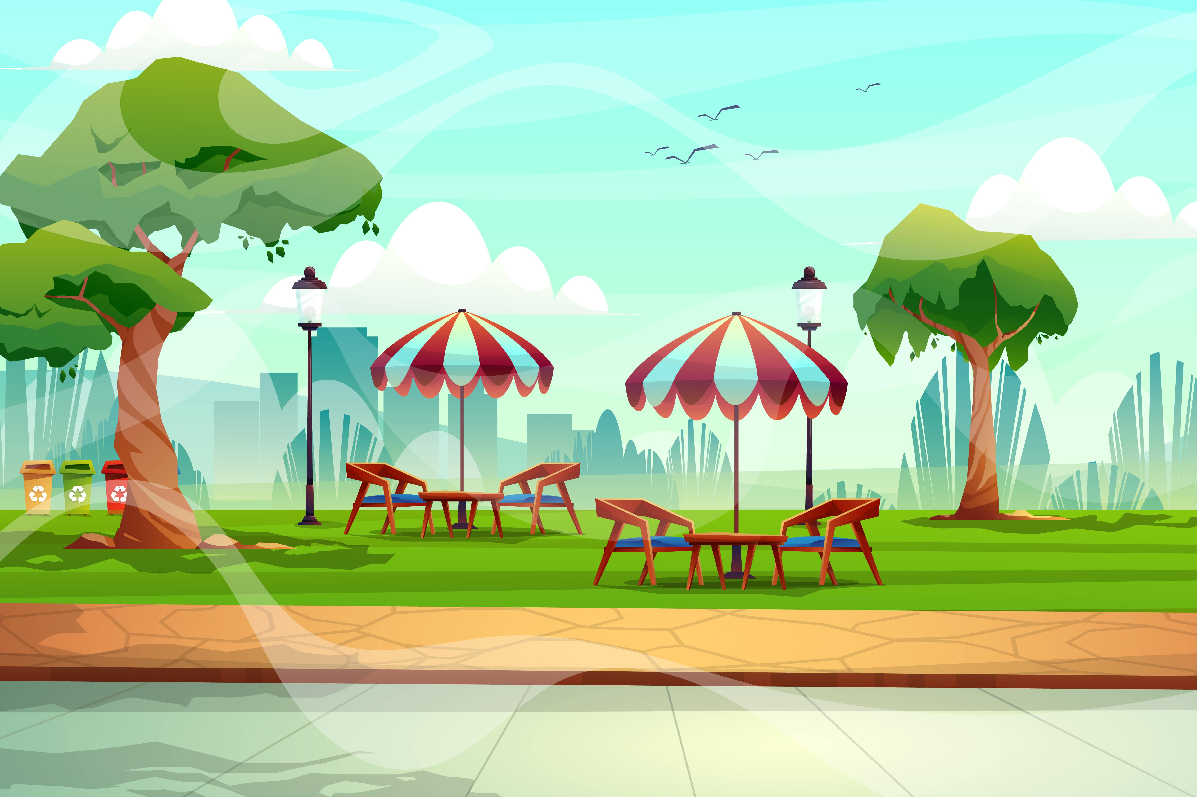

1. How many objects that are furniture are present? 6 (taxonomic) (tables and chairs)

2. How many objects are under umbrellas? 8 (relational) (chairs)

3. If the trees were removed, how many birds would be visible? 3 (taxonomic) (birds)

## Image 117 (park)

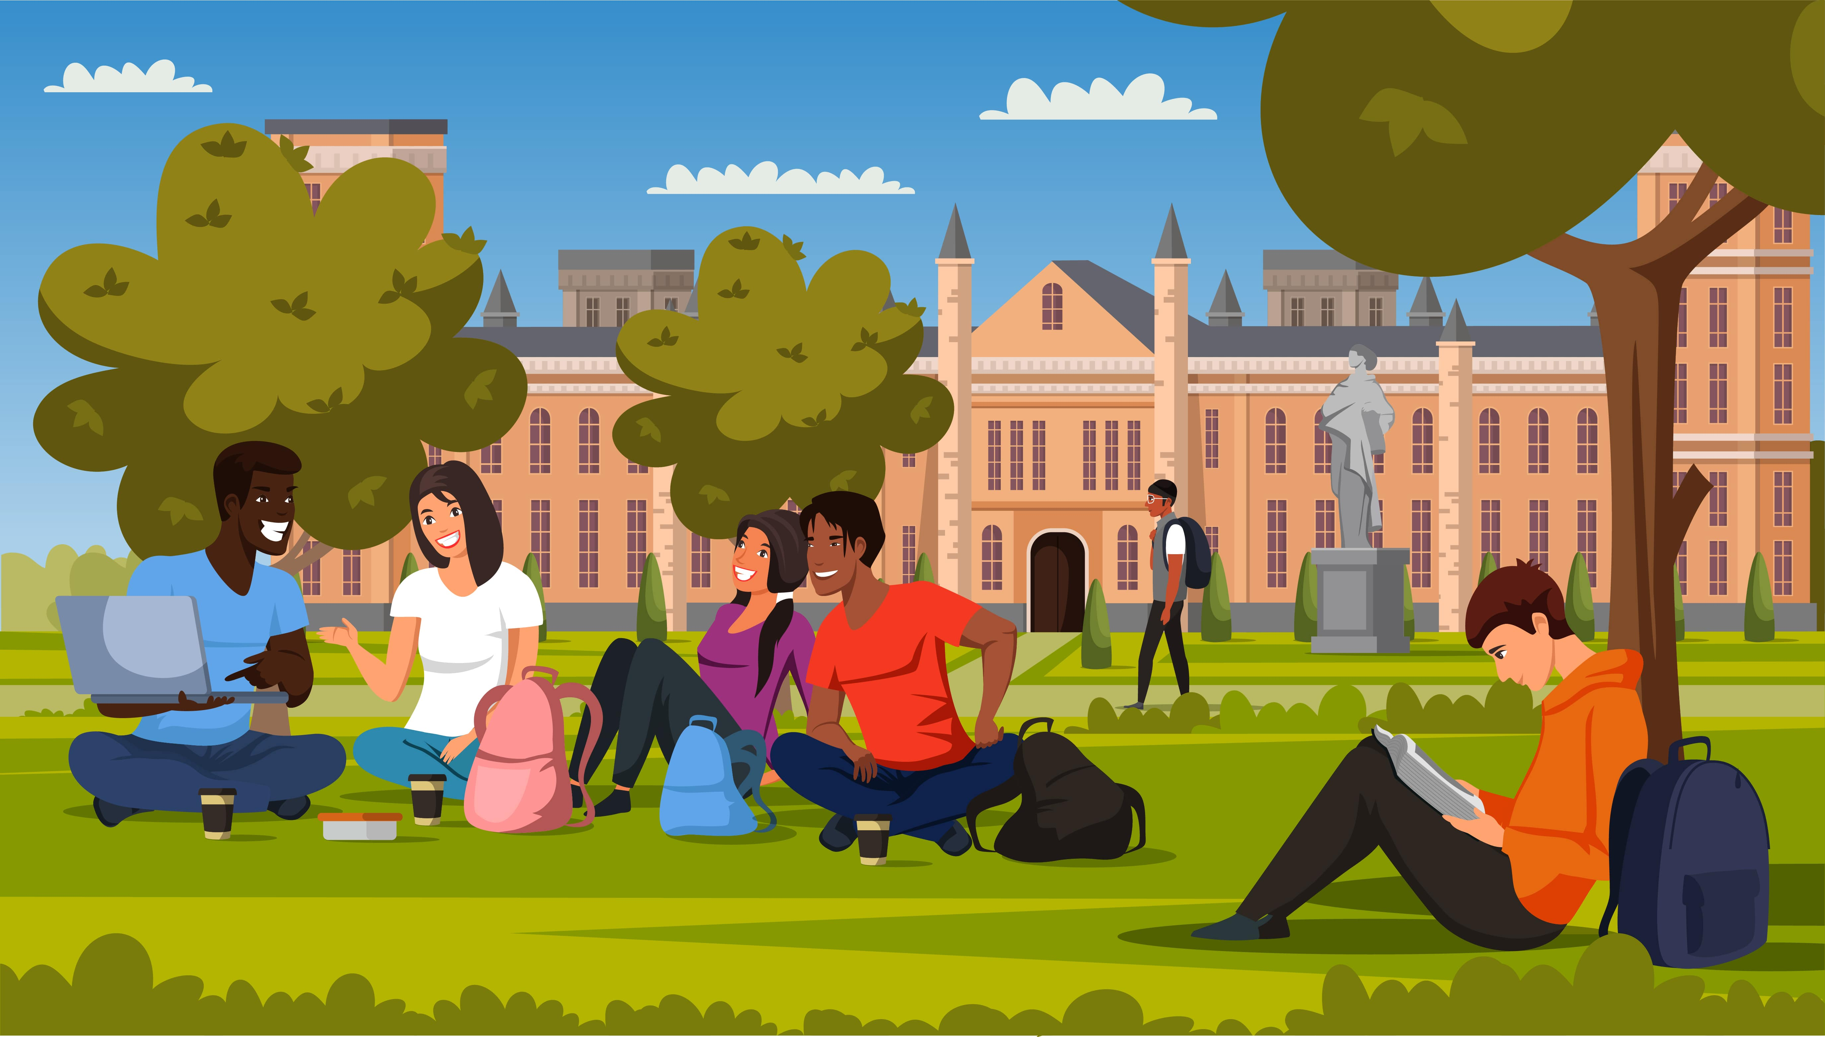

1. How many people are visible? 8 (taxonomic) (humans)

2. How many backpacks are visible? 4 (functional) (bags)

3. If all the birds flew away, how many birds would be visible? 0 (taxonomic) (birds)

## Image 118 (kitchen)



1. How many people are wearing aprons? 2 (taxonomic) (chefs)

2. How many items are hanging on the wall? 7 (relational) (kitchen utensils)

3. If the oven was a different color, how many silver appliances would be visible? 2 (physical) (refrigerator, range hood)

## Image 119 (urban)



1. How many people are present? 6 (taxonomic) (people)

2. How many objects with wheels are visible? 3 (physical) (skateboard, bicycle, scooter)

3. If the buildings were removed from the background, how many trees would be visible? 3 (taxonomic) (trees)

## Image 120 (zoo)

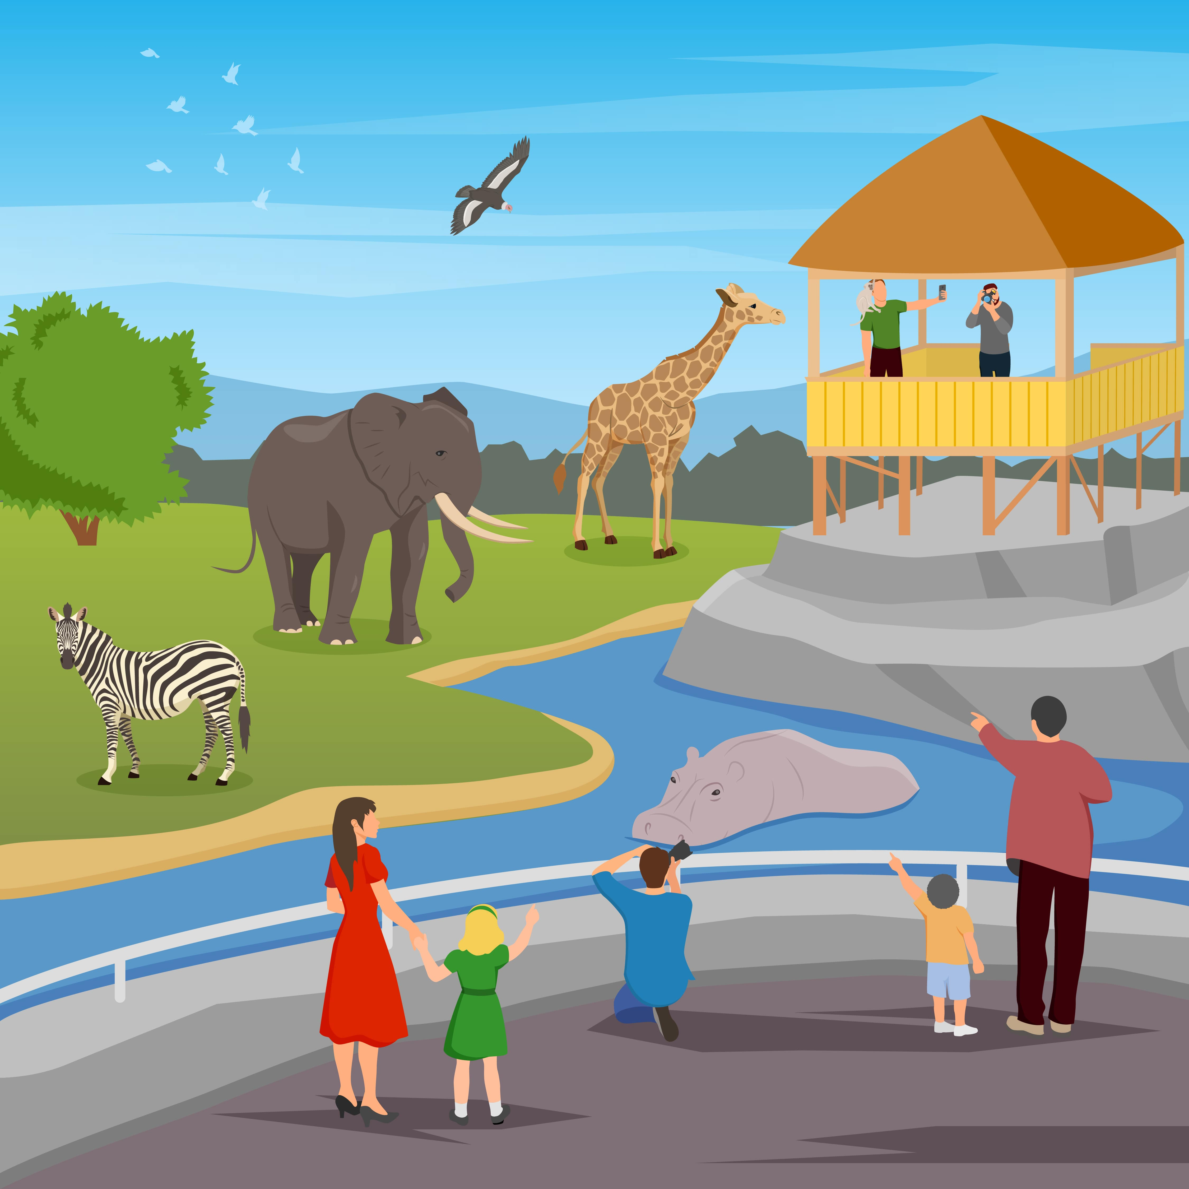

1. How many mammals are visible? 6 (taxonomic) (elephant, giraffe, zebras, hippo, people)

2. How many people are looking at the animals? 5 (relational) (people)

3. If the birds were replaced with butterflies, how many flying insects would be visible? 8 (taxonomic) (butterflies)